

SIP-T800N / T800N (P/G/W/K)
user manual

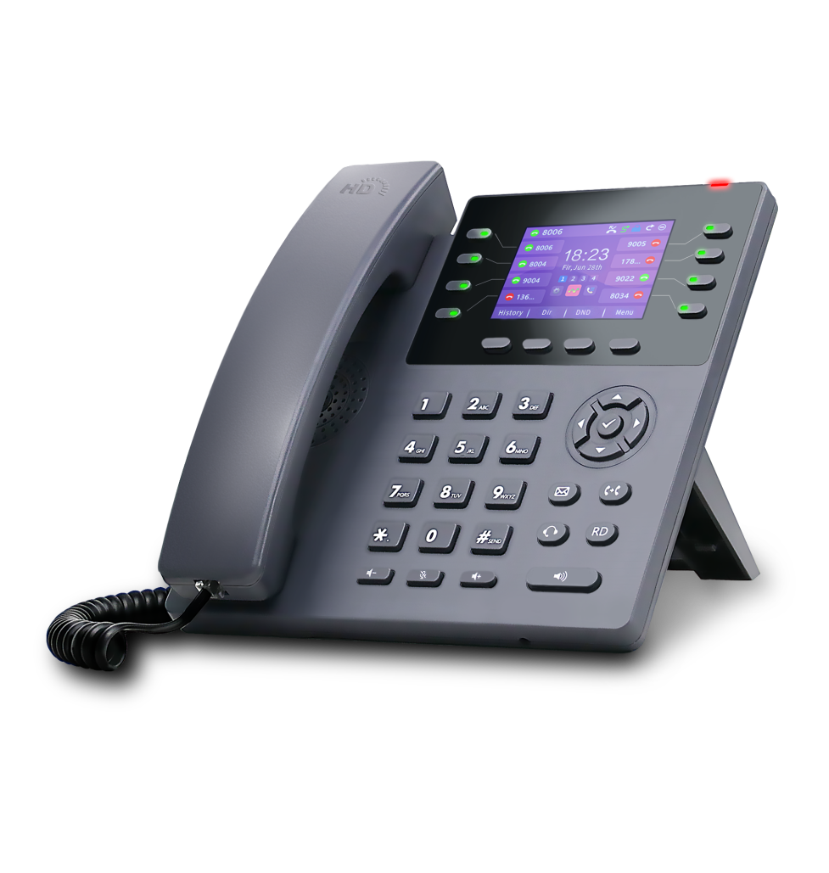

Document Version: V.3.1.0
Published: 20240427

copyright
Copyright © 2024 Guangdong Shanglu Information Technology Co.
Without the express written permission of Guangdong Shanglu Information Technology Co., Ltd, no unit or individual may reproduce, copy or translate part or all of the contents of this manual without authorization.
It shall not be used in any form or by any means (electronic, video, printed or otherwise) for commercial use, profit-making purposes, and Guangdong Shanglu Information Technology Co., Ltd. will not be responsible for any property or other losses caused by any such illegal behavior.
When this document is used for Internet distribution, the Company allows users to download or print it for private use.

warranties
The product specifications and inquiries mentioned in this manual are for reference only and are subject to update without notice. Unless otherwise agreed, this manual is intended only as a guide to use and provides the most accurate statements, information and advice possible, and makes no warranty, express or implied, as to what constitutes. The user shall be solely responsible for the application of the product.Guangdong Shanglu Information Technology Co., Ltd. disclaims all warranties with respect to this guide, including, but not limited to, the implied warranties of merchantability and fitness for a particular purpose. Shanglu Information Technology Co., Ltd. shall not be liable for any damages, indirect or incidental, resulting from the misuse of this guide.

herald
This device complies with the essential requirements of CE, FCC and other relevant regulations. You can check the CE and FCC information on the label on the back of the phone.




CE Mark
The device complies with the EU Safety Directive 2014/35/EU and the EMC Directive 2014/30/EU.

FCC Regulations Part 15
The equipment complies with Part 15 of the FCC regulations. Operation should comply with the following two requirements
1. The device does not produce harmful interference.
2. The equipment must accept any interference received, including interference that may cause unintended operation.

WEEE Mark

Since there are certain hazardous substances in electronic products, in order to properly dispose of these electrical and electronic wastes and to recycle valuable resources, when users intend to dispose of this product, it should not be disposed of with other household wastes, but should be handled independently.

Customer Feedback
We are working hard to improve the quality of the documentation and would love to receive your feedback. If you have suggestions or questions about the content of the documentation, please send your feedback to pan.jiandong@lvswitches.com.

Purpose of preparation
Thank you for using SIP-T800N/SIP-T800N(P/G/W/K) IP Phones, which is a feature-rich and simple office phone, in addition to high-definition sound quality, unique design, multi-language interchangeable; support for dual network ports, POE power supply; compatible with many vendors' service platforms, such as IPPBX, cloud PBX, IMS core network, softswitch, etc.; detachable stand to change multiple views, 8 customizable function buttons and a friendly user interface to fully meet the needs of users' communication and collaboration.

SIP-T800N/SIP-T800N(P/G/W/K) use the same firmware, the software functions are the same, the difference is in the hardware, the following table describes the difference between these hardware.
Product Model | clarification
SIP-T800N | regular version
SIP-T800N(P/G/W/K) | P (carrying PoE power)  G (carries Gigabit Ethernet port)  W (with WIFI module)  K (with external network port for expansion station)

This guide contains all the features of the phone and instructions to familiarize you with the features of the T800N IP phone. Before installing the T800N IP phone, please read the following of this guide. Safety Instructions and Packing List sections of this guide for safe and quick use of the T800N IP phone.

For more help, contact your network administrator or reseller.

Content of the manual
This guide contains the following:
- 1. Overview
- 2. safe Notes on
- 3. Phones Getting Started with
- 4. Telephone customization
- 5. Basic functions
- 6. Advanced features

catalogs

copyright 2
warranties 2
herald 2
CE Mark 2
FCC Regulations Part 15 2
WEEE Mark 2
Customer Feedback 3
Purpose of preparation 4
Content of the manual 4
catalogs 6
summarize 10
Hardware Composition 10
Display icon composition 13
Indicator light description 16
Configuration Interface Description 16
Phone Interface Configuration 17
Computer Web Configuration 17
Mobile Scanning Configuration 18
Using Documents 22
Safe Use 23
Getting Started with Phones 25
Packing List 25
Phone Installation 27
Mounting Base 28
Connection handle, headset (optional) 28
Connecting the power supply and network cable 29
Phone initialization 31
Phone Standby Interface 31
Check the status of your phone 32
Setting up the phone network 33
Register for an account 36
Phone Input Methods 37
Phone customization 40
Basic settings 40
multilingualism 40
Time & Date 42
Call-out button 47
Keypad lock 47
Power lamp 51
Backlight 52
Pop-up notification window 52
Boot Picture 53
Screensavers 54
Sound Settings 55
Volume settings 55
Ringtone Setting 57
Keypad tone 58
SMS alert tone 59
Signal tone 60
Sound Gain 62
Contact Management 63
local contact 63
Blacklists 73
LDAP Configuration 76
Call Record Management 80
Remote address book 82
Update Address Book 84
Address Book Settings 85
Accessory Customization 87
Headset use 87
Extension desk 89
System Customization 97
Account Management 97
Programmable keys 100
Dialing Rules 111
Basic Functions 121
make a telephone call 121
Answer the phone 124
End a call 125
Redial 125
DND 126
Call transfer 129
Active transfer 129
Automatic transfer 130
call forwarding 135
Blind transfer 135
Advisory Transfers 137
Call Waiting 139
PIN call 140
Call hold 140
Automatic redial 141
Status return code 142
Call completion. 143
Auto Answer 145
Anonymous call 146
Hotline 148
Two-dimensional barcode 148
Conference 150
Update 151
Upload ringtones 152
Capture & Diagnose 153
Scheduled reset 154
Configuration management 155
Advanced Features 156
BLF (Busy Lamp Field) 156
Configuring the BLF key 156
Using the BLF Function 158
Walkie-talkies 158
Setting the intercom function buttons 158
Intercom function setting 159
Intercom function description 160
Multicast 160
Multicast Configuration 161
Multicast List Configuration 162
Accept multicast RTP streams 165
Multicast Usage 167
Message 168
Text message 168
Voicemail 171
TR069 173
Automatic update 174
Preparatory step 174
Automatic update procedure 176
Remote control 179
SIP Configuration 181
SIP Session Timer 181
Native SIP ports vs. TLS SIP ports 182
Action URL 183
Enables actions to be reported to the server 183
Description of variables 186
Web Configuration Instructions 187
Type of web access 187
Trusted Certificates 188

summarize

This section provides a brief overview of the T800N IP Phones, with the following key points:
- Hardware Composition
- Description of display icon
- Indicator light description
- Configuration Interface Description
- Using Documents

Hardware Composition
The hardware components of the T800N phone mainly include the panel control panel, LCD display, call handles and external expansion disk. The details are shown in the figure below:
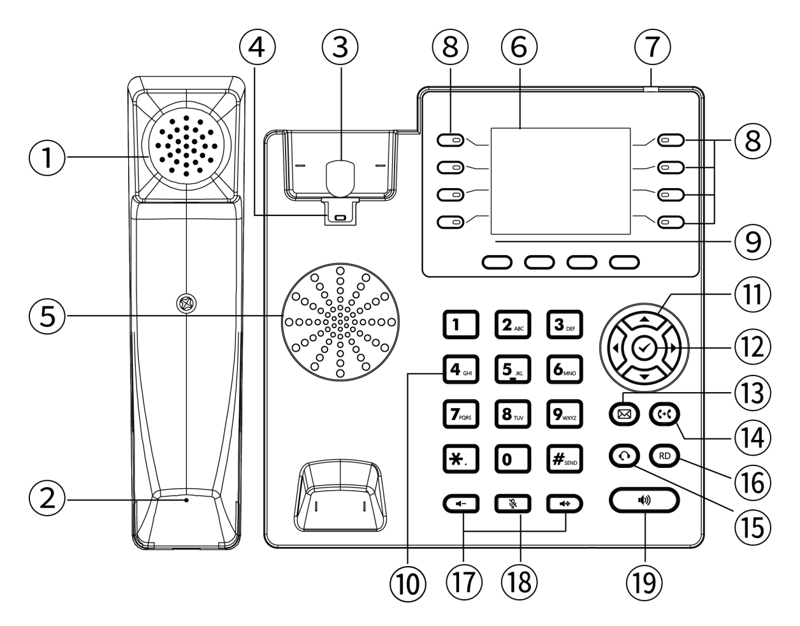

serial number | name | clarification
1 | Handset earpiece | Audio output when using the handle for calls.
2 | handheld microphone | Audio input when making a call using the handle.
3 | switch hook | Handle placed/hookswitch pressed - hang up.  Handle lift/hookswtich bounce -- pick up Pak hook -- Flash operation.
4 | Handle Hooks | Used to secure the handle.  Hang the phone on the wall with the hook protruding upwards.
5 | speakers | Outputs audio while the phone is on a hands-free call.
6 | liquid crystal display | Displays information about the phone:  - Register account information (display name, display number).  - Time Date.  - Tip Icons (see details) Display Icon Description ).  - Prompt messages (incoming calls, missed calls, e-mail messages).  - Operational Cues.
7 | Breathing light | - Incoming Call Alert Breathing Light" flashes fast.  - The "Message Alert Breathing Light" flashes slowly.  For details, please refer to Indicator light description .
8 | account key | - Switching accounts.  - Intercom button.  - Caller ID call account light.
9 | 4 soft keys (below the display) | Corresponding to the four function names at the bottom of the display  (For example,there are 4 soft key functions displayed on the main interface:History Dir DND Menu).  These four soft key will change with the operation of the phone keys. In the function desciption below, the soft key refer to are these four keys,The soft key functions correspond to the text at the bottom of the display screen.
10 | numeric keypad | Provides numeric input, upper and lower case letter input, punctuation input (* # . :).
11 | Up, down, left and right buttons | Options for toggling the display.
12 | keystrokes | - Function setting confirmation operation.  - Dialing after enter a number.  - Answer the call when it comes in.  - View network status (IP address, MAC address, version information, etc.).
13 | Message Button  (old SMS)  (Message) | Configure the message feature code, which is provided by each IPPBX, and press the number to quickly query the voice information of the phone after configuration.
14 | Call Forwarding/Forwarding Button  (Transfer) | - Blind transfer.  - Inquiry transfer.  - Quick-switch call forwarding when the phone is idle.  This can also be accomplished with the soft keys at the bottom of the screen.
15 | Headset buttons (Headset) | Pressing the headset button causes the audio to go to the headset, which must be plugged in to use headset mode.  For more information, please refer to Headset use .
16 | RD button  (Redial) | For redialing.
17 | Volume up and down buttons   | Provides 0~15 frame volume setting.
18 | mute button  (Mute) | Press the Mute button during a call to mute the call.
19 | hands-free button  (Speaker) | Use hands-free calling.

Display icon composition
The main icons used in the T800N display and the corresponding descriptions of the icons are shown in the table below:

typology | Icon Style | Icon Description
Account  (statistics) correlation |  | Account not enabled/not registered.
 |  | Account registration in progress.
 |  | Account is registered.
Voice status |  | Phones are free of interruptions.
 |  | Auto-answer.
 |  | Missed calls.
 |  | Voice mail.
 |  | Text message.
 |  | The phone is in mute mode.
 |  | Hands-free mode for calls.
 |  | Call Handle Mode.
 |  | Talking headset mode.
 |  | Call mute.
 |  | Call Forwarding Enabled.
Call record icon |  | Missed calls.
 |  | Received call.
 |  | Dialed number.
 |  | Transferring calls.
System icon |  | The network is unavailable.
 |  | Wifi icon when selected the base color turns red
 |  | Advanced Settings icon when selected the base color turns red
 |  | Function icon when selected the base color turns red
 |  | CDR icon when selected the base color turns red
 |  | Basic Settings icon when select the base color to red
 |  | Address Book icon when selected the base color turns red
 |  | Message icon when selected the base color turns red
 |  | Status icon when selected the base color turns red
 |  | Keyboard lock enabled
Feature icon |  | DTMF
 |  | XML browser
 |  | XML group
 |  | Hold
 |  | Local group
 |  | Message
 |  | Intercom
 |  | Callback
 |  | Keypad lock
 |  | Hot desking
 |  | DND
 |  | Prefix
 |  | Fetch resident
 |  | Group listening
 |  | Group pickup
 |  | Speed dial
 |  | Call park
 |  | Directory
 |  | Voice mail
 |  | Designated pickup
 |  | Transfer
 |  | Paging
 |  | Multicast list

Indicator light description
The T800N indicator status and description are described in the following table:
typology | Indicator status | clarification
Breathing light  (red light) | go out | Standby, power off.
 | Ever Bright | The initialization indicator is always on when the phone starts up.
 | flash | The indicator light flashes rapidly when the phone is ringing from an incoming call.
 | slow flash | Indicator light blinks slowly when the phone receives message alerts such as voice mail, missed calls, etc.
Account line light  (green light) | go out | The account is idle.
 | Ever Bright | The account line is being occupied.  The account line is on the line.
 | flash | The line flashes rapidly when the phone is ringing from an incoming call.

Configuration Interface Description
The T800N phone supports the following ways to configure the phone:
- Phone Interface Configuration
- Computer Web Configuration
- Mobile Scan Web Configuration

Quickly configure the phone, through the phone LCD display and the phone keypad panel you can configure and use the phone functions. If you know the IP address of the phone, you can also enter the IP address of the phone into your browser to view all the features of the phone and configure them through your browser. If you don't have a computer nearby you can use your smartphone to scan the QR code provided by the phone to configure it. The details are described below:

Phone Interface Configuration
Enter the menu through the soft key of the phone, you can configure the basic settings (language, ringtone, etc.), and configure the advanced settings (account number, network, etc.), if you need to enter the advanced settings you have to enter the administrator password, the initial administrator password of the T800N is admin, input it and enter. Meanwhile, there are some basic functions in the menu, please check the introduction of specific function settings in Function Configuration Chapter.

Computer Web Configuration
- Method to view the IP address (IPv4 or IPv6) of the phone:
It can be viewed in any of the following ways:
1. Press the confirm button to view.
2. Press the Menu soft key -> Enter Status Options to view.
Description IPv4 address e.g. 192.168.1.123.
IPv6 addresses such as 2003:4998:c:e33::1004 .

After obtaining the IP address of the phone, enter the IP address in the web browser of your computer, for example: IPv4 address (192.168.1.123 or http://192.168.1.123), IPv6 address ([2003:4998:c:e33::1004] or http://[2003:4998:c:e33::1004]), enter the login page of the phone, use the login password to enter the main interface, the initial administrator account password are lowercase admin.), For the specific function settings, please refer to Function Configuration Chapter.

Mobile Scanning Configuration
Get the QR code of the phone through the QR code function of the phone, before scanning, the smartphone needs to be connected to the same network as the phone's WIFI, in order to use the smartphone to scan the QR code to access the phone's management page, the specific function setup introduction, please check the Function Configuration Chapter. For more help, please contact your network administrator.

A comparison of the features that can be configured on the three configured method is shown below:
functional item | Phone Configuration | Web Configuration | Scanning Configuration
Status | √ | √ | √
├ IPv4
├ IPv6
├ MAC address
├ Version
└ More
├ Network
├ Device
└ Accounts
Account |  | √ | √
├ User information | √
├ Label | √
├ Display name | √
├ User name | √
├ Register name | √
└ Password | √
├ Server information
├ Sip server 1 | √
├ Sip server 2 | √
├ Sip port number | √
├ Transmission mode | √
├ Re-registration times | ×
└ Proxy server | √
├ Server Expires | ×
├ Auto Answer | √
├ Proxy Server | √
└ NAT | √
├ Codec Setting | √
└ Advanced
├ DTMF | √
├ User Agent | ×
├ SRTP | ×
├ Keep Alive Type | ×
├ Retransmission | ×
├ Caller ID Source | ×
├ Session Timer | ×
├ Session Expires | ×
├ SIP Registration Retry Timer | ×
├ Conference Type | ×
├ Directed Call Pickup Code | ×
├ Unregister When Reboot | ×
├ RFC 2543 Hold | ×
└ Synchronize Server Time | ×
Network setting |  | √ | √
├ Basic Setting
└ IPv4/IPv6/IPv4 & IPv6 | √
├ DHCP | √
└ Static IP | √
├ Advanced Setting
├ CDP & LLDP | √
├ VLAN | √
├ Voice Qos | ×
├ Web Server Type | √
└ VPN
├ OpenVPN | ×
└ L2TP | ×
├ Diagnosis
├ Pcap
├ Normal Pcap | ×
└ Enhanced Pcap | ×
└ Diagnostics
├ Ping | √
└ Traceroute | √
├ NAT
└ STUN | ×
└ SNMP | ×
Features |  | √ | √
├ Call forward
├ Always Forward | √
├ Busy Forward | √
└ No Answer Forward | √
├ Call transfer | √
├ Auto Answer | √
├ Anonymous Rejection | √
├ Local Anonymous | √
├ Hotline | √
├ Call Hold
├ Hold Tone | ×
└ Hold Tone Delay | ×
├ Call Number Filter | ×
├ QR code | √
├ DND | √
├ Call Waiting | √
├ Psw Prefix | ×
└ Conference
├ Local Conference | ×
└ Network Conference | ×
Advanced Features |  | √ | √
├ BLF (Busy Lamp Field) | √
├ Multicast | √
└ Multicast Codec | ×
├ SMS
├ Text Message | √
└ Voice Mail | √
├ Auto Redial | √
├ Status Return Code | ×
├ Dual Headset | ×
├ Headset Prior | ×
├ Intercom | √
├ Action URL | ×
├ Remote Control | ×
└ Auto Provision | √
Customization |  | √ | √
├ Sound
├ Key Tone | √
├ Ring | √
├ SMS Beep | ×
├ Signal Tones | ×
└ Sound Gain | √
├ Display
├ Time&date | √
├ Language | √
├ Power LED | ×
├ Notification Popups | ×
├ Backlight | ×
├ BootUP Image | ×
└ ScreenSaver | ×
├ Key As Send | √
├ Dial Plan | ×
├ Dsskey
├ LineKey | √
├ Programmable Key | ×
└ EX Module | ×
├ Keypad Lock | √
├ Auto Reboot | ×
├ Import/Export Configuration | ×
├ TR069 | ×
├ SoftKey Layout | ×
└ SIP Setting | ×
Directory |  | √ | √
├ Local Contacts | √
├ Blacklist | √
├ Remote Phone Book | ×
├ History | √
├ Update Directory | ×
└ LDAP | ×

Description QR code Configuration and PC Web Configuration have the same functionality, the following chapters only show the diagrams for PC Web Configuration.

Using Documents
The T800N is supplied with the following technical support manual:
name | clarification | gain | language type
T800N Quick Start Manual | Includes easy installation and customization of the phone | Comes with phone package | Chinese/English
 |  | Lvswitch official download
T800N IP Phone User's Guide | Detailed Functions and Usage | Lvswitch official download | Chinese/English

Safe Use

Please read the safety instructions carefully before installing and using the phone to ensure safe and convenient use of the phone!

- Use the power adapter specified for the product (included in the package). If you need to use a power adapter supplied by another manufacturer, please make sure that the voltage and current of the supplied adapter are in accordance with the specifications of the product (see details. Connecting the power supply and network chapter ), and it is also recommended to use a product that has passed the safety certification, otherwise it may cause damage to the equipment or even result in fire or electric shock accidents. Before using this product, please check whether the power cord is damaged or not. Do not use damaged power cords and power cords in abnormal condition, such as twisted, stretched, or bundled power cords, as this may cause fire and electric shock accidents.

- Non-technical service personnel do not disassemble or repair the product by yourself, improper installation or repair may cause electric shock, fire and other accidents, while your product warranty will be invalidated, For technical support, please contact the agent or your network administrator.

- Maintain the temperature and humidity of the product to meet the working requirements of the product. Ensure that the product is placed flat on the working platform, and check that the anti-slip rubber on the base of the product has not come off and caused the phone to slide on the platform. Place the device away from electrical appliances with strong magnetic or electric fields, such as microwave ovens or refrigerators. Keep the device away from sources of ignition.

- Do not put metal foreign objects such as large pins, wires, etc. into the vents or crevices. Otherwise, it may cause electric shock and other injuries caused by the current passing through the metal foreign objects. If foreign objects or similar metal objects fall into the product, it should be stopped in time.

- This product contains small parts inside, place the device out of reach of children to avoid accidental swallowing of small parts.

- If you need to clean the phone, please cut off the power supply, use a dry rag to wipe, and after cleaning, place it in a ventilated place to dry naturally, the power adapter needs to be kept dry and clean, otherwise accidents may occur.

Getting Started with Phones

This chapter introduces you to getting started with the T800N IP Phone, as follows:
- Packing List
- Phone Installation
- Phone initialization
- Phone Standby Interface
- Check the status of your phone
- Setting up the phone network
- Register for an account
- Phone Input Methods and Input Methods

Packing List
The following accessories are included in the shipping package of the T800N IP phone:
Accessory Name | quantities | photograph
T800N IP Phone Host | ×1 | 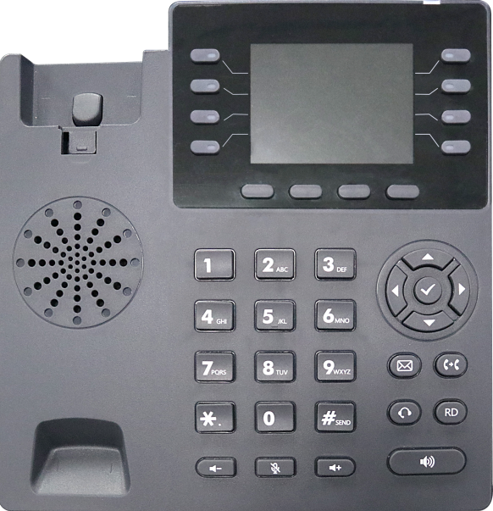
T800N IP Phone Handle | ×1 | 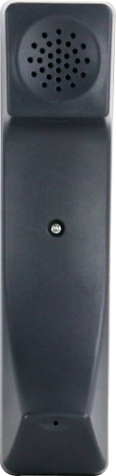
T800N IP Phone Base | ×1 | 
T800N IP Phone Connection Cable | ×1 | 
Ethernet cable | ×1 | 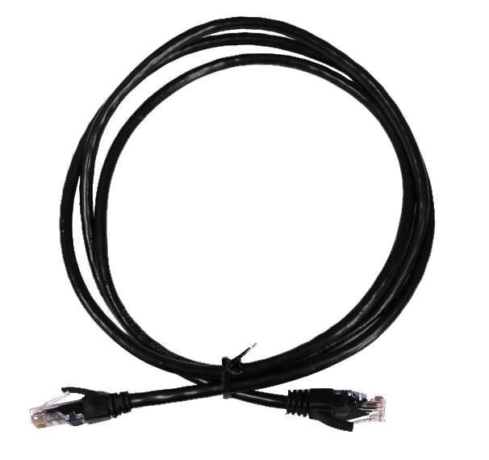
Power adapter (5.5mm DC plug 5V ⎓ 1A) | ×1 | 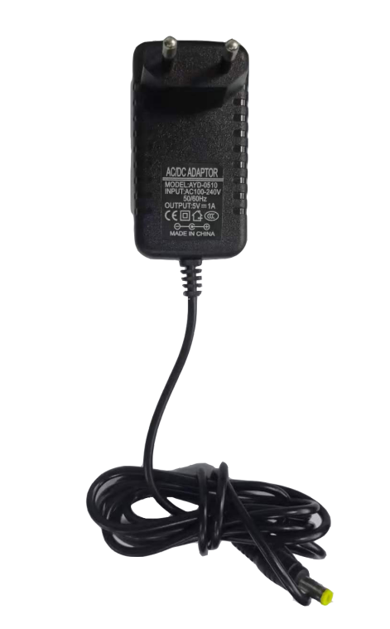
Quick Start Guide | ×1 | 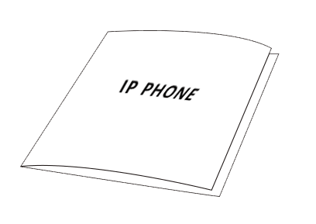
Instruction Before installing the phone, please check the completeness of the accessories according to the packing list, if any accessories are missing, please contact your network administrator or seller.

Phone Installation
If you have already successfully installed the phone, skip this section and navigate to the Initializing the Phone section.
The installation steps are as follows:
- Mounting Base
- Connection handle, headset (optional)
- Connecting the power supply and network cable

Mounting Base
There are two types of base mounting:
a) Desktop mounting
- Wall mounting

- Desktop mounting
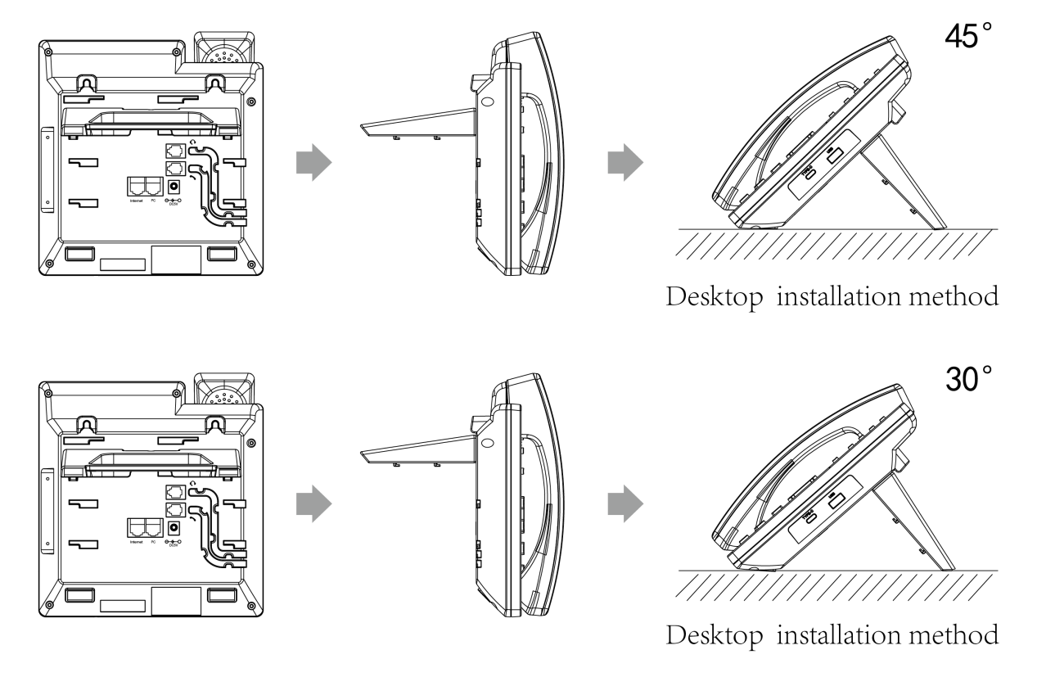

- Wall mounting
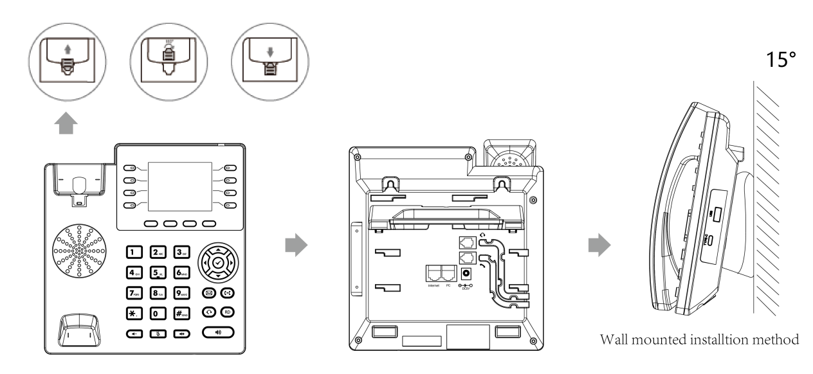The hook of the phone for wall mounting requires reversing the handle hook to prevent the handle from falling off the phone.

Connection handle, headset (optional)
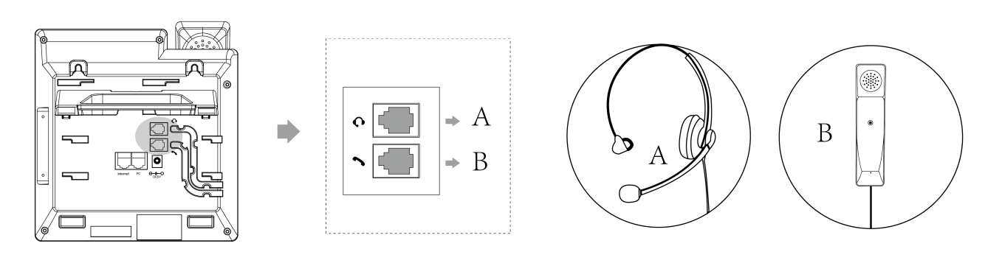
Instruction To use the headset, you need to turn on the headset mode, please check the details of how to use it. Using the headset section for details on how to use the headset.

Slot A is the headset jack and slot B is the handle jack.

Connecting the power supply and network cable
The phone supports two types of power supply:
a) AC power supply
- POE Power Supply

- AC power
Use the power adapter included in the package to connect the power outlet to the DC5V socket of the phone; use the Ethernet cable included in the package or use a standard parallel cable to connect the upper layer switch/router to the Internet port on the back of the phone.
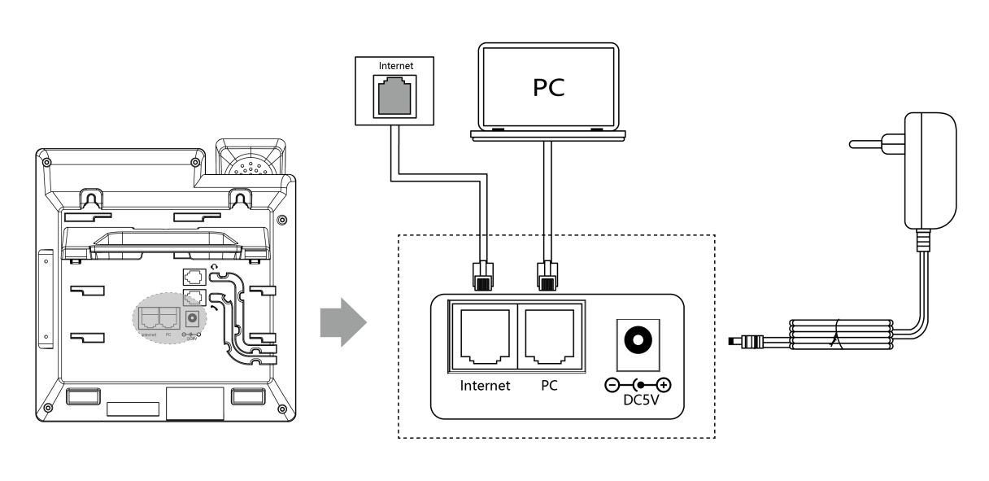

- PoE Power Supply
Use an Ethernet cable to connect a PoE switch to connect the hub to and the Internet port on the back of the T800NP IP phones.
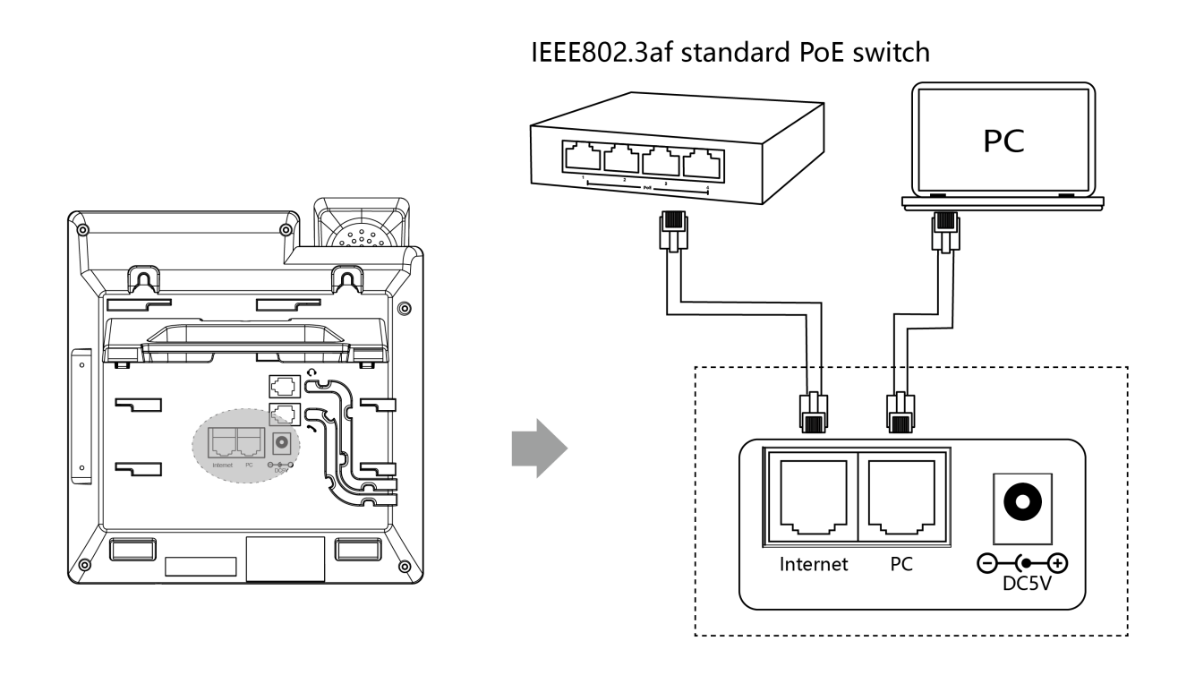
Instructions The voltage of the adapter used should not be higher than 5V ⎓ 1A to avoid damage to the phone chip. For safe use of the phone, please read theSafe Use Instructions for for safe use of the phones.

Note: If you are using PoE power, please check if your computer and switch support PoE power. If you use PoE power supply, you don't need to connect the adapter for power supply, if you need help, please contact your network administrator or reseller for confirmation.

Phone initialization
When the phone is properly installed and powered up, the phone startup will make the following display:
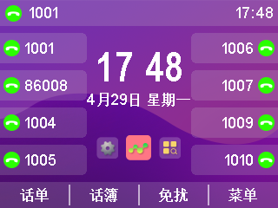
- Phone initialization
The red breathing light is always on and the account sof tkey light is always on, and the LCD screen displays "Initializing.... . please wait".
- Obtaining a network (the phone's initial network is automatically obtained by DHCP)
After successfully starting the phone, the phone will automatically obtain the assigned IP address, subnet mask, default gateway and DNS server and other network configurations. If the network cable is connected after the phone is started, the LCD display will show a prompt that the network is being obtained.
Description If you are unable to obtain network information, please check the Network Settings section, or contact your network administrator or dealer to check.

Phone Standby Interface
The display screen after the phone starts normally is as follows:
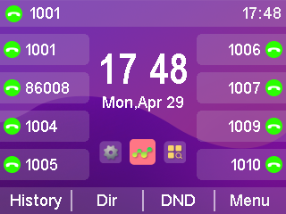
The phone standby screen displays the time and date of the phone, the status of the phone (Do Not Disturb, Missed Calls), the registration status of the account, the extension number, labels, and labels for the four soft keys (History, Dir, DND, Menu) at the bottom of the LCD. For icon descriptions of the standby screen, please refer to Display Icon Composition .
- The standby screen quickly jumps
1. Press the left and right keys to switch to the corresponding option. (You need to configure the left and right buttons of the programmable function keys to switch left and switch right.)
2. Pressshortcut key to enter the corresponding option list. (Configure the OK programmable function key to entering key)
For example, if you need to enable the auto answer function, you can press the left and right keys to switch to the function options, and press to quickly jump to the function interface for configuration.

Check the status of your phone
The phone status contains the following information:
- network information
IP Mode, IPv4 / IPv6 Address, Subnet Mask, Default Gateway, DNS Servers.
- Account Status
SIP account registration information.
- Equipment Information
Firmware version, product name, hardware version, MAC address, product ID.

Viewing the status of the phone can be done in the following ways:
- Phone interface for viewing
1 . Press the button or press the softkey Menu->Status to access the view.
2. Press or to select up or down, and enter "More..." to see more detailed status.
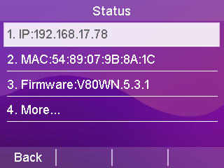
- Computer Browser Interface for Viewing
1. Open your browser.
2. Enter the IP address (IPv4/IPv6) of the phone, such as 192.168.0.130 as shown above.
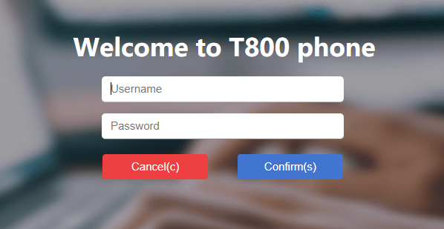
3. Enter the phone login page, enter the account &password to login, the initial account& password (admin/admin).

Setting up the phone network
The T800N can be set up with three network modes: IPv4, IPv6, IPv4 and IPv6.
Explanation When you enter an IPv6 address, you must put brackets around the address, such as [fe80::daec:a3ff:fe43:ad34], otherwise you can't access the web page of the phone through the IPv6 address, and not all servers support IPv6, so please consult with your network administrator before you use it.

Explanation If there is no need to configure the network mode and the default IP mode of T800N is IPv4, skip this step.

- Setting the network mode through the phone interface
1. Press Menu->Settings->Advanced Settings (password: admin)->Network->WAN Port.
2. Press the Switch softkey to select the desired mode (IPv4, IPv6, IPv4 and IPv6) in IP Mode.
3. In case of IPv4 and IPv6 modes, you can configure the mode priority, press or to select the mode priority and press the Toggle soft key to switch.
4. Press the Save soft key to save after selecting the mode.

- Setting the network mode through the web interface
1. Log in to the phone page by IP address.
2. Click Network Configuration (N)->Basic (b)->WAN Interface and select it in the drop-down box.
3. Click the Submit button to save the configuration.
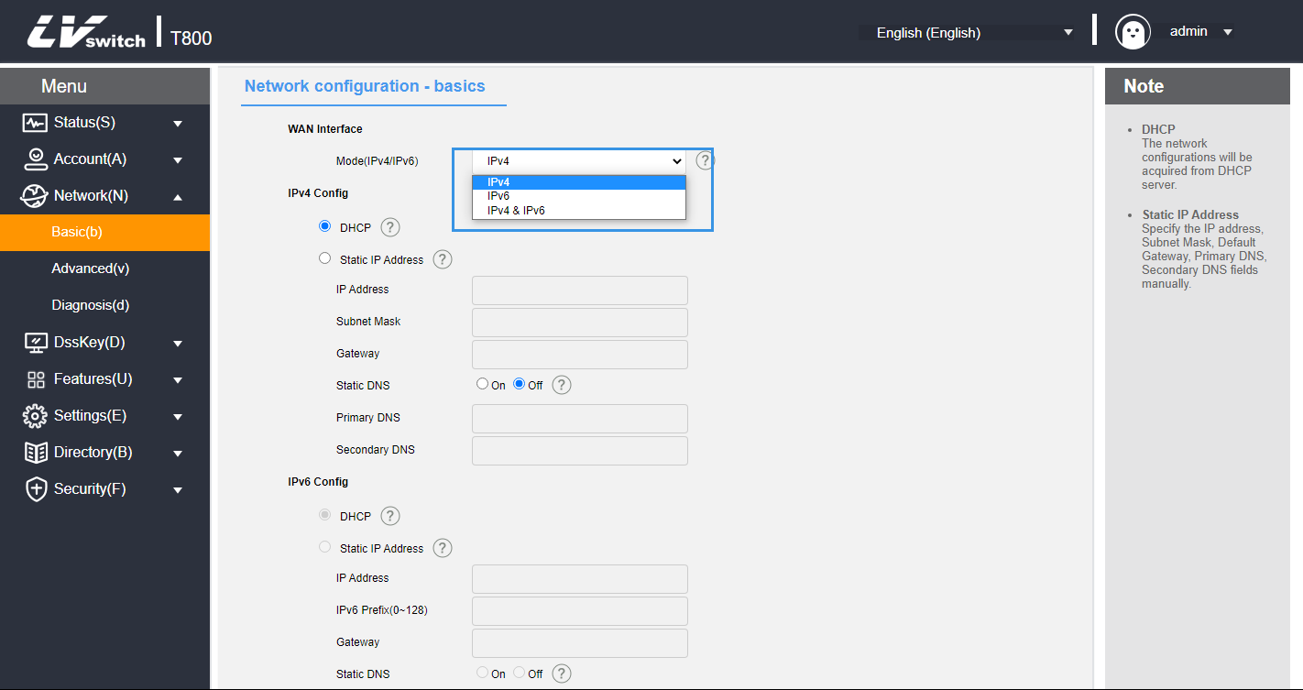
The T800N phone can be set up with a static IP address.
- Setting up a static IP through the phone interface
1. Press Menu->Settings->Advanced Settings (password: admin)->Network->WAN Port.
2. Press or to select IPv4 or IPv6 -> Static IPv4 Client and press the Enter softkey to enter the detailed settings.
3. Press or to select.
IPv4 requires IP address, subnet mask, default gateway, preferred DNS and alternate DNS.
IPv6 requires IP address, IPv6 prefix, default gateway, preferred DNS and alternate DNS.
4. Press the Save soft key to save the configuration or the Return soft key to cancel the setting when you are done.
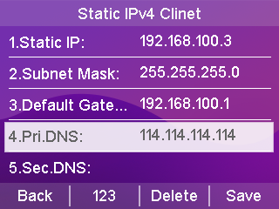

- Setting up a static IP through a web browser
1. Log in to the phone page by IP address.
2. Click Network Configuration (N)->Basic (b)->IPv4 Configuration or IPv6 Configuration.
3. Check Static IP address according to the selected WAN interface mode.
IPv4 requires IP address, subnet mask, default gateway, preferred DNS and alternate DNS.
IPv6 requires IP address, IPv6 prefix, default gateway, preferred DNS and alternate DNS.
4. Click the Submit button to save.
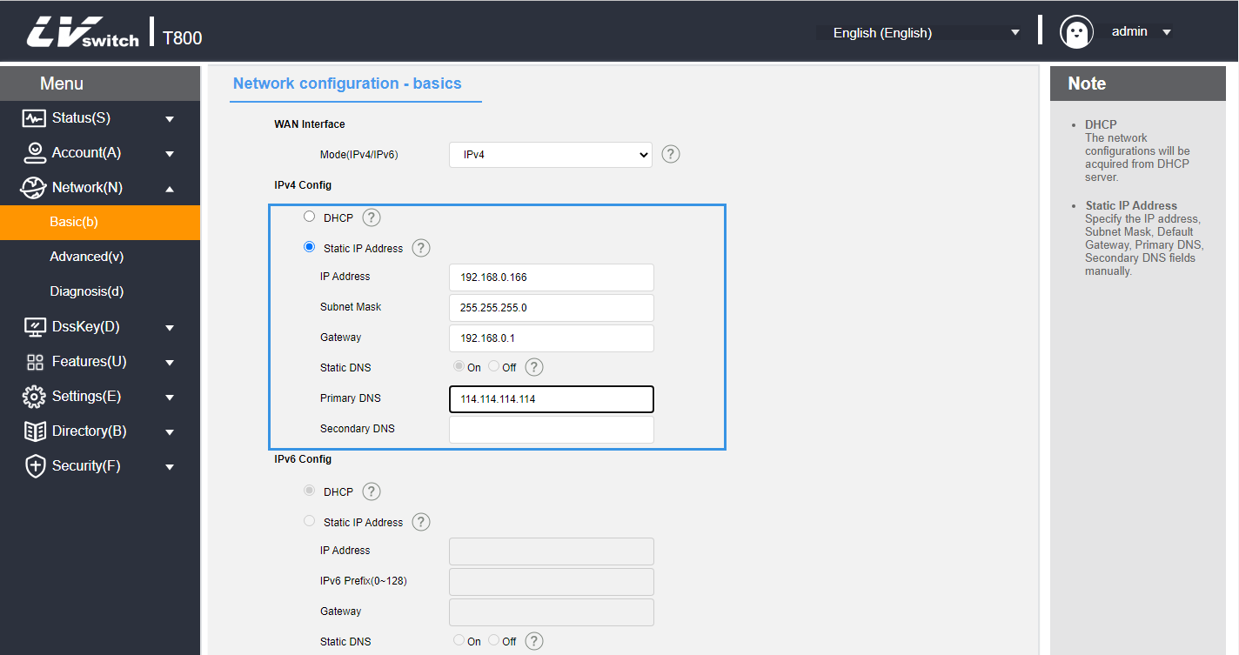
Explanation Wrong IP configuration may cause the phone can not access the web interface, before configuration, please make sure the IP address is not the same as the IP in the LAN, if you need help, please contact your network administrator.

Register for an account
The T800N phone supports two types of configuration:
- Manual Configuration
- Software Batch Configuration
T800N IP phone supports up to 8 accounts registration, account switching through the phone's account button, the phone is generally configured centrally by the system administrator, when you get the phone which has been configured account, as long as you plug in the Internet cable to get the IP and the account registration is successful, you can use the account to make a phone call. If the phone has not been configured with an account, you need to manually configure the account, for details, please refer to Account Management section.

Phone Input Methods
The phone supports keypad input, using the numeric keypad you can enter data into the screen to configure the phone's functions.
T800N supports four input methods: 123, abc, ABC and 2aB, where you need to enter data, use the soft keys to switch between these input methods, when the input method is in 2aB, press the key repeatedly to switch the characters to be entered(numbers/letters/punctuation), when switching to the character you want, stop and wait for 1 second before enter the next character is entered.

- The characters that can be entered by different input methods of the keyboard are listed in the table below:
input method  keystrokes | 123 | 2aB | abc | ABC
 | 1 | 1
 | 2 | 2abcABC | abc2 | ABC2
 | 3 | 3defDEF | def3 | DEF3
 | 4 | 4ghiGHI | ghi4 | GHI4
 | 5 | 5jklJKL | jkl5 | JKL5
 | 6 | 6mnoMNO | mno6 | MNO6
 | 7 | 7pqrsPQRS | pqrs7 | PQRS7
 | 8 | 8tuvTUV | tuv8 | TUV8
 | 9 | 9wxyzWXYZ | wxyz9 | WXYZ9
 | 0 | 0 | Space | Space
 | *. | *.' #?! \-()$@/:_ | *.' #?! \-()$@/:_ | *.' #?! \-()$@/:_





- Input way Introduction:
Instance | way
Input English words  Switch | - Switch input method to 2aB  1. Press the key continuously until S appears.  2. Press the key continuously until w appears.  3. Press the key continuously until i appears.  4. Press the key continuously until t appears.  5. Press the key continuously until c appears.  6. Press the key continuously until h appears.  Finally form the word.
Enter IP address  192.168.0.1 | - Switch the input method to 123  1. Enter the number.  2. Press the key consecutively until the '.' appears. .

Phone customization

You can customize the phone according to your own habits, such as: language, time and date, ringtones, contacts, and phone lists, etc. This chapter will give a detailed introduction to customizing the phone, the main contents are as follows:
    - Basic settings
    - Sound Settings
    - Contact Management
    - CDR Management
    - Accessory Customization
    - System Customization

Basic settings
The Basic T800N Setup contains the following:
- multilingualism
- Time & Date
- call-out button
- keypad lock
- Power lamp
- backlight
- pop-up notification window
- Boot Picture
- screensavers

multilingualism
T800N supports multi-language, the default language of the initialization of the phone is English, the phone interface and the web interface are integrated: after changing the language of the phone, the web page will update the language synchronously with the phone after refreshing; after changing the language of the web interface, you need to restart the phone.

- Setting the language through the phone interface
1. Press Menu->Settings->Basic Settings->Language.
2. Press or to select the language you want to change.
3. Press the Save soft key to save the language selected by the arrow as shown below.
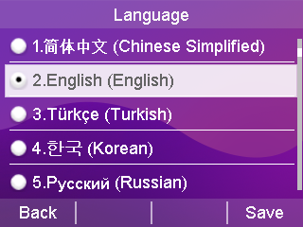

Description When you change the language in the phone interface, the language of the web interface will be changed to the language set by the phone after it is refreshed (e.g., if you set English in the phone interface and the web interface is refreshed, the language of the web interface will also be changed to English).
- Setting the language through the web interface
1. Enter the IP address of the phone to enter the web interface.
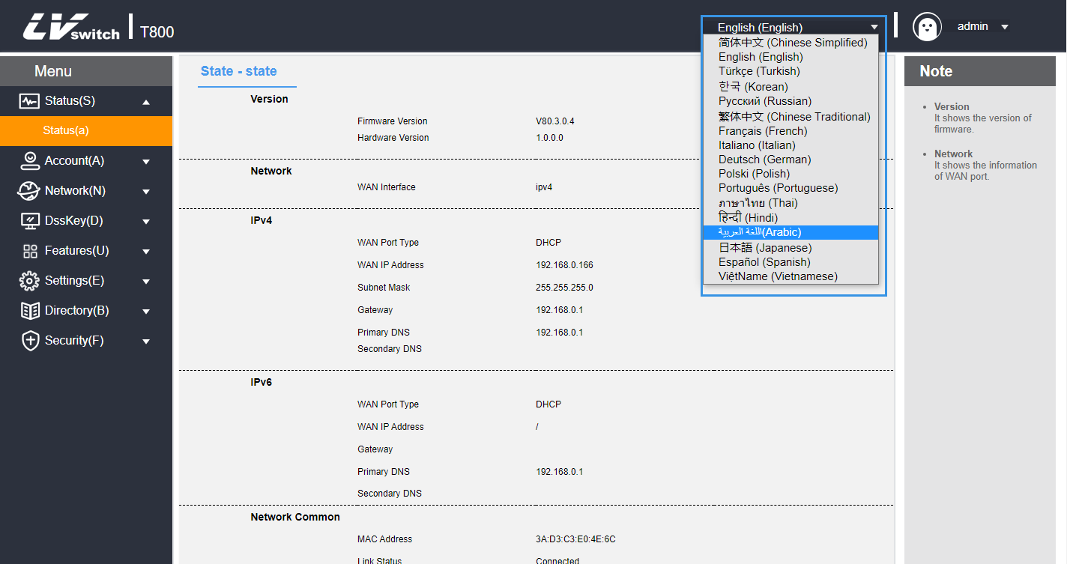
2. At the top right of the web interface, switch languages by using the drop-down box.

Explanation When you change the language in the web interface, the language of the phone interface will be synchronized to the language set in the web interface only when the phone is restarted (e.g., if you set English in the web interface and the phone is restarted, the language of the phone interface will also be changed to English).

Time & Date
The T800N can be set to display the time on the LCD when the phone is on standby, configure your NTP server to get the time and date automatically, or set the time and date manually.

- Automatic time and date acquisition through the phone interface
1. Press Menu->Settings->Basic Settings->Time & Date->Automatic Timing.
2. Press the OK soft key to save .

- Manually set the time and date through the phone interface
1. Press Menu->Settings->Basic Settings->Time & Date->Manual Time Setting.
2. Press or to select.
3. Enter the time and date you want to set via the numeric keypad.
4. Press the OK soft key to save the settings when they are complete.
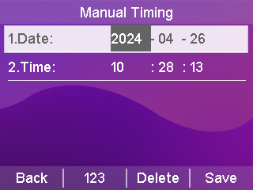

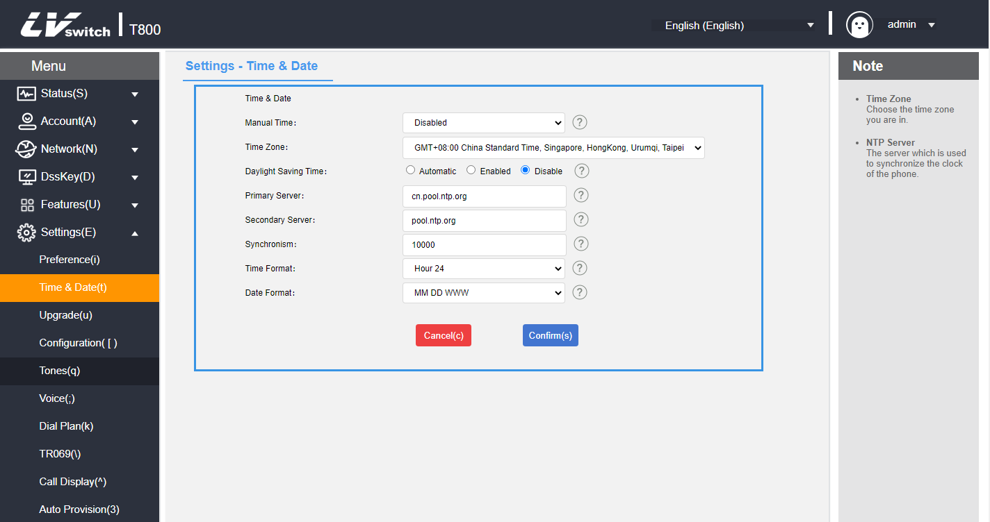

- Automatically obtaining time through web browsers
1. Log in to the phone page by IP address.
2. Press Setup (E) -> Date Time (t).
3. Manual settings are disabled by default.
4. You should fill in the NTP server address in the Preferred Server and Alternate server.
5. Set the synchronization period in (seconds).
6. Click the Submit button to save the settings when they are complete.

- Manual time setting via web browser
1. Login to the phone page by IP address .
2. Press Setup (E) -> Date Time (t).
3. Manual setting is selected as Enable.
4. Set the time and date as needed.
5. Click the Submit button to save the settings when they are complete.
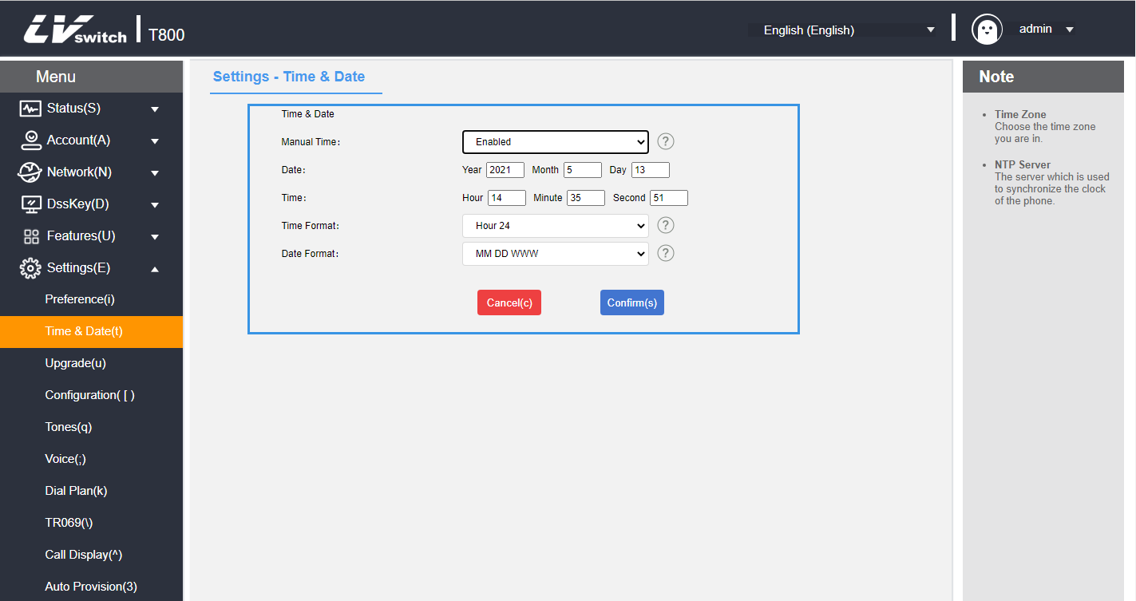

- Daylight Saving Time Setting
1. Log in to the phone page by IP address .
2. Press Setup (E) -> Date&Time (t).
3. Daylight saving time is set automatically, just select the corresponding location.
4. The manual setting method of daylight time can divided into weekly and date methods,You should set the start of time and end time of Daylight Saving Time.
5. Click the Submit button to save the settings when they are complete.

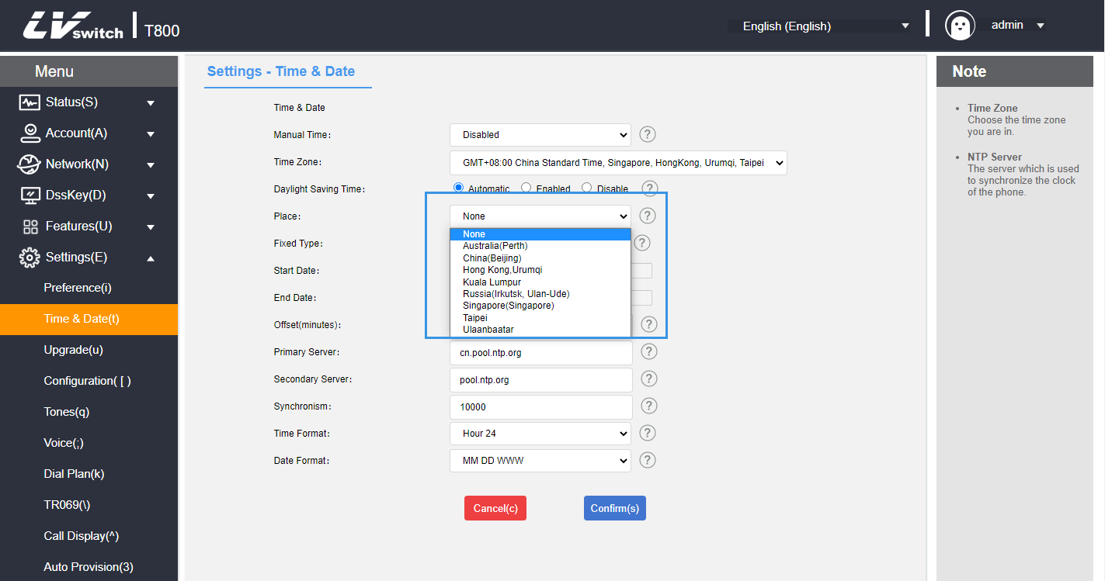
- Automatically sets daylight saving time:

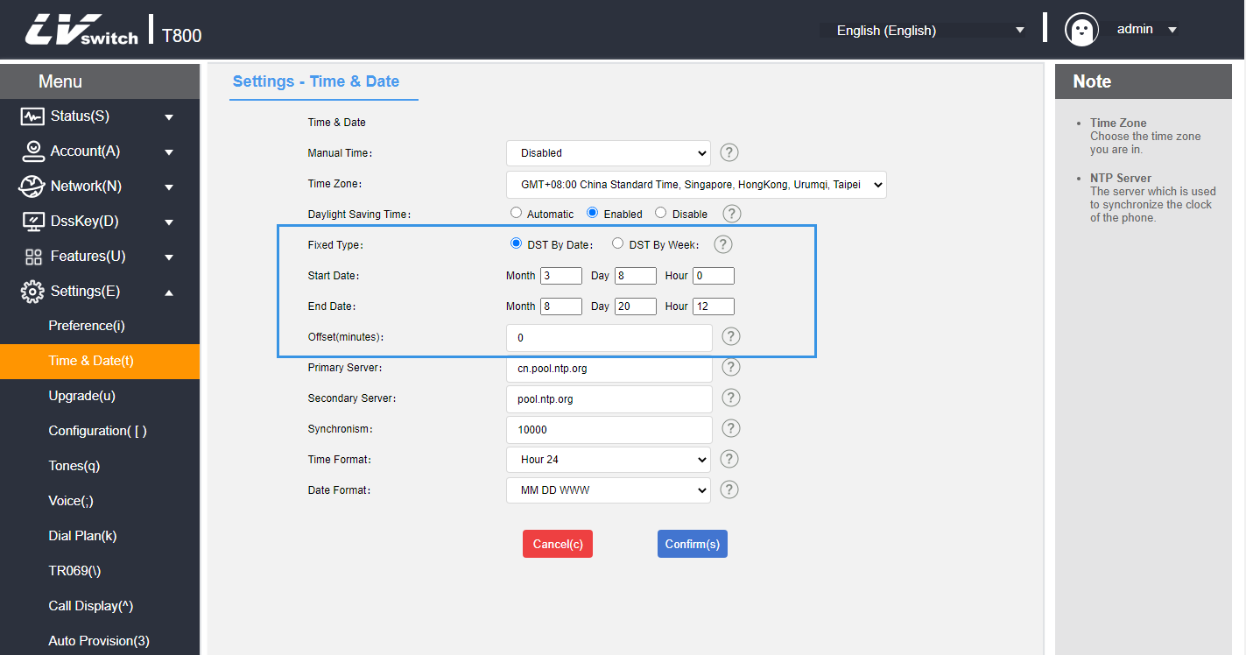
- The date method sets daylight saving time:

- Weekly way to set daylight saving time:
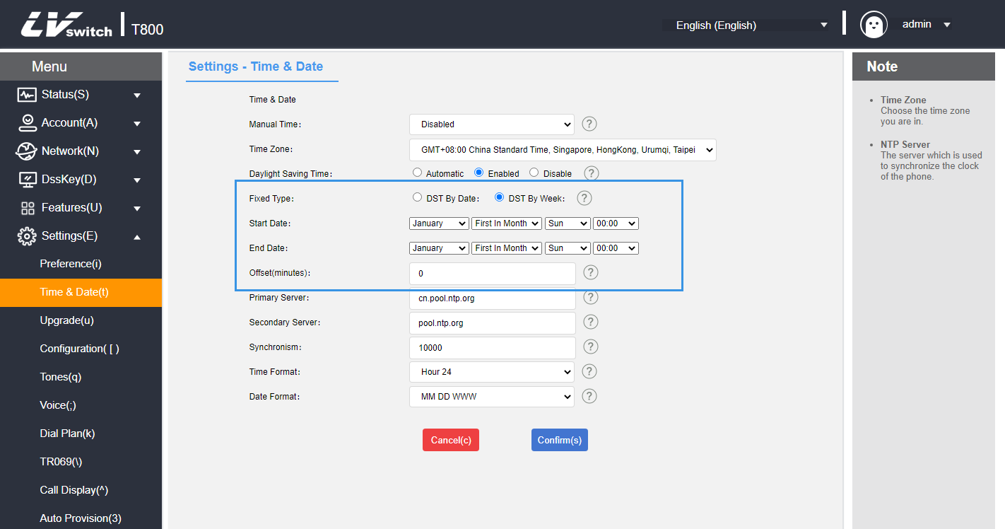

- Setting the time and date display format through a web browser
1. Log in to the phone page by IP address .
2. Press Setup (E) -> Date Time (t).
3. Select the corresponding format in the time format (12-hour and 24-hour systems are supported).
4. The phone supports 7 date formats, different date formats will show the corresponding date on the LCD display of the phone.

The following table shows the dates displayed for each date format:
date format | The display shows
MM DD WWWW | Tuesday, April 7
YY MM DD | 20-04-07
YYYYY MM DD | 2020-04-07
YYYYY/MM/DD | 2020/04/07
YY/MM/DD | 20/04/07
YYYYY MM DD | April 7, 2020
MM DD WW | Tuesday, April 7

- Synchronization of server time via web configuration
1. Log in to the phone page by IP address .
2. Press Account (A) -> Advanced (j).
3. Select Synchronize server time.
4. Click Submit to save the configuration, you can realize the synchronization of SIP server time, which can be used in the case of invalid NTP server.

Call-out button
The T800N can be set up with the * and # symbols as call-out buttons, or you can use the button, dialing softkeys for call-outs, depending on your personal habits.

- Setting the call-out key in the phone interface
1. Press Menu->Features->Callout key.
2. Use the Toggle soft key to toggle the callout key (*, #, disable).
3. Press the Save soft key to save the operation after switching.
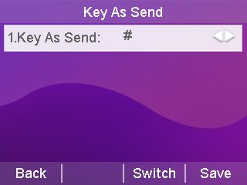
Description For details on how to make a phone call, please see Dialing a Phone Number section.

Keypad lock
Enabling keypad lock on the phone prevents the phone from being used by unauthorized personnel or accidentally operated due to misuse. Only emergency numbers can be dialed while the keypad is locked; unlocking the keypad is required to dial other numbers.

Keypad locks can be categorized by type: menu keys, function keys, and all keys.
Menu Key: The menu soft keys and programming keys set to menu key are locked, all other keys are available.
Function keys: Direction navigation key, OK key, Message key, Transfer key, Redial key, 4 soft keys etc function keys are locked. Other keys work normally.
All keys: except * key, # key, numeric keypad, speakerphone key, account number key, and volume adjustment key,all keys are locked. The dialing screen can only dial emergency numbers with preset values. Incoming calls can be answered by lifting the handle, the Handsfree key, the Headset key, the Answer soft key, and the corresponding account key. Calls can be rejected with the Reject soft key.

- Setting the keypad lock through the handset interface
1. Press Menu -> Settings -> Basic Settings -> Keyboard Lock.
2. Enter the keypad lock password (factory default password is admin) at the Unlock PIN and press the OK soft key to enter.
3. If you enter the default password, you will be prompted to change the password, which is used to enter the keypad lock settings and unlock the keypad.
4. The Enable Keyboard Lock option can be enabled by pressing the left or right button or toggling the soft key.
5. Press the left or right button or switch softkey to select the type of keypad lock at the Lock Type option.

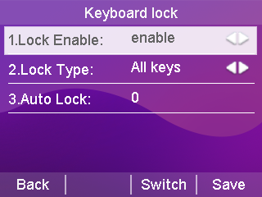

6. Enter the auto-lock time (0 to 3600 seconds) in the keypad lock time input box
a.If the setting time is 0 seconds, the keypad lock will not be locked automatically after saving the keypad lock, you need to long press to enable the keypad lock.
b. Set another time (e.g., set 10 seconds), then the phone will be on lock after the set time (e.g., 10 seconds) in the standby state.
7. Press the Save soft key to save the settings.
When the keypad lock is in effect, the handset LCD display will indicate that the keypad is locked. At the same time, the softkeys change to Emergency (for emergency calls) and Unlock (for unlocking the keypad lock). This is shown in the figure below:

- Setting the keyboard lock through the web interface
1. Log in to the phone page by IP address.
2. Press Function (U) -> Keypad Lock (=).
3. Enable keyboard lock.
4. Select the keypad lock type.
5. To change the unlock code set the unlock code.
6. Enter the auto-lock time (0~3600 seconds) in the keypad lock time input box.
a.If the setting time is 0 seconds, the keypad lock will not be locked automatically after saving the keypad lock, you need to press and hold to enable the keypad lock.
b. Set another time (e.g., set 10 seconds), then the phone will be locked after the set time (e.g., 10 seconds) in the standby state.
7. Set the emergency call number.
8. Submit for save operation.
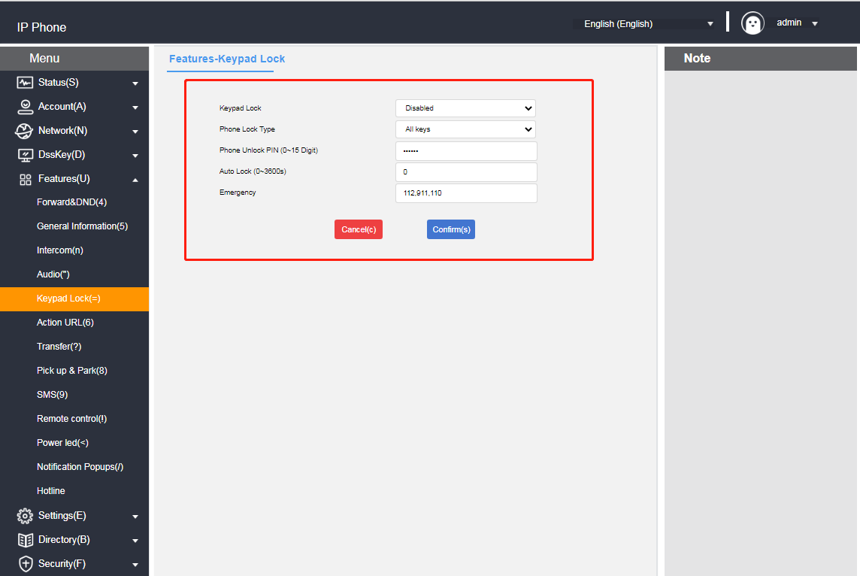

- Unlocking the keypad lock at the phone interface
1. Press the Unlock soft key or press any locked key, Menu key, Function key, All key.
2. Enter the Unlock PIN at Unlock PIN (default PIN: admin).
3. Press the OK soft key.
Standby interface unlock soft key disappears, that is, successfully unlocked, long press or wait for unlocking timing will lock the key again
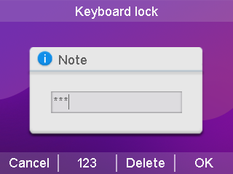

Power lamp
Instructions If you forget to unlock the PIN code, you can log in to the web interface to reset it.

T800N can set the power lamp status, when the phone is in different states the power lamp display is different,it can also be set according to personal habits.

- Setting the power light on the web page
1. Log in to the phone page by IP address.
2. Click Function (U) -> Power Lamp (<).
3. Set the power lamp status.
a.Default power indicator.
b. Power light flashes when ringing.
c. When there are voice and text messages the power lamp flashes.
d. Power indicator flashes when muted.
e. Power indicator flashes while holding a call.
f. Turn on the power light when talking or dialing.
g. The power indicator light flashes when an incoming call is not received.
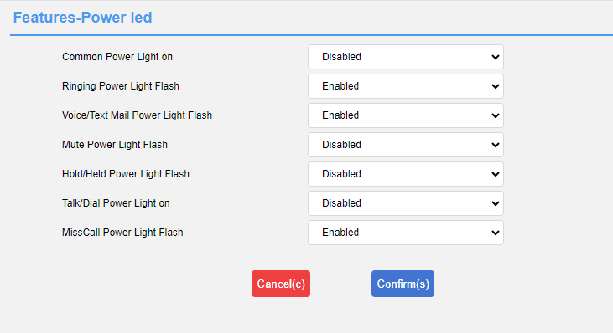
4. Submit for save operation.

Backlight
The T800N can set the backlight status.You can turn off the backlight when the phone is in a silent state for N seconds, or you can set it according to your personal habits.

- Setting the backlight on the web page
1. Log in to the phone page by IP address.
2. Click Settings (E) -> Priority (i).
3. Set the backlight status.
a. Backlight time: Normal light / Normal dark / 10 seconds / 30 seconds / 1 minute / 2 minutes / 5 minutes / 10 minutes / 30 minutes.
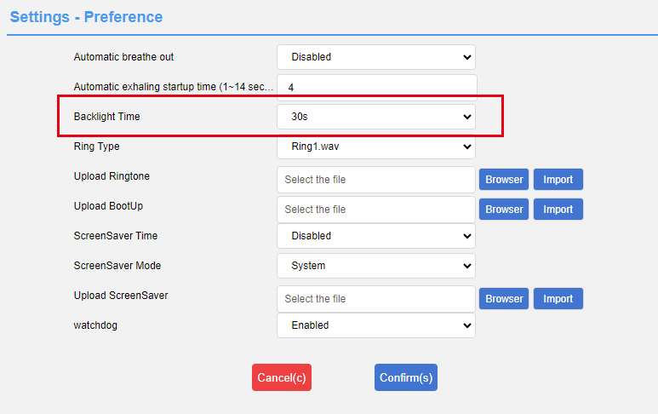
4. Submit for save operation.

Pop-up notification window
T800N can set the pop-up notification window, whether to display a pop-up box alert when the phone has unread calls or messages, or you can set it according to your personal habits.

- Setting up pop-up notification windows on web pages
1. Log in to the phone page by IP address.
2. Click Function (U) -> Popup Notification Window (/).
3. Set the popup notification window status.
a. Display the voice message pop-up window.
b. Show missed call pop-up window.
c. Display the Transferred Incoming Calls pop-up window.
d. Display a text message pop-up window.
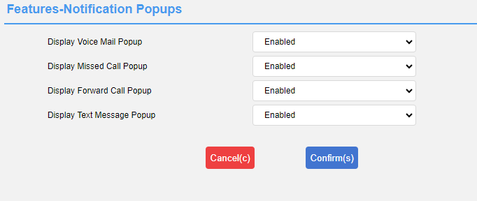
4. Submit for save operation.

Boot Picture
The T800N allows you to set the phone's power-up picture, which is displayed when the phone is powered up and started, according to your personal habits.

- Setting the boot image on the web page
1. Log in to the phone page by IP address.
2. Click Settings (E) -> Preference (i).
3. Import the boot image.
a. Requires a png image in the format 320*240.
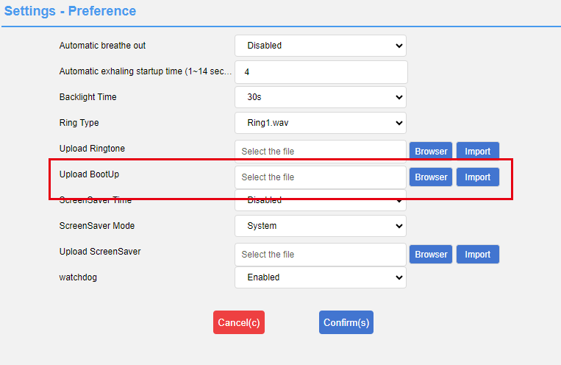
4. Submit for save operation.

Screensavers
T800N can be set up with a screensaver for phone,which enters the screensaver mode when the phone has been inactive for a period of time, and you can be set up according to your personal habits.

- Setting a screensaver on a web page
1. Log in to the phone page by IP address.
2. Click Settings (E) -> Priority (i).
3. Set the screen saver status.
a. Screen saver on time: 10 seconds/30 seconds/1 minute/2 minutes/5 minutes/10 minutes/30 minutes.
b. Screensaver type: Custom/System.
c. Screensaver image: 320*240px png format image.
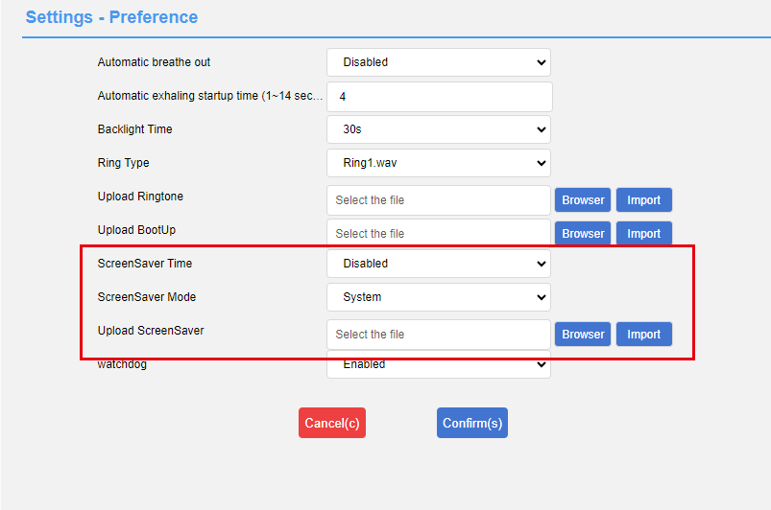

Submit for save operation.

Sound Settings
There are several sound settings inside the T800N, including the following:
- Volume settings
- Ringtone Setting
- keypad tone
- SMS alert tone
- signal tone
- Sound Gain

Volume settings
The T800N handset can set the ringing volume and the volume during the call, the volume setting range is 1-15, and the volume becomes larger with the value.

- Setting the incoming call ringer volume in standby/ringing mode
- Press or to adjust the ringer volume as follows.

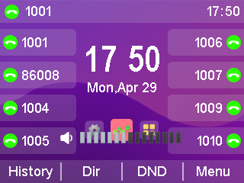

- Setting the volume of devices such as handset, speaker,headsets, etc. on incoming calls
- Press or to adjust the call volume as shown.
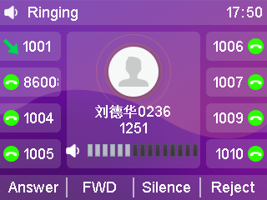
- Setting the ringing method
- The ringing method can be configured in Web Functions (U) → Sound.
a) Using Handsfree: Handsfree ringing;
b) Using a headset: headset ringing;
c) Using headset group and handsfree: headset & handsfree synchronized ringing;
- Click Submit to save the configuration.
Note: The headset ringing method only works when the phone is in headset mode:

Ringtone Setting
You can set different ringtones for your phone to distinguish incoming calls. In addition to unified ringtones, you can also set different ringtones for contacts to distinguish incoming calls from different contacts. There are 10 default ringtones to choose from.

- Setting the ringtone for incoming calls in the phone interface
1. Press Menu->Settings->Basic Settings->Sound->Ringtone.
2. Press or for ringer selection.
3. Press the Save soft key to save the selected ringtone.
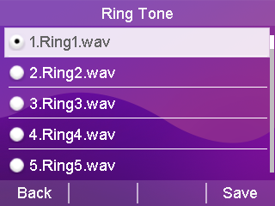

- Setting a contact's ringtone for incoming calls in a web browser
1. Log in to the phone page by IP address .
2. Press Contacts (B) -> Local Contacts (x).
3. Add a contact or click a contact in the list to edit it.
4. Ringtone selection box for ringtone selection for this contact.
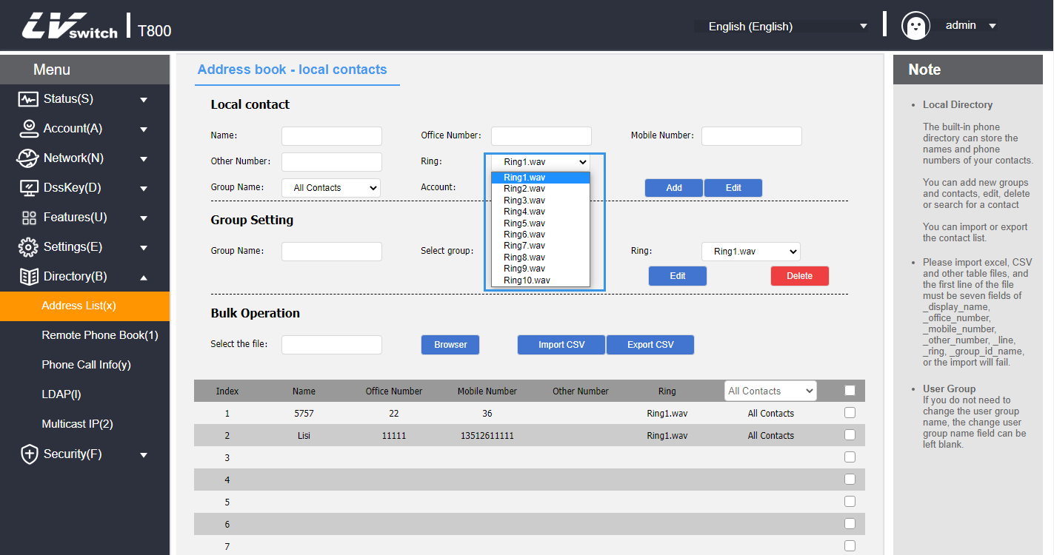
5. Click the Add button if you are adding a contact, or click the Edit button if you are modifying a contact.

Keypad tone
The phone will emit a key tone when the keypad keys are pressed to indicate that the key has been triggered, and the key tone can be enabled and disabled through the settings.

- Setting the phone key tones through the phone interface
1. Press Menu->Settings->Basic Settings->Sound->Key Tone.
2. Press the Switch soft key to enable and disable the state of the key tone.
3. Press the Save soft key to save the operation.
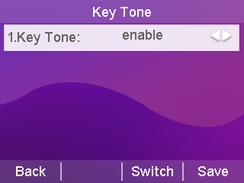

SMS alert tone
Whether or not to play a "drop" tone when the phone receives a voice message or text message can be turned on or off from the web page.

- Setting SMS alert tones via web browser
1. Log in to the phone page by IP address .
2. Press Features (U) → General Information (5).
3. Configure to turn on or off the voice message tone and SMS alert tone.
a) Enable/disable voice message tones;
b) Enable/disable SMS alert tone;
4. Press the Confirm button to save.
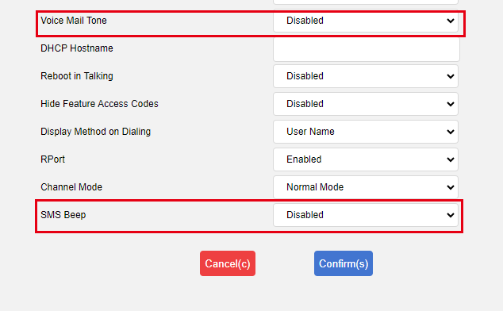

Signal tone
An audible signal sent by the switch to the user to indicate that the phone is in a certain state. The signal tone follows a uniform standard in each device, and you can customize the signal tone according to the national standard, or customize the signal tone; the lower the value, the more subdued the signal tone.

- Setting the signal tone through the web browser
1. Log in to the phone page by IP address.
2. Press Setup (E) -> Signal Tone (q).
3. According to the national standard please select the country, if you want to customize the signal tone, select custom in the country option.
4. Selecting Custom requires you to fill in your own values to change the signal tone.
5. Press the Submit button to save.
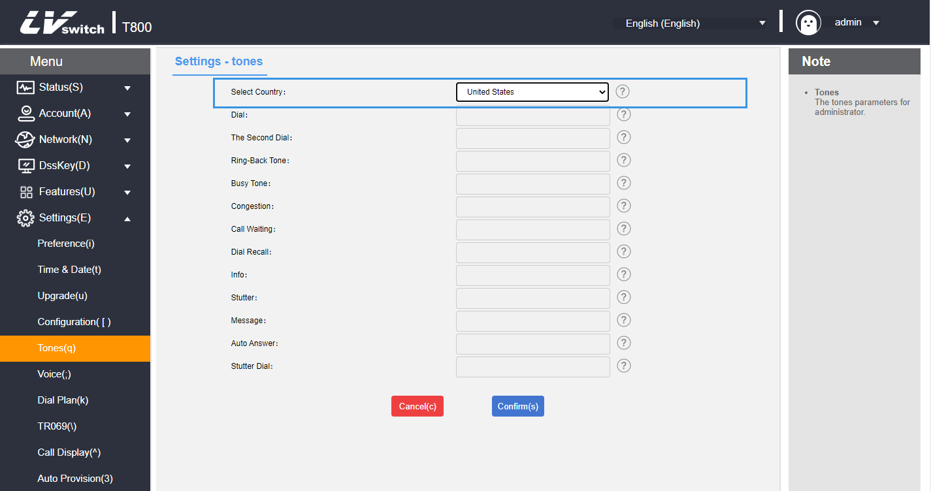
- Signal Tone Types Introduction and Standards
signal tone | frequency | Transmit frequency (dBm0) | clarification
Dial tone | 450±25 | -10±3dBm0 | Used to notify the calling subscriber that they are ready to dial
redial | 450±25 | -10±3dBm0 | Tone on second dialing
ring-back tone | 450±25 | -10±3dBm0 | Indicates that the called subscriber is in the ringing state
busy signal | 450±25 | -10±3dBm0 | Indicates that the line is busy or the called subscriber is busy for this connection.
network congestion tone | 450±25 | -10±3dBm0 | Indicates that this connection is experiencing line congestion
Call Waiting | 450±25 | -10±3dBm0 | Indicates that the phone is on call waiting
callback tone | 450±25 | -10±3dBm0 | Indicates that the phone is in the callback state
Special information | 450±25 | -10±3dBm0 | Beep when you receive a special message
Voice mail alert tone | 450±25 | -10±3dBm0 | Tone when you receive a voicemail message
message tone | 450±25 | -10±3dBm0 | Tone for incoming messages
auto-answer | 450±25 | -10±3dBm0 | In auto answer state beep
Voice  Message Callback | 450±25 | -10±3dBm0 | Voice mail callback tone

Sound Gain

- Setting the sound gain through a web browser
1. Log in to the phone page by IP address .
2. Press Settings (E) -> Voice (;).
3. Configure echo cancellation and RTP jitter buffers as required.
4. Press the Submit button to save.

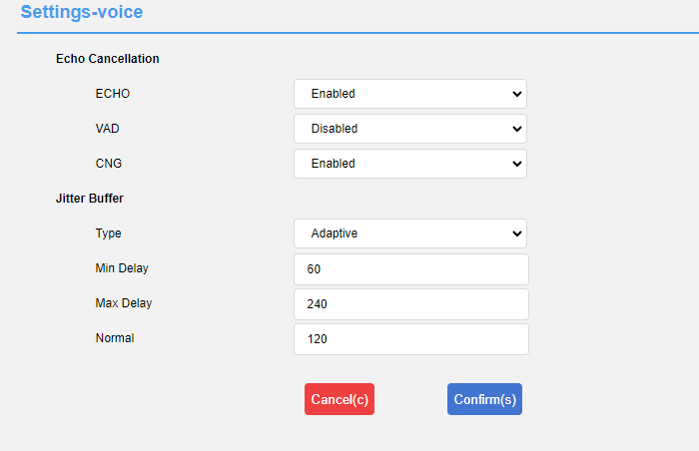
- Setting the sound through the web browser
1. Log in to the phone page by IP address .
2. Press Function (U) -> Sound (").
3. Configure the sound input/output values as required.
4. Press the Submit button to save.

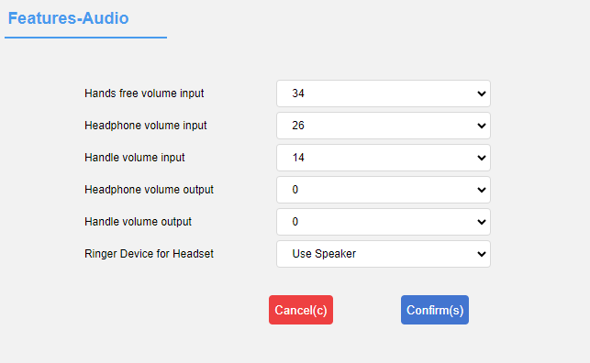

Contact Management
Contact management for the T800N IP Phones consists mainly of:
- local contact
- blacklists
- LDAP settings
- Call History
- remote address book
- Update Address Book
- set up

local contact
Local Contacts can save the contact's name, internal extension number, cell phone number, etc. T800N supports saving 1000 local contacts and 10 contact groups (including default groups).It supports contact adding group, editing, setting ringtone, setting account number, editing contact and other operations.

Add Group
- Adding a group by phone
1. Press the soft key Directory->Local Contacts->Add Group.
2. Enter the group name in the Group Name input box.
3. Press the Save soft key to save the group.
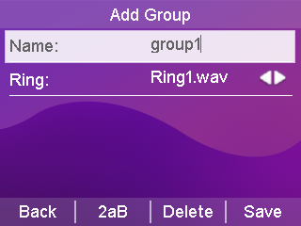

- Adding Groups via Web Browser
1. Log in to the phone page by IP address.
2. Click Contacts (B) -> Local Contacts (x).
3. Enter the group name in Group Name.
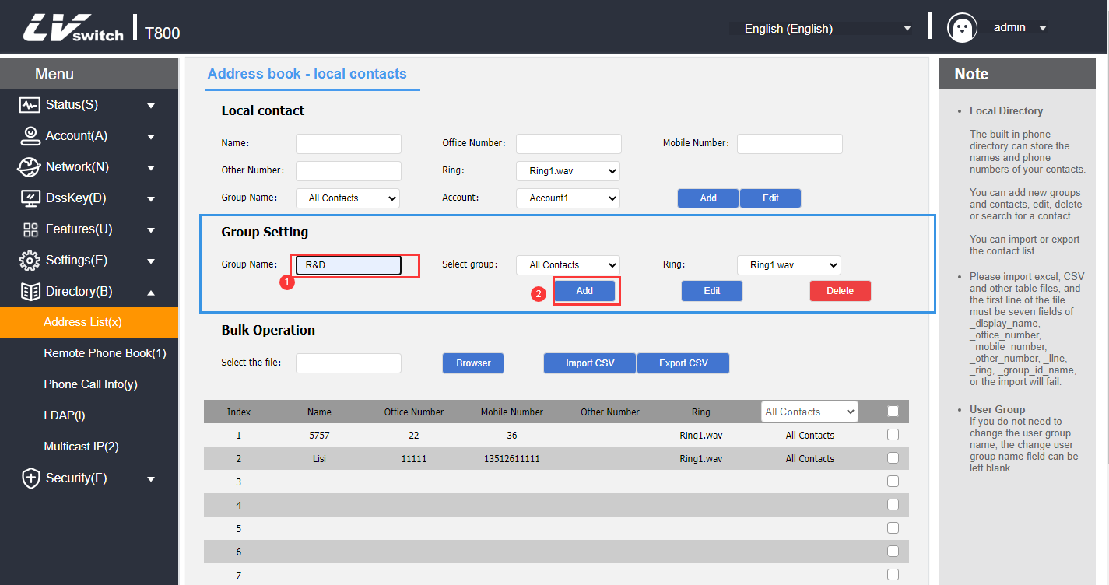
4. Click the Add button to add a group.
Description of T800N T800N can add up to 9 groups and the default group All Contacts, a total of 10 groups, and then adding groups will prompt "The group is full, can not be added", if you need other groups, please edit the group or delete the original group and then add it.

Edit Group
- Group editing via phone (default grouping cannot be edited)
1. Press the Directory->Local Contacts soft key.
2. Press or to select the group to be edited.
3. Press the softkey Option->Details to enter the edit screen.
4. Enter a new group name in the Group Name edit box (only English can be entered in the phone interface).
5. Press the Save soft key to save the group.
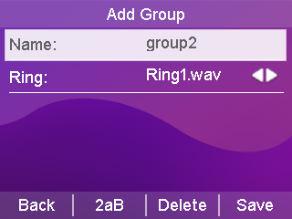

- Editing of groups via web browser (default groupings cannot be edited)
1. Log in to the phone page by IP address.
2. Click Contacts (B) -> Local Contacts (x).
3. Select the group.
4. After selecting, choose the group to become the input mode, and modify it to the name you want to change.
5. Click the Edit button to make changes.
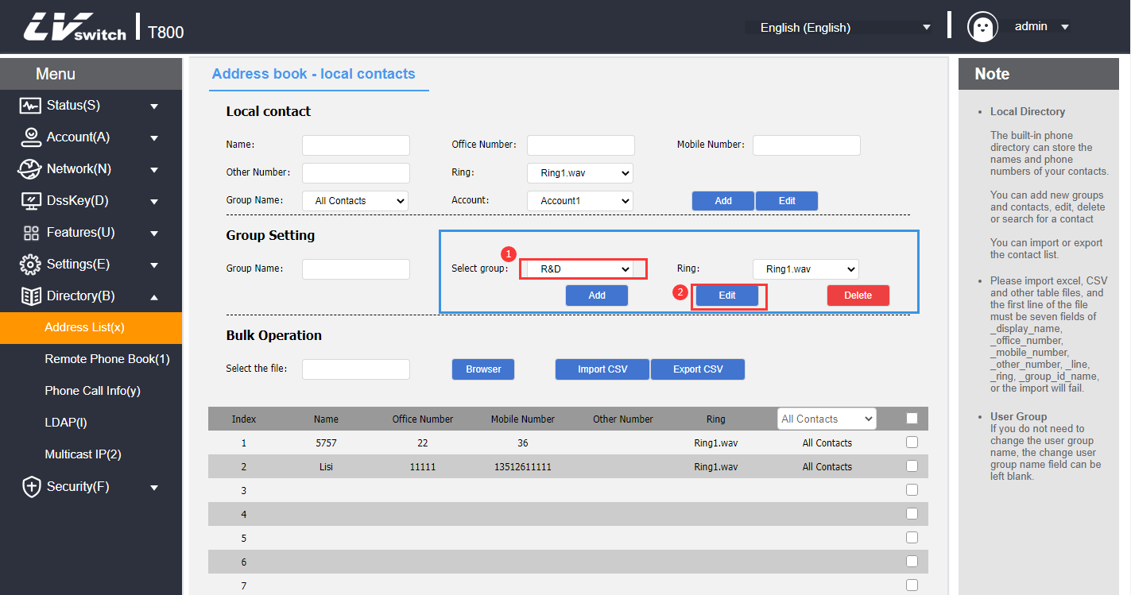

Delete Groups
- Deletion of groups via the phone (default groups cannot be deleted)
1. Press the Directory->Local Contacts soft key.
2. Press or to select the group to be deleted.
3. Press the Option soft key.
4. Press or to select the delete option.
5. Press the OK soft key to delete.
To delete all contacts, press Options -> Delete All.
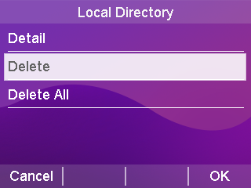

- Deletion of groups via web browser (default groups cannot be deleted)
1. Log in to the phone page by IP address.
2. Click Contacts (B) -> Local Contacts (x).
3. Select the group in the Groups module.
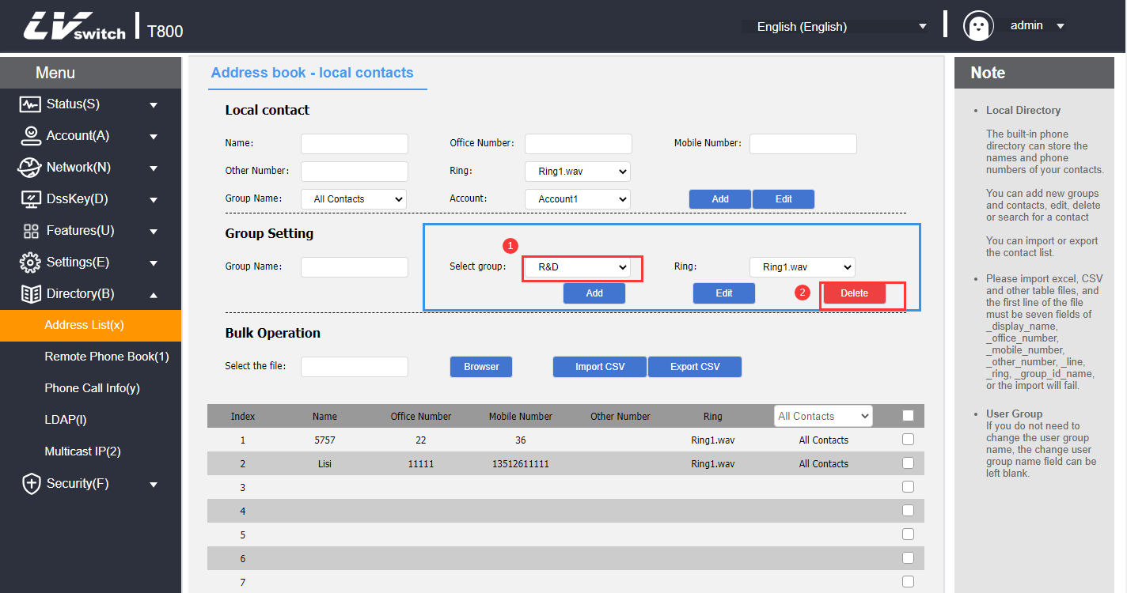

4. Click the Delete button in the Group Settings module to delete it.
Description If a group is deleted, the contacts in the deleted group will be grouped into the default group "All Contacts".

Add Contact

Contacts can be added in the following three ways:
- Add manually
- batch import
- Add from call log

- Adding a contact via call history through a phone interface
1. Press the History soft key in standby.
2. Press or to select the number to add as a contact.
3. Press the softkey Options -> Add to Contacts.
4. Press or to complete the contact information (name, group).
5. Press OK to save the contact.
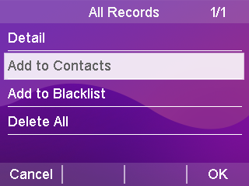

- Adding contacts via local contacts in the phone interface
1. Press Directory->Local Contacts->All Contacts softkey in standby interface (or press Menu->Directory->Local Contacts).
2. Press or to select the group to which you want to add contacts.
3. Once in the group, press the Add soft key to enter the Add screen.
4. Press or to fill in the contact information (name, phone number, you can switch to another group).
5. Press the Save soft key to save the contact.
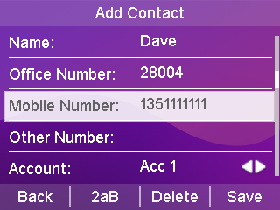

- Adding contacts via web browser
1. Log in to the phone page by IP address.
2. Click Contacts (B) -> Local Contacts (x).
3. Local Contacts module fills in the contact information.
4. Click the Add button in the Local Contacts module to add it.

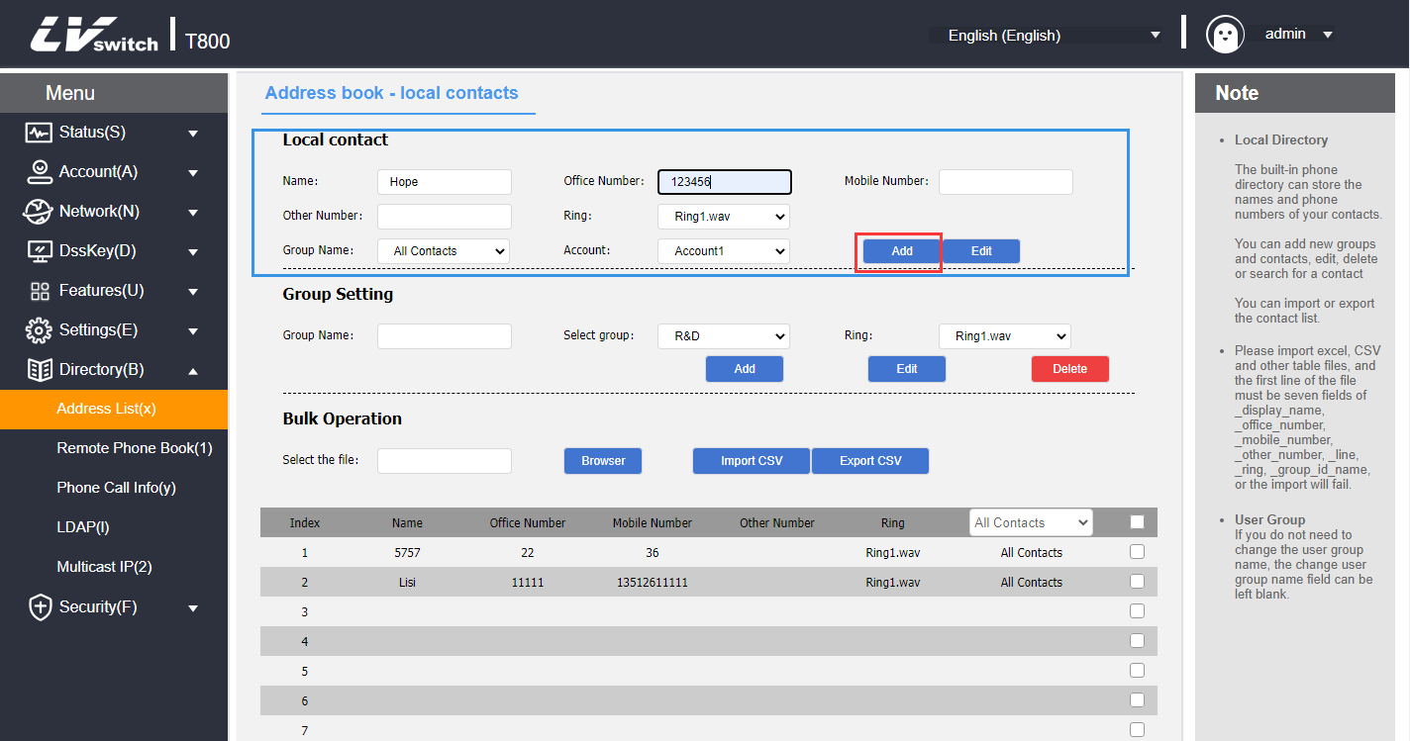
- Bulk import of contacts via web browser
1. Log in to the phone page by IP address.
2. Click Contacts (B) -> Local Contacts (x).
3. Batch operation module click CSV format export contact template.
4. Add/edit contact information in the form.
5. Batch operation module click Browser to find the CSV file to be imported, click CSV format to import to add contacts. (Currently only supports importing xls, csv, xlsx file types)
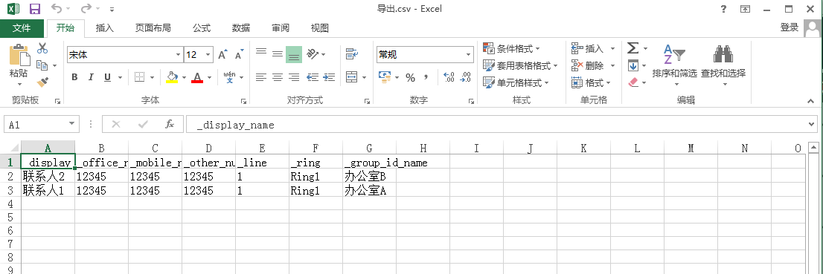
The following prompt appears after you click Import:
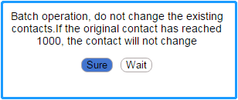

Edit Contact
- Editing contacts through the phone interface
1. In standby mode, press Directory->Local Contacts softkey (or Menu->Directory->Local Contacts)->All Contacts.
2. Press or to select the contact name to edit.
3. Press the softkey Options->Details to enter the contact editing page.
4. Press or to select the contact information to edit.
5. Press OK to save the editing operation.
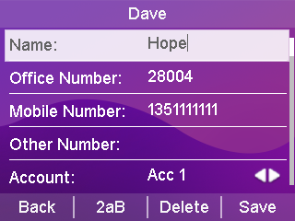

- Editing contacts via web browser
1. Log in to the phone page by IP address.
2. Click Contacts (B) -> Local Contacts (x).
3. Tap the contact you want to edit in the contact list below, and the information will be filled into the local contact module.
4. Modify the contact's information in the Local Contacts module.
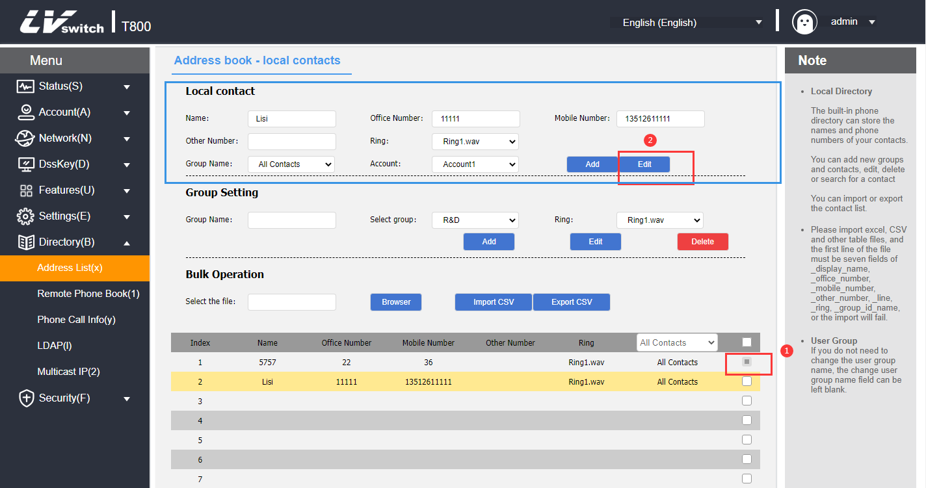
5. Click the Edit button to save the editing operation.

Delete Contacts
- Deleting contacts through the phone interface
1. In standby mode, press Directory->Local Contacts softkey (or Menu->Directory>Local Contacts)->All Contacts.
2. Press or to select the contact name to delete.
3. Press Options->Delete/Delete All.
4. Press the OK soft key to delete.
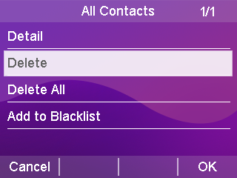
- Deleting contacts via web browser
1. Log in to the phone page by IP address.
2. Click Contacts (B) -> Local Contacts (x).
3. Tap the contact you want to delete in the contact list below.
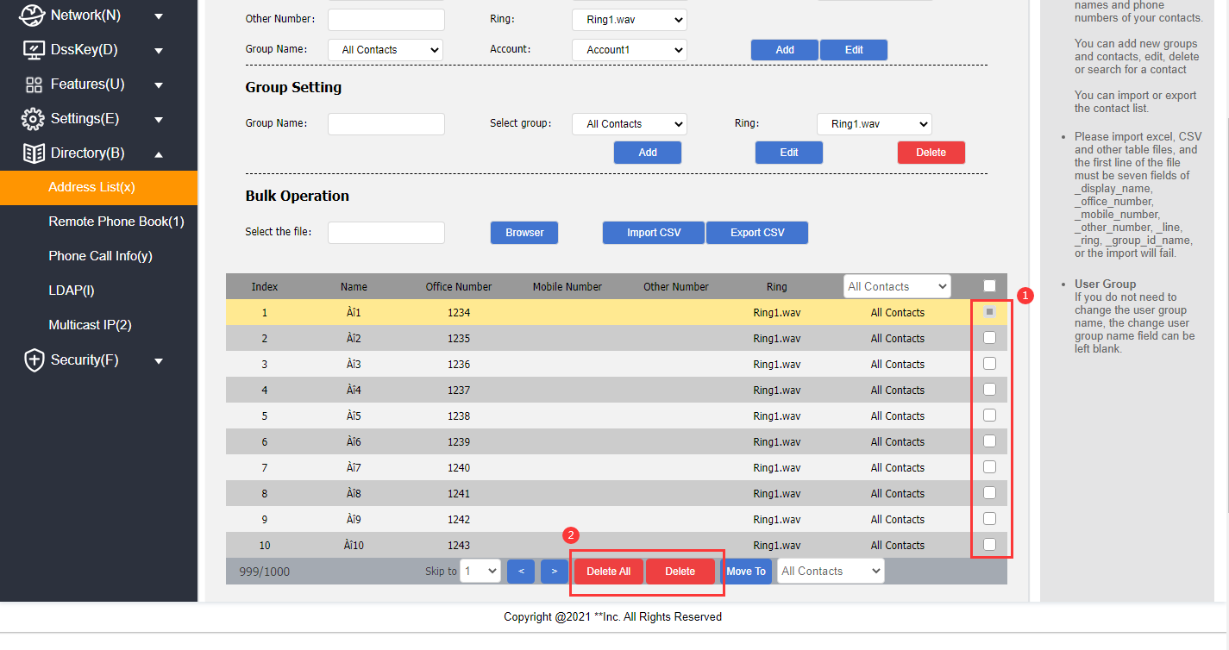
Description Deleted contacts are not recoverable, confirm that you want to delete them before deleting them.

4. Click the Delete/Delete All button under the list to delete the contact.

Call a contact person
- Calling local contacts through the phone interface
1. In standby mode, press the softkey Directory->Local Contacts (or Menu->Directory ->Local Contacts)->All Contacts.
2. Press or to select the name of the contact to call.
3. Press the Send soft key to enter the contact number list.
4. Press or to select the number you want to call to make the call.
5. Press the Send soft key to make a call.
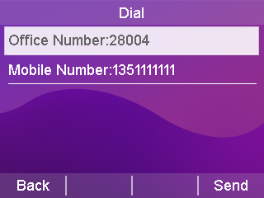

Blacklists
The T800N can save up to 30 blacklisted contacts, and phone numbers with blacklists set will be automatically rejected by the phone.

Add Blacklist
- Adding a blacklist through the phone interface
1. In standby mode, press the softkey Menu->Directory->Blacklist->Add.
2. Press or to select Edit Blacklist Information (Name, Number).
3. Press the Save soft key to save the changed blacklist members.

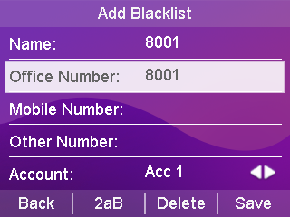
- Adding blacklists from call history through the phone interface
1. Press the History soft key in standby.
2. Press or to select a number to add to the blacklist.
3. Press the softkey Options -> Add to Blacklist.
4. Completion of information on blacklisted members.
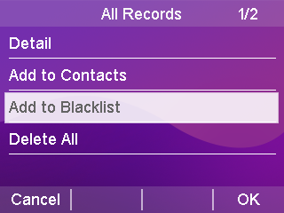
5. Press OK to save the blacklist.

- Blacklisting via web browser
1. Log in to the phone page by IP address.
2. Click Contacts (B) -> Local Contacts (x).
3. Fill in the name and phone number to be added to the blacklist in the Local Contacts module, and select the grouping as BlackList (BlackList).
4. Click the Add button to save the blacklisted contacts.
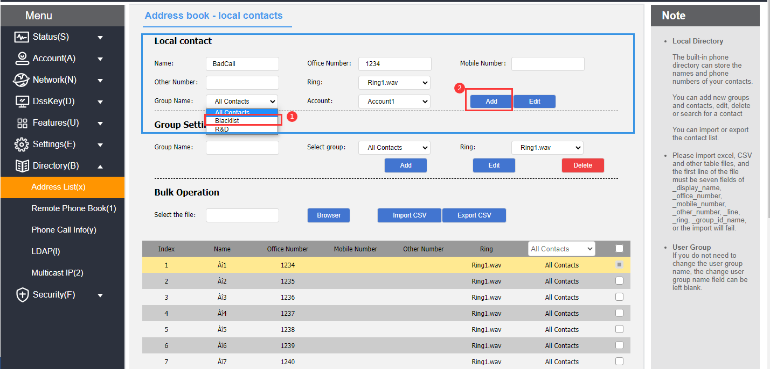

Delete Blacklist
- Blacklist removal through the phone interface
1. In standby mode, press the softkey Menu->Contacts->Blacklist.
2. Press or to select the blacklist member to be deleted.
3. Press Options->Delete/Delete All.
4. Press the OK soft key to delete.
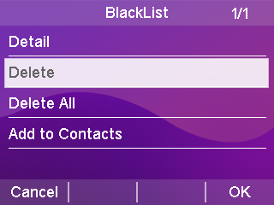
- Blacklist removal via web browser
1. Log in to the phone page by IP address .
2. Click Contacts (B) -> Local Contacts (x).
3. Select BlackList in the drop-down box below the contact list.
4. Check the blacklists to be deleted.
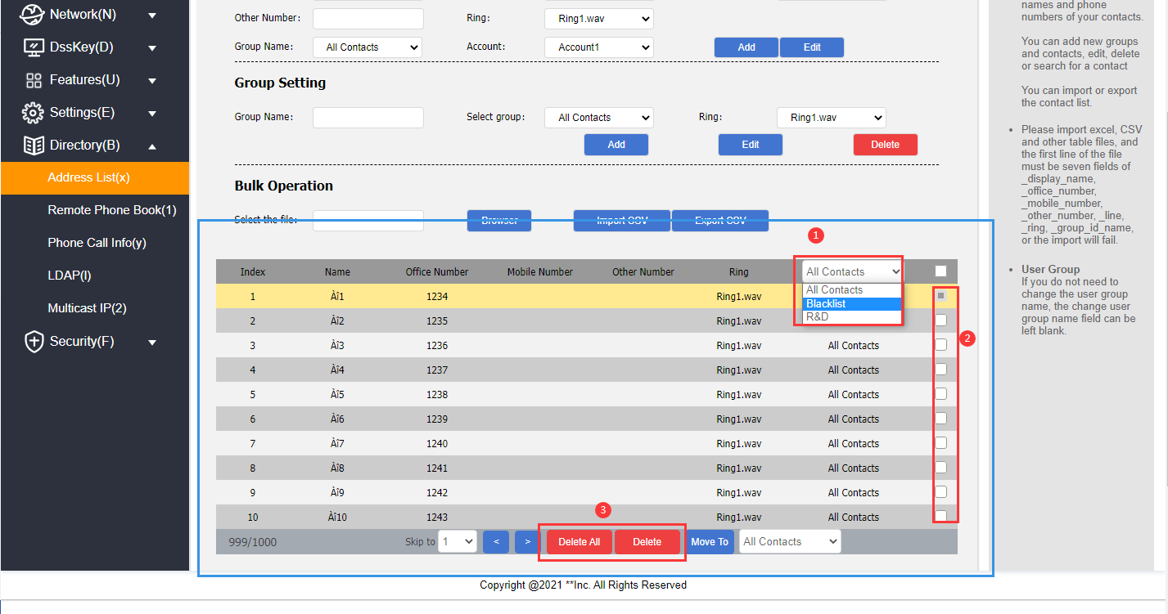
- Click the Delete/Remove All button under the list to remove the blacklist.

LDAP Configuration

Functional Description
LDAP (Light Directory Access Protocol) is an application layer protocol that runs over IP networks and provides a range of functions for accessing and maintaining distributed directory information services. Simply put, LDAP is a fast way to get centralized static data about people or resources; And is most useful for storing information that needs to be read from different locations, but doesn’t need to be updated often; LDAP is very effective at storing a company's employee phone book and organizational charts, and is especially handy for querying information.
For example: in accordance with the tree structure, the root of the tree is the name of the company, the next logical branch out of the various departments, departments can be branched out of the next various employees can be in a certain range in accordance with specific rules to retrieve contacts, such as retrieval of a company's hardware department name contains "J" of the employees.
You can configure the phone to connect to an LDAP server that supports LDAPv2 or LDAPv3. The phone supports the following LDAP servers:
● Microsoft Active Directory
● Sun ONE Directory Server
● Open LDAP Directory Server
● Microsoft Active Directory Application Mode (ADAM)

The biggest advantage of LDAP is that users can quickly find contacts from the LDAP server without the need to maintain a local phonebook.The contact information returned by the LDAP server is read-only.Users can call the LDAP contacts, but they cannot add, edit or delete LDAP contacts.Administrators can configure the LDAP query filter conditions on the phone, such as displaying the contact information and how to sort the contacts. The administrator can configure the filters for LDAP query on the phone, such as the number of contacts to be displayed, the information to be returned, and how to sort the contacts, etc. SIP-T800N series IP phones perform LDAP search on the phone:
Enter the search directly into the pre-dial/dialing screen (make sure LDAP is enabled on the caller's contact match list) and the phone will perform a query from an LDAP server. If results are available, they are displayed on the LCD screen and the user can select a contact and initiate a call.
●
Press LDAP programmable button or press Menu->Contacts->LDAP, enter the content to be searched in the LDAP search interface, the phone will query the related contacts from the LDAP server and display them on the LCD interface, the user can select a certain contact and initiate a call, or add the contact to the local address book or black list.
The phone sends a search request to the LDAP server, which searches all contacts based on the search input and configured filters, and then returns the matching results to the phone.

Configuring the LDAP Server
The following examples are for reference only. You can modify the LDAP attribute values according to your specific needs.
1. Open the Web interface of the phone and log in.
2. Click Contacts -> LDAP.
3. Configure the LDAP service,The example is as follows:
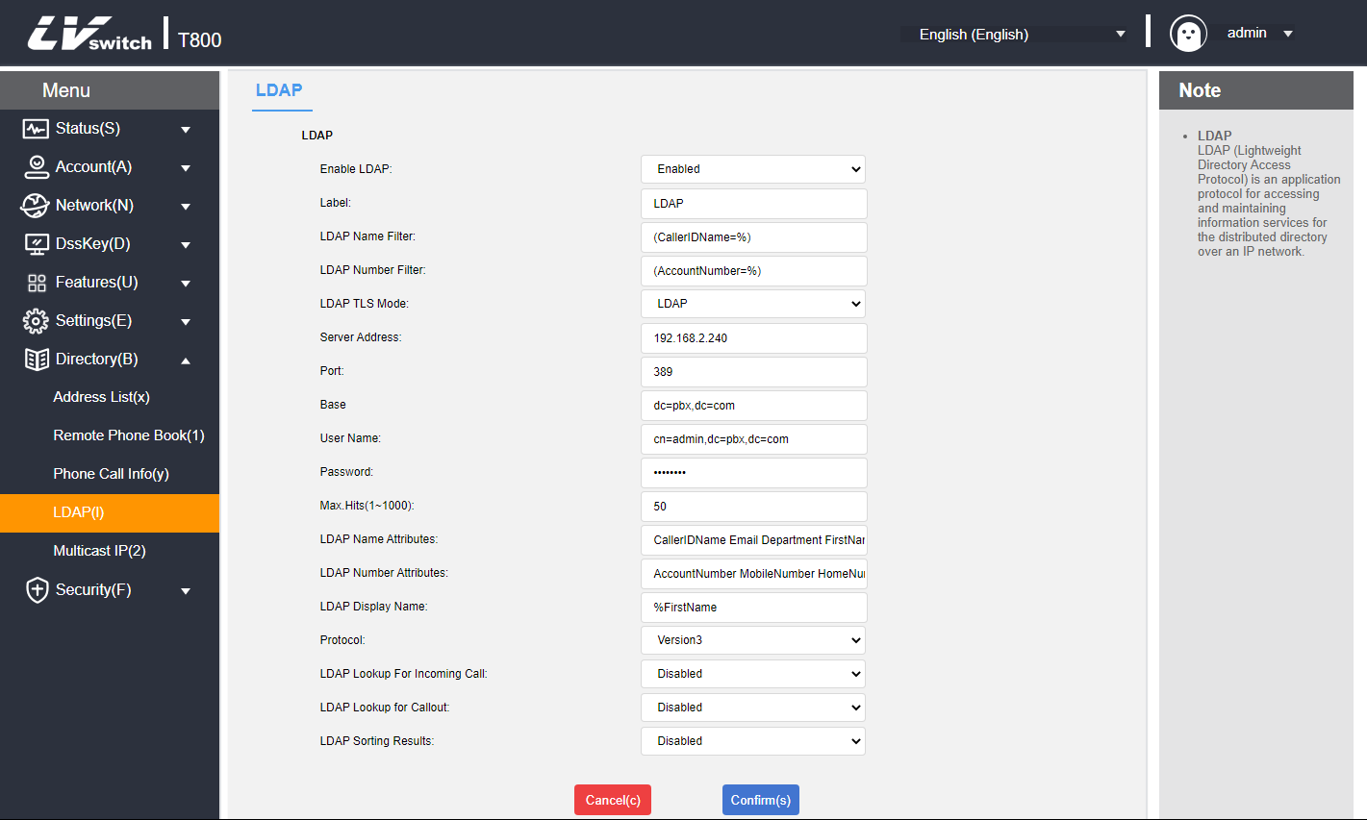

LDAP Setup Instructions
LDAP settings | clarification | typical example
Start LDAP | Enables or disables LDAP function. | Enable
LDAP Tags | Fill in the name of the phone book. | Telephone Directory
LDAP Name Filtering | Sets whether or not the phone can search for contact information by "Nickname" or "Last name".  * stands for any letter.  The % represents the string entered and is used to filter the prefix criteria. | (CallerIDName=%)
LDAP Number Filtering | Set whether the phone can search for contact information by "Cell phone number, office number, or home number".  * stands for the arbitrary letter.  % represents the string and is used to filter the prefix criteria. | (AccountNumber=%)
LDAP encrypted transfer mode | Set how the LDAP server connects to the IP phone:  ①LDAP  ②LDAP TLS Start  ③LDAPS  Note: The S-Series small and medium IPPBX supports LDAP protocol. | LDAP
LDAP server address | Fill in the IP address of the PBX. | 192.168.17.30
Ports | Fill in the LDAP server address port. | 389
Base | Fill in the root node of the LDAP server or one of the phonebook nodes from which the LDAP server will start searching for contacts.  ① Fill in the directory node of the LDAP server, and the LDAP server will search for contacts from all phone books.  ② Fill in a certain phonebook node, and the LDAP server will search for contacts from this phonebook. | dc=pbx,dc=com
User Name | Fill in the user name of the LDAP server. | Username provided by the LDAP server
Password | Fill in the password for the LDAP server. | Password provided by the LDAP server
Maximum number of hits (1~1000) | Set the maximum number of entries in the LDAP server search results. | 50
LDAP Name Attributes | Set the name attribute to be acquired. Multiple name attributes can be set, separated by spaces. | CallerIDName Email Department FirstName LastName
LDAP Number Properties | Set the number attributes to be acquired. Multiple number attributes can be set, each separated by a space. | AccountNumber MobileNumber HomeNumber Fax
LDAP Display Name | Set the name to be displayed for LDAP server search results. The display name format must begin with %. | %FirstName
protocol version | The version of the LDAP server protocol.  Note: The S-Series small and medium IPPBX supports version 3. | 3
LDAP Matching Call | Sets whether or not LDAP searches are performed on incoming calls. | Enable
LDAP Outbound Queries | Set whether to search for numbers in the LDAP phonebook when making a call. | Enable
LDAP Search Sorting | Sets whether or not the search results are sorted in numeric or alphanumeric order. | Enable

Search for LDAP contacts via Address Book
- Enabling LDAP Phonebook
1. Login to the phone web interface and click Contacts -> LDAP.
2. Enable LDAP phonebook.
3. Click Submit.

- Search LDAP Contacts
1. Log in to the phone's web interface and click Menu -> Contacts -> LDAP.
2. Enter the number or name of the contact, and the contact information that matches the search criteria is displayed on the screen.
3. Use or to select a contact.
4. Press the Send soft key to initiate a call.

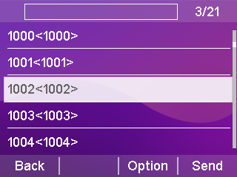

Call Record Management
T800N's call records contain dialed numbers, missed calls, received calls. And transferred calls,Each record supports up to 300 records.
You can view, delete, add contacts, add blacklists, and so on. For more information about the operation of contacts, please see Contacts Management section.

- Viewing the call record through the phone interface
1. Press the Menu soft key, the LCD display shows a list of numbers for the recent call records.
2. Press or to select the record you want to view.
3 Press the softkey Option->Detail. Details of the record can be viewed.
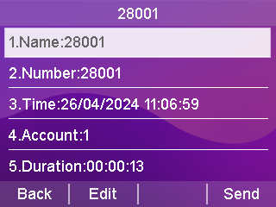
- Viewing of call history through a web browser
1. Log in to the phone page by IP address.
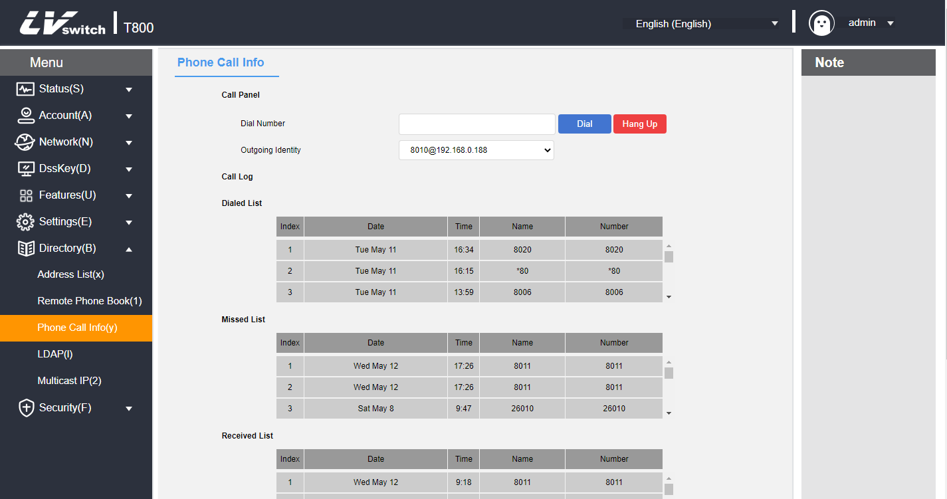
2. Click Contacts (B) -> Call History (y).

- Calls made through call record
1. Press the History soft key while the phone is in standby.
2. Press or to select the number to dial.
3. Press the Send soft key to dial.
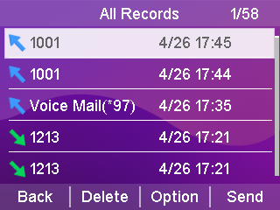
- Calls made through the web page
1. Log in to the phone page by IP address.
2. Click Contacts (B) -> Call History (y).
3. Enter the call number and press Dial to send the call.
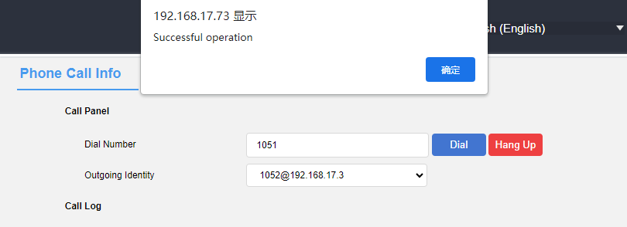

Remote address book

Functional Description
Remote Phone Book (Remote Phone Book) from the name can be visualized as a remote access address book. Administrators need to add the established format of XML to the remote server, The phone achieve the purpose of expanding the scope of the address book by accessing the remote address book.It is mainly used in the enterprise to facilitate the update of the enterprise address book, maintenance at the same time can save the phone's memory to do a double whammy.

The phone supports accessing the XML file on the HTTP/HTTPS/FTP/TFPT server, reading the contact information in the XML file and displaying it on the screen of the phone to realize the remote address function.

XML format
<?xml version="1.0" encoding="UTF-8"? >
<SLIPPhoneMenu>
<T>Company I</T>
<M N="group">
<U N="Zhang San" P1="6131" P2="4566" P3="6788" d_p="Resource:"/>
<U N="Li Si" P1="6136" P2="4567" P3="6789" d_p="Resource:"/>
</M>
<M N="Group II">
<U N="Wang Wu" P1="1234" P2="4566" P3="6788" d_p="Resource:"/>
<U N="Bull I" P1="1235" P2="4567" P3="6789" d_p="Resource:"/>
<U N="Zhang San" P1="1006" P2="4566" P3="6131" d_p="Resource:"/>
</M>
</SLIPPhoneMenu>

Phone Configuration Remote Address Book
1. Put the XML complying with the rules to remote server that can be accessed (About server building there is a detailed description in the automatic update chapter, do not repeat here).
2. Web page click Address Book -> Remote Address Book.
3. Configure the remote address book service. An example is shown below:
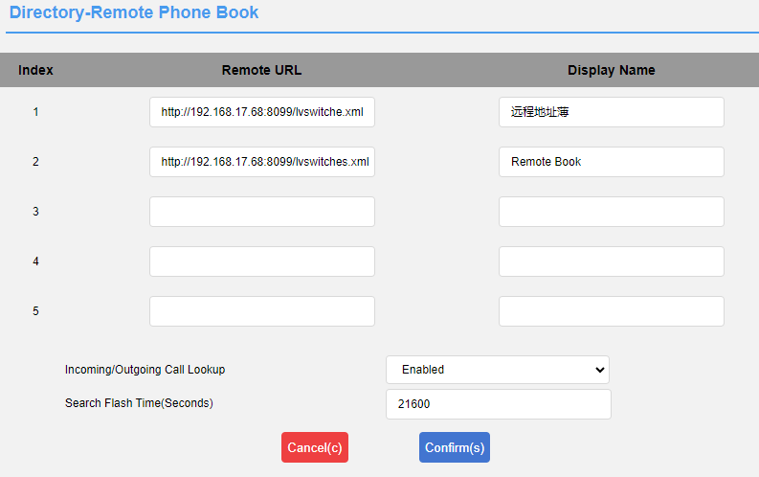

Using the Remote Address Book
- View Remote Address Book
1. Press Phone Menu -> Contacts -> Remote Address Book.
2. Use or to select the list.
3. Press the Enter soft key to view the corresponding remote address book.
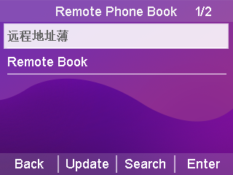
- Search Remote Address Book
1. Press Phone Menu ->Directory -> Remote Address Book -> Search.
2. Enter the number or name of the contact, and the information of the contact that matches the search criteria is displayed on the screen.
3. Use or to select a contact.
4. Press the Call soft key to initiate a call.
5. Press the Options soft key to view the contact information or add to Contacts/Blacklist.
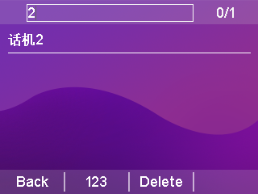

Update Address Book
- Remote updating of address book via web page
The Remote Update Contacts feature makes it easy to update local contacts without having to maintain a separate address book for each person. Files with the same MobileNum contacts in front will be overwritten by the later contacts.

1. Log in to the phone page by IP address.
2. Click Address Book (B) -> Remote Update Address Book.
3. Configure updated address book information.
a) Server URL: support http/https/ftp/tftp path;
b) Automatic update: enable/disable;
c) Time: Fixed time of the day;
d) Update Now: Click the button to update automatically;
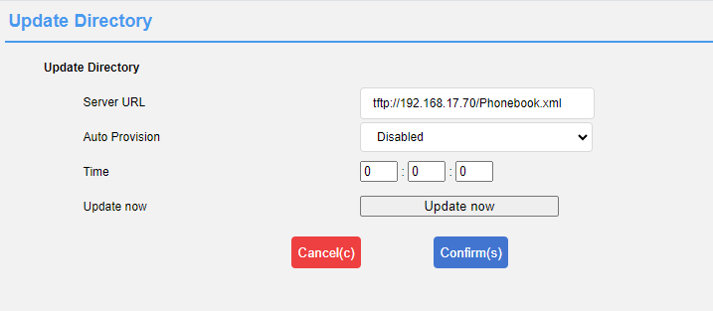
4. Click Submit to save the configuration;
The file format is as follows, just upload it to the server after configuration.
<?xml version="1.0" encoding="utf-8"? >
<all>
<PhoneBooks>
<book FirstName="adm" LastName="gj" MobileNum="456" OfficeNum="123" OtherNum="789" />
</PhoneBooks>
</all>

Address Book Settings
The T800N phone supports Address Book Enable/Disable and Caller Contact Match List Enable/Disable.

- Enable/Disable Address Book via Web
1. Log in to the phone page by IP address.
2. Click Contacts (B) -> Settings (%).
3. Select the address book you want to enable, you can set local contacts, call history, remote address book, blacklist, LDAP.
4. Adjust the sorting by ↑↓ key and then submit;
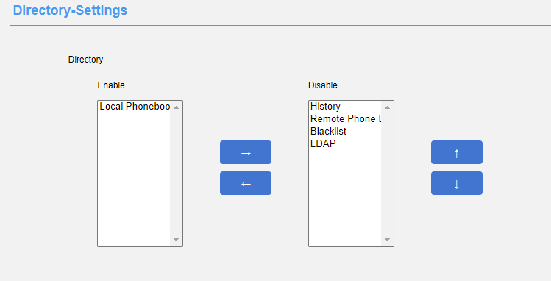
- Enable/disable caller contact matching via web page
1. Log in to the phone page by IP address.
2. Click Contacts (B) -> Settings (%).
3. Select the matching list of caller contacts to be enabled, you can set local contacts, call logs, remote address book, LDAP.
4. Adjust the sorting by ↑↓ key and then submit;

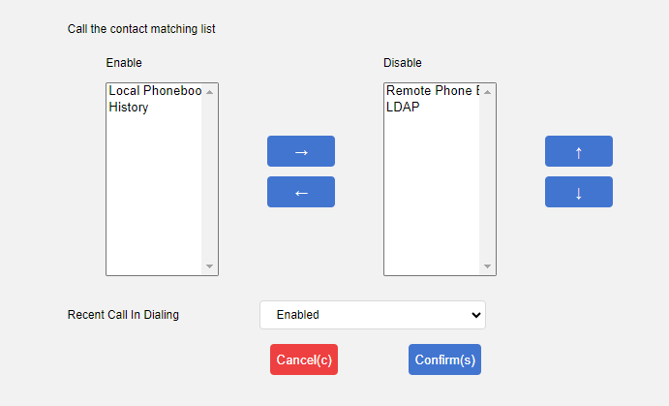

Accessory Customization
The T800N can be used with a variety of accessories, the main ones are listed below:
- headset
- extension desk

Headset use
The T800N can be used with a headset. Before using the T800N, you need to connect the headset and activate the headset mode by using the function button (Headset) on the panel of the phone, for the installation of the headset, please see Headset Installation .

- Activate headset mode
1. Press the key (Headset) on the faceplate of the phone.
The icon in the upper left corner on the LCD screen changes to the headset icon .
When the handset receives an incoming call, press the Answer soft key to answer the call and the phone automatically enters headset talk mode.
Dial a number and press the Send key, the phone will automatically make a call using the headset mode.
- Exit headset mode:
1. Press the key (Headset) on the faceplate of the phone.
The LCD screen displays that the icon in the upper left corner changed to .
- Dual headset mode:
To use dual-headset mode the phone must be accessed headset and handle simultaneously, after successful configuration one can hear and speak over the headset,but one can only listen to var handle.
- Log in to the phone page by IP address.
- Click on Functions (U) -> Basic Information (5).
- Configure to enable/disable the dual headset feature.
- Click Submit to save the configuration.
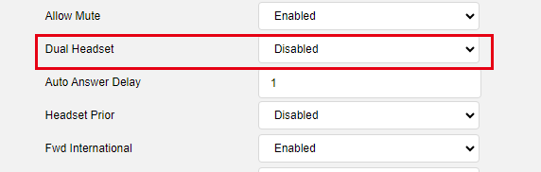
Description The Dual Headset feature can only be configured via the web and must be accessed with both the handset and the headset.
The headset mode needs to be activated when the phone needs to be used after the configuration is successful.
No response from picking up and putting down the handset after turning on the dual headset mode.

- Headphones are preferred:
The Headset Priority feature is for those who use headphones frequently or full-time.
- Log in to the phone page by IP address.
- Click on Functions (U) -> Basic Information (5).
- Configure to enable/disable the headset priority feature.
- Click Submit to save the configuration.
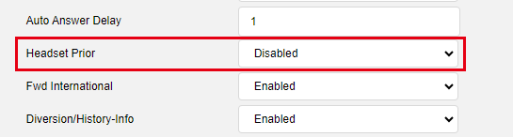
Description The Headset Priority feature can only be configured via the web and the headset must be accessed.
The headset mode needs to be activated when the phone needs to be used after successful configuration.
Pressing the handsfree button after activating headset mode in headset priority mode will not exit headset mode.
Dual headset mode and headset priority mode can be turned on at the same time

Extension desk
Expansion stations greatly enhance the functionality and expandability of the T800N. Each Expansion Station has 32 programmable keys (bi-color LEDs) and connects to IP Phones that support Expansion Stations via a type-C straight-through cable. The T800NK supports up to six expansion stations and provides 192 programmable keys. In conjunction with IP-PBX, each programmable key can be used for speed dialing, BLF, and call answering in collaboration with the server.

The Extension Desk is suitable for front desk switchboards, administrative assistants, call center agents, and users who need to monitor or manage a large number of calls.

Product Information
parameters | clarification
keystrokes | 32 programmable function keys with red and yellow-green LED bi-color LEDs.
Panel jam | 32 handwritten notes.
Key Function | Speed dialing, call forwarding, call waiting, call pickup, BLF, DND.
connector | One type-C data interface (IN), one type-C cascade interface (OUT), the maximum support for simultaneous cascade 6 expansion stations.
Maintentence | The main phone Web page maintains all data.
power supply | No external power supply, powered by the telephone network cable.
operating temperature | 0~60 ℃.
relative humidity | 10% to 90%.
sizes | 174mm*100mm*35mm (L*W*H).
weights | 0.25KG.

Extension table packing list
Open the box of the Expansion Console and carefully check whether the relevant accessories are complete against the packing list, which is shown below:
- 1 x Expansion Desk
- 1 type-C data Cable
- 1 metal mounting fastener (with 4 mounting screws)
- Extension table bracket

Connecting an Expansion Station
- Connects the phone to the extension station:
1. Connect the phone and the extension station through the metal mounting fasteners and secure them with the mounting screws.
2. Mounting bracket.
3. Use the type-C data cable (straight-through cable) to access the IN port of the expansion station at one end, and the other to access the OUT port of the phone, as shown in the following figure:
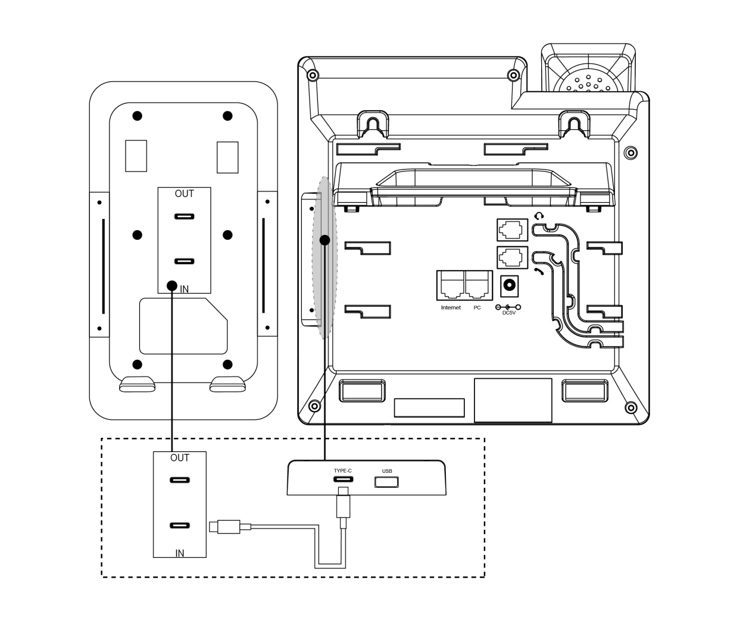
- Multiple expansion stations cascade:
1. Connect two or more expansion stations by metal mounting fasteners and install screws to fix them.
2. Mounting bracket.
3. Use a type-C data cable (straight-through cable) to connect one end to the OUT connector of Expansion Station A and the other end to the IN connector of Expansion Station B. As shown in the figure below:
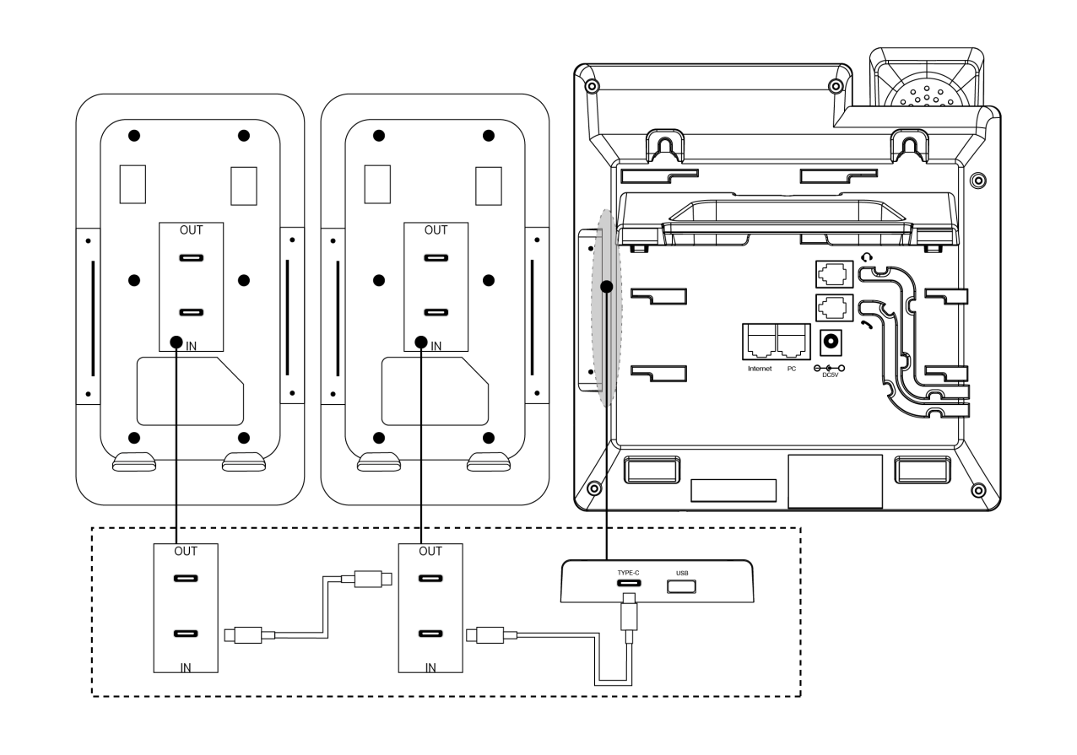

Description Up to 6 expansion stations can be connected.
After connecting the extension station, you can set it up through the Web management interface of the phone.

Expansion Table Hardware Overview
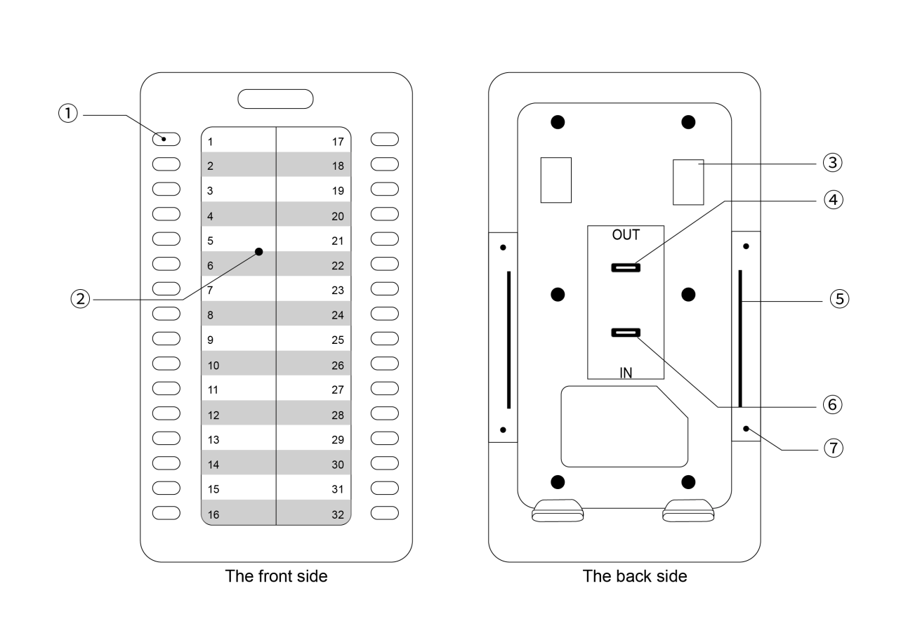

serial number | name | clarification
1 | programmable key | Can be used to bind a speed dial number for speed dialing.  It can be used to set certain function codes to work with SIPServer to realize the function.  When BLF* (Busy Line Detection) is turned on, you can check the busy and idle status of the corresponding number:  1) Red color is always on: The remote line is talking  2) Flashing red: Incoming call on remote line  3) Yellow-green color is always on: Remote line idle **  Sequential programming of programmable keys:  Left side from top to bottom: 1 to 16.  Right side from top to bottom: 17 to 32.
2 | Extension table jam | Provides user identification definitions of the speed dial numbers and the function keys set up for easy access.
3 | Bracket slot | Used to secure the extension table bracket.
4 | OUT connector | Used for connecting to the IN port of the downlinked expansion unit.
5 | Metal fastener slot | Metal fastener insertion position.
6 | IN port | Used to connect to the OUT connector of a microphone or to the OUT connector of an uplinked expansion station.
7 | metal screw hole | Screw holes for mounting metal fasteners.

Test Expansion Station
Connect the extension unit After connecting the expansion unit, you can use the phone diagnostic function to check whether the keys and LEDs of the expansion unit are normal or not. If you want to set the key functions of the expansion unit, please go to the Web interface to configure them, and check the function description of the expansion unit for details.
For each connected station, you need to select the serial number of the station to install, and through this process, the phone recognizes the serial number of the connected station. After successful installation, you can only check the status of the extension station in the Phone Status section of the web page.

- Installation of the expansion table
- Operate on the phone, click Menu->Features->Expansion Disk Installation, the screen displays "Press 1-6 of the expansion station to select the serial number, OK button to finish".
- At this time, all the keys on the expansion unit with selectable serial numbers will light up in yellow-green (left to up to down 1~6 keys), and the key corresponding to the current serial number of the expansion unit will light up red and blink, press the corresponding key, and the key will light up red and blink to determine or modify the serial number of the expansion unit.
- Press the key or the OK softkey to submit the save.

- Key Diagnostics
- To operate on the phone, click Menu->Settings->Basic Settings->Diagnostics->Expansion Disk->Keypad.
- The screen will display the two-line string shown below:
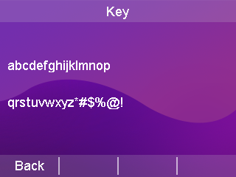
abcdefghijklmnop --------> Indicates keys 1-16 on the expansion disk.
qrstuvwxyz*#$%@! --------> Indicates expansion disk keys 17-32
Tap the 32 keys on the expansion disk in sequence and the characters on the screen will disappear accordingly. If the corresponding characters on the screen do not disappear when a key is pressed, there is a problem with the key. If all the characters disappear, there is no problem with the 32 keys.
Instructions 1. If you detect that characters do not disappear when a button is pressed, please contact your network administrator or dealer for troubleshooting confirmation.
2. Repeat the above steps when multiple expansion stations are connected.

- Button LED Diagnostics
1. To operate on the phone, click Menu->Settings->Basic Settings->Diagnostics->Expansion Disk->Light.
2. The screen displays the following:
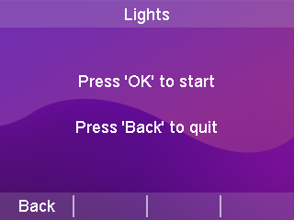
3. Cyclically press the button, the LED of the expansion station will light up (multiple expansion stations will light up at the same time when cascading), red, yellow, and green, and observe whether the key LED is off, dim, and blinking without operation.
DESCRIPTION For previous irregularities, please contact your network administrator or reseller for problem troubleshooting.

Extension Desk Functional Description
After installing the extension station (i.e., after setting the serial number for the extension station), you can set up operations for the keys on the extension station. Here, you can bind the key to a remote extension number for speed dialing; or set it to some function code setting to realize some function with SIP Server. Of course, you may also need to apply the BLF* function of the keypad to view the call status of the corresponding remote extension.

- Web Setup Extension Desk
Configuration and status can be made easier and more convenient by setting up the Web page. When setting up the Web page, the following points must be sure:
1) Connect the computer and the IP phone with the extension desk to the same network. If there is no network interconnection device, you can connect the computer directly to the PC port of the IP phone through a straight-through cable;
2) Ensure that the phone has been operated properly and check the IP address of the phone;
3) Enter the phone IP address in the address bar of your browser;
4) Enter the administrator username and password to enter the webpage configuration page. The default administrator username is admin and the default password is admin;
5) Click "Programmable Keys" > "Extension Desk" in the left navigation bar to open the Extension Desk settings page.
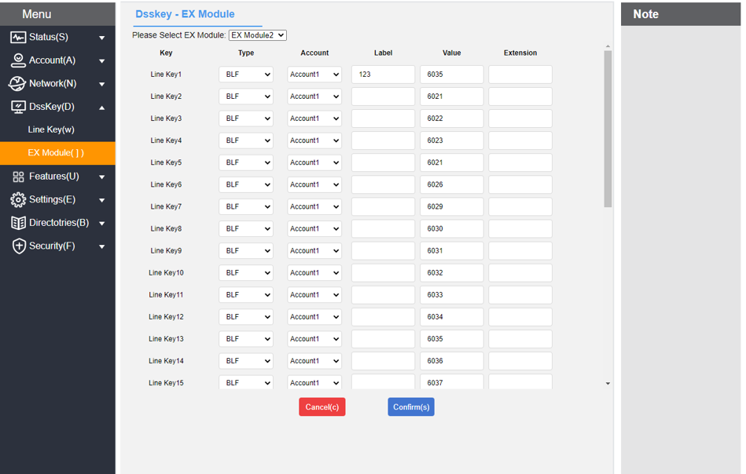
As shown:

- Setting up the expansion table
1. Select the expansion station n you need to configure.
2. Select the keys you need to configure (refer to the Expansion Console Overview - Keys and Hardware section for the specific key sequence).
3. Select each parameter to set and modify:
* :: Type: Select the function of the account.
* Account: Select the SIP account associated with this key.
* Label: sets the name description of the key.
* :: Value field: sets the key to carry out dialing a number or a feature code that realizes a function of a server.
* :: Extension number: Fill in the feature code supported by the server on demand, depending on the type.
Refer to the programmable keys for parameter settings of the function.
4. Tap the Submit button to save.

System Customization

Account Management
T800N can register SIP accounts, up to eight accounts, and make calls through the registered SIP accounts. The eight accounts can be used to make multiple calls at the same time,by pressing the account key to switch the account used.

Account Registration
- Register for an account through the phone interface
1. Press Menu->Settings->Advanced Settings (Password:admin)->Account.
2. Press or to select the account to be configured and press the Enter soft key to enter the configuration screen.
3. Account status can be enabled or disabled by toggling the softkey.
4. Press or to select the label, display name, registration name, user name, password, server address, and note.
Register the server port, transmission method.
5. Change the transmission mode by switching the softkey: UDP or TCP.
6. Press the Save soft key to save the account.
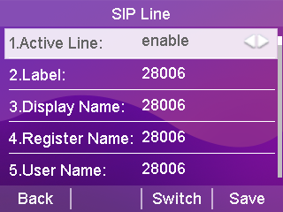

- Registering for an account through the web interface
1. Log in to the phone page by IP address.
2. Click Account (A) -> Register (r).
3. Fill out and submit (required fields: user name, registered account, password, server address, port).

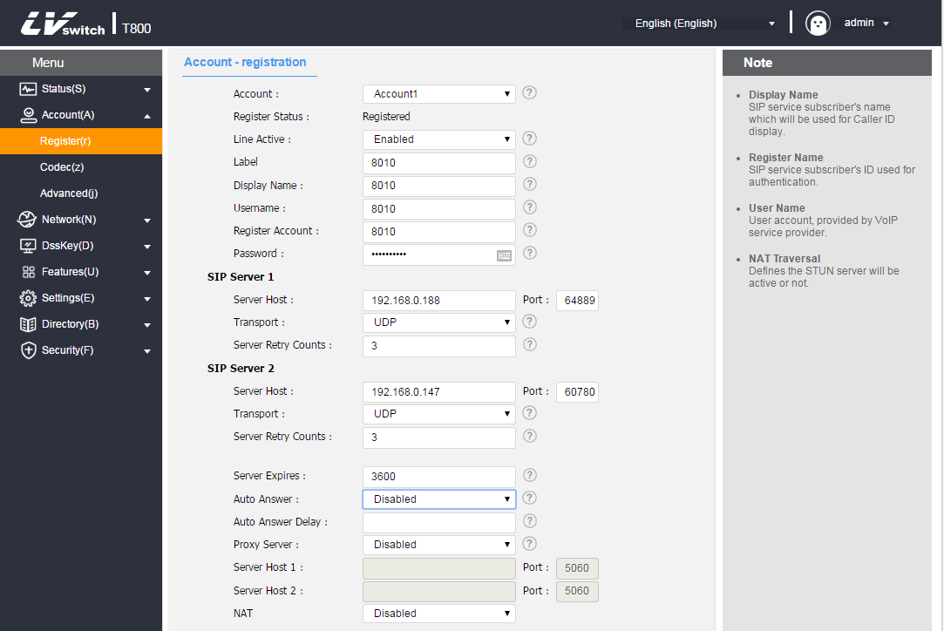

- Configuration of codecs through the web interface
1. Log in to the phone page by IP address.
2. Click Account (A) -> Codec (z).
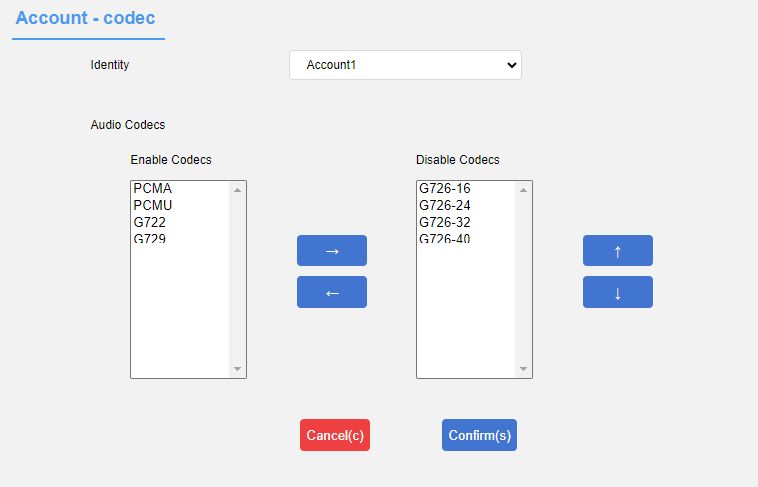
3. Select the codec you want to enable and then submit it (support type: PCMA/PCMU/G722/G729/G726, etc.).

- Configuration of codecs through the phone interface
- Press Menu->Settings->Advanced Settings (password:admin)->Account Advanced settings ->Codec.
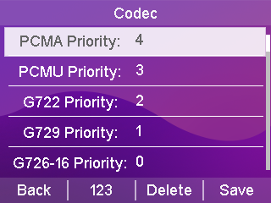
2. Press or to select the codec input value to be configured, the higher the value the higher the codec priority.
3. Press the Save soft key to save.
Explanation If there is a problem that the phone can not be registered, please check whether the registered information is filled in correctly, check whether the network of the phone is normal, if you need help, please contact your network administrator.

Programmable keys
Divided into account keys, Expansion Station keys, and programmable function keys.

Account key
The T800N phone has 8 account keys located on both sides of the LCD display. You can set different functions for each of this keys and can set the label of the account keys,the label will be displayed on the LCD display corresponding to the account key when the phone is in standby.

- Setting the account key function through the phone interface
1. Press Menu->Features->Programmable Keys.
2. Press or to select the account key to be changed.
3. Press the Toggle key to change the type selection.
4. Press or to select a label/username to fill in.
5. Press the Save soft key to save.
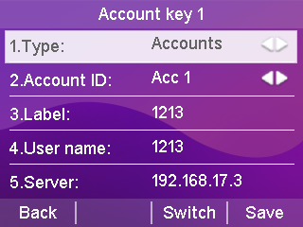

- Setting up account key functions through the web interface
1. Log in to the phone page by IP address.
2. Click the programmable key (D) -> account key (w).
3. Select different functions in the type selection.
4.Number field Fill in the called number, the filled in label will be shown on the right side of the LCD in standby.
5. Press Submit to save when you have finished selecting.
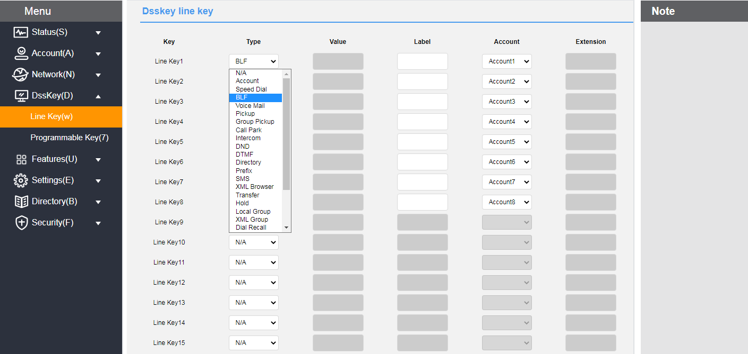

Account Key Function Type Description
 | typology | Instructions and use
account number key | Account | The system defaults to the account key.  - Usage:  1. Set the account type to "Account".  2. The number does not need to be filled in.  3. Set up labels on demand.  4. Click on the account number key, the key's green light is always on and a dial tone is emitted, prompting the user to dial the number.
 | walkie-talkies | After setting up the intercom, pressing the account button will automatically dial the set number to realize intercom.  - Usage:  1. Set the account type to "Walkie Talkie".  2. Number Fill in the number of the intercom to be carried out.  3. Set up labels on demand.  4. The other party's phone needs to be set to answer automatically.  5. Click the Account button to automatically dial to the set number.  6. The handset of the called number automatically answers the intercom call.  For details, please refer to Features Walkie Talkie for a detailed description.
 | key event | -Key Type  1. Call Parking: Park the call at the PBX designated parking space by feature code.  -value fills in the call park feature code.  2. Callback: Quickly dial the number of the last incoming call.  3. DND: Same as the initial interface scrambling.  4.DTMF: Quickly enter pre-configured DTMF content during a call.  -value Fill in the DTMF content you want to configure.  5. Address Book: Same function as the initial interface of Address Book.  6. Group listening: handle and hands-free simultaneous radio, handle can speak, hands-free can not speak.  7. Group pickup: Intercepting (answering on behalf of) calls within the same group by means of a feature code.  -Account ID selects the intercept account  -Value Fill in Group Pickup Code  8. Hold: Same as hold in a call.  9. Local Groups: Quickly jump to the specified groups.  -Local Groups Specify Groups to Jump to  10. Multicast: Quickly initiate a multicast.  -value Fill in the multicast address IP + port number.  -Channel selects one from 0-30  11. Multicast List: Quickly jump to Menu→Function→Multicast List interface.  12. Specify Intercept: Specify intercept the call by designated pickup feature code.  -When the specified intercept is not enabled on the web side, fill in the intercept code + extension number; otherwise, fill in the extension number only.  13. Prefix: Quickly enter a pre-configured prefix for easy dialing.  -value Fill in the prefix to be configured  14. Text Message: Quickly jump to Menu→Messages→Text Message interface.  15. Call Forwarding: Quickly forward calls to a specified number.  -value for the forwarding number  16. Voice message: the same as SMS key, set the voice feature code or speed dial the voice feature code to listen to the voice message.  -Account ID selects the specified account  -value fill in voice feature code  17. XML Browsing: Browse XML in accordance with the specified format, support for browsing text, images, address book and so on.  -value fill in XML browser address  18.XML Groups: Quickly jump to a specified remote address book.  -XML group fill in the remote address book name, you need to open data in the remote address book before use.  19. Keypad Lock: When the keypad lock is activated, press to quickly lock.  20. Hot desking: Clear the current account configuration and enter a new account password to quickly configure the phone.
 | retrieve a call parked call | Retrieve calls parked at the PBX's designated moorings by feature code.  - Usage:  1. The account type is set to "Retrieve park".  2. Account ID sets the call account.  3. Set up labels on demand.  4. The value is filled with the corresponding feature code of the server.  5. Click on the account button to get the call back via the feature code.
 | speed dial | Quickly dial the designated account number.  - Usage:  1. The account type is set to "Speed Dial".  2. Account ID sets the account number for dialing out.  3. Set up labels on demand.  4. The value is filled in with the other party's number.  5. Click the account number key to set the green light corresponding to the dialed out account to always light up and emit a dial tone.
 | BLF | Used to monitor the working status of other phone numbers and call pickup.  - Usage:  1. Set the account type to "BLF".  2. Account ID Select the number you want to call.  3. Set up labels on demand.  4. The value is the number to monitor or intercept.  5. Extension number can be optional, when you need to intercept the answer, fill in the server specified intercept code  When the green light is always on, clicking the account number key is equivalent to speed dialing;  When the red light is blinking, if you set the intercept code, you can make a call on behalf of the call by clicking the account button at this time.  A red light is always on to indicate that the listening number is in a call.

Programmable Function Keys
You can customize the functions of the soft keys, arrow keys, and functional buttons below the screen for T800N according to your personal habits.

- Programmable function keys via web interface
1. Log in to the Web interface.
2. Click Programmable Key (D) -> Programmable Function Key (7).
3. Softkey 1 ~ Softkey 4 set the label content, which can be displayed on the LCD screen.
4. Click the Submit button to save.
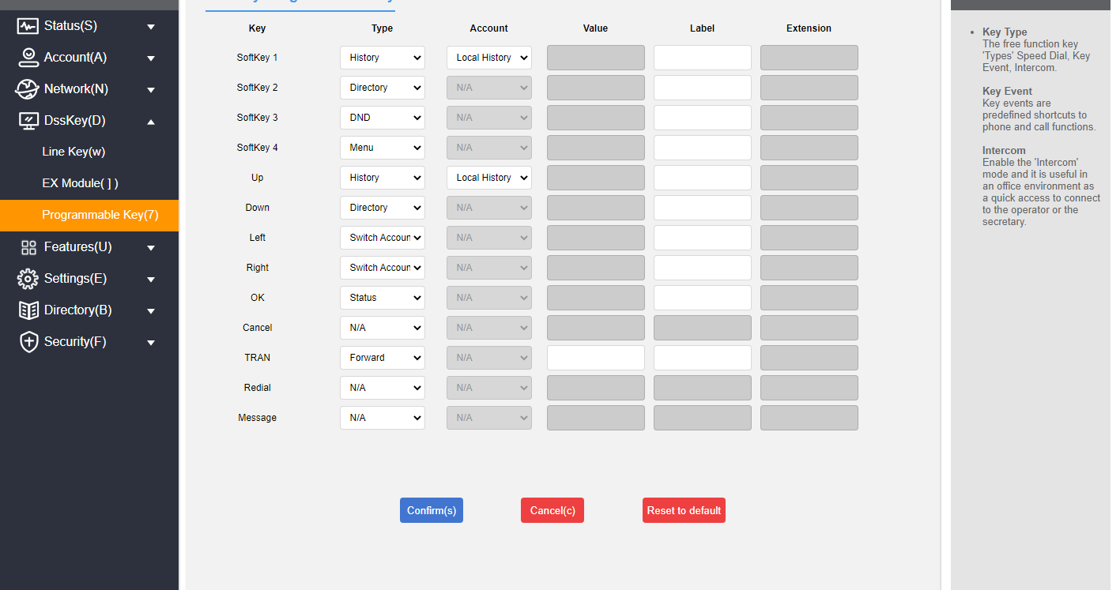

Description Programmable function keys are set in the web interface.
If there is a problem with the settings, you can click Restore Defaults to restore all keys to their factory state.

Programmable Function Key Type Description
 | typology | Instructions and use
Programmable Function Keys | unoccupied | /
 | speed dial | Quickly dial the designated account number.  - Usage:  1. Set the type to "Speed Dial".  2. The account is set to the corresponding account that needs to realize speed dialing.  3. The value field is set to the number of the other party.  4. Set up labels on demand.  5. Pressing after setting will speed dial the set number.
 | group pickup | Setting up group interception allows you to intercept accounts in the same interception group.  - Usage:  1. Set the type to "Group Intercept".  2. The account is set to the corresponding account that needs to realize the group interception.  3. The value field is set to the group pickup feature code.  4. Set up labels on demand.  5. When there are accounts in the Intercept Group in the incoming call status, press the Group Intercept key to realize group interception.
 | walkie-talkies | After setting up the intercom, pressing the account button will automatically dial the set number to realize intercom.  - Usage:  1. Set the type to "Walkie Talkie".  2. Account Fill in the account to be intercom.  3. The value field is set to Intercom Prefix + the number of the other party to be intercomed.  4. Set up labels on demand.  5. Click the Account button to automatically dial to the set number.  6. The phone of the called number automatically answers the intercom call.  For details, refer to the detailed description of the function intercom.
 | prefix | Quickly enter pre-configured prefixes for easy dialing.  - Usage:  1. Set the type to "Prefix".  2. The value field is set to the value you want to configure.  3. Set up labels on demand.  4. Pressing after setting will bring up the dialing screen with the prefix value.
 | local group | Quickly jump to a specific group.  - Usage:  1. Set the type to "Local Group".  2. The account selects the group you need to jump to.  3. Set up labels on demand.  4. Pressing after setting will quickly jump to the designated group.
 | XML Browsing | Browsing XML that conforms to a defined format, with support for browsing text, images, address books, etc.  - Usage:  1. Type is set to "XML Browser".  2. The value field is filled with the XML browser address.  3. Set up labels on demand.  4. After setting up press will browse the related XML.
 | History | You can go directly to the call log page after setting up call log.  - Usage:  1. Set the type to "History".  2. The account defaults to the local call record.  3. Set up labels on demand.  4. Pressing this key takes you directly to the call log.
 | menu | - Usage:  1. Set the type to "Menu".  2. Set up labels on demand.  3. Pressing the key takes you directly to the menu.
 | Forward | - Usage:  1. Set the type to "Transfer".  2. Set up labels on demand.  3. Press the key for the first time to enter the page of setting the unconditional transfer number, and set it as the unconditional transfer switch.
 | DND | - Usage:  1. Set the type to "Do not disturb".  2. Set up labels on demand.  3. Set it up as a do-not-disturb switch.
 | Call back | - Usage:  1. Set the type to "Callback".  2. Set up labels on demand.  3. Set up for the callback button.
 | SMS | Quickly jump to the Menu→Message→Text Message screen.  - Usage:  1. Set the type to "SMS".  2. Set up labels on demand.  3. After setting, press will jump to the text message interface.
 | new SMS | Quickly jump to Menu → Messages → Text Messages screen → New Message.  - Usage:  1. Type is set to "New SMS".  2. On-demand labeling  3. After setting, press will jump to the new message editing interface.
 | Status | - Usage:  1. Set the type to "Status".  2. Set up labels on demand.  3. After setting up, press to check the status of the phone.
 | multicast | Quickly initiate a multicast.  - Usage:  1. Set the type to "Multicast".  2. The value field is filled with the multicast address IP + port number.  3. Set up labels on demand.  4. Extension number fill in the channel number.  Please refer to the detailed description of the function multicast configuration for more information.
 | local contact | - Usage:  1. Set the type to "Local Contact".  2. Set up labels on demand.  3. Press to enter local contacts after setting.
 | Hot Desking | Clear the current account configuration Enter a new account password to quickly configure the phone.  - Usage:  1. Type set to "Hot Desking"  2. Set up labels on demand.  3. After setting up and pressing will prompt whether to clear all account configurations.
 | Switching Accounts Upwards | - Usage:  1. Set the type to "Upward account switching".  2. Set up labels on demand.  3. After setting up, press the key to switch the default account upwards.
 | Switching Accounts Down | - Usage:  1. Set the type to "Downward account switching".  2. Set up labels on demand.  3. Press the key to switch the default account down after setting.
 | directory | - Usage:  1. Set the type to "directory".  2. Set up labels on demand.  3. Press the key to enter the address book after setting.
 | multicast list | Quickly jump to the Menu→Functions→Multicast List screen.  - Usage:  1. Type is set to "Multicast List".  2. Set up labels on demand.  3. Press after setting will enter the multicast list interface.
 | Change page | 1. Set the type to Change page.  2. Set labels as required.  3. Press this key to turn the page of the account keys.  4. Note: It is only used in Line Key page-turning mode. The setup method:Click Settings → Priority on the web page and set Line Key page-turning mode to use programmable keys;
 | Switch left | Toggle left desktop default quick access options.  - Usage:  1. Set the type to "Switch left"  2. Set labels as required.  3. After the Settings are set, press to switch to the left menu of the standby screen.
 | Switch right | Toggle the desktop default quick access option to the right.  - Usage:  1. Set the type to "Switch Right"  2. Set labels as required.  3. After the Settings are set, press to switch right to the menu option on the standby screen.
 | Enter selected | Quickly jump to the specified menu option.  - Usage:  1. Set the type to Enter.  2. Set labels as required.  3. After the Settings are complete, switch the menu options left and right to select the menu you want to enter. Press it to enter the corresponding interface.

Dialing Rules
Setting up dialing rules allows the phone to dial conveniently according to the syntax set up by the dialing rules.
Description This function can only be set in the web interface.

Dialing Rule Syntax
Before using dialing rules, you need to understand the dialing syntax; if you are already familiar with that syntax, you can skip this step and check the
Dialing Rules Feature Content.

Dialing Rule Symbol Description:
character | clarification | (for) instance
. | Indicates any number of placeholders | Enter "78."  Match "786", "7856", "78911", "7857713", etc.
x | Indicates a placeholder | Enter "78x"  Match "781," "782," "783," "784." ... "789", etc.
- | Indicates an interval range | Enter "[7-9]".  Match "7" or "8" or "9".
[] | Indicates an interval range, there is only one [] in the string, use it with the - symbol. | Enter "12[7-9]45".  Match "12745," "12845," "12945."
() | Indicates multiple interval range combinations with multiple [] in the string | Enter "([1-2][7-8])".  Match "17," "27," "18," "28."
DESCRIPTION For questions about the syntax and use of dialing rules, contact your network administrator.

Dialing Rules Feature
Dialing rules include the following:
- Replacement rules
- Call out immediately
- Area code
- Restriction of outgoing calls

1) Replacement rules
You can customize the replacement rules up to 100. Replacement rules mean that you can enter a string of characters and the phone will automatically replace it with your customized string. In practice, for example, if you set a substitution rule to input "1" and replace it with "10086", when you dial 1 on the phone and press the Send softkey or #, the phone will automatically replace it with 10086 for dialing.
Using substitution rules, you can also make quick IP point-to-point calls.

- Adding replacement rules through the web interface
1. Log in to the phone page by IP address.
2. Click Settings (E) -> Dialing Plan(k) -> Replace Rules.
3. Enter a string in the Prefix field (e.g., 1).
4. Enter the replacement string (e.g., 10086) in the Replacement area.
5. Select the lines to which the rule applies at the account number (where all indicates all accounts).
6. Click the Add button to save the rule.
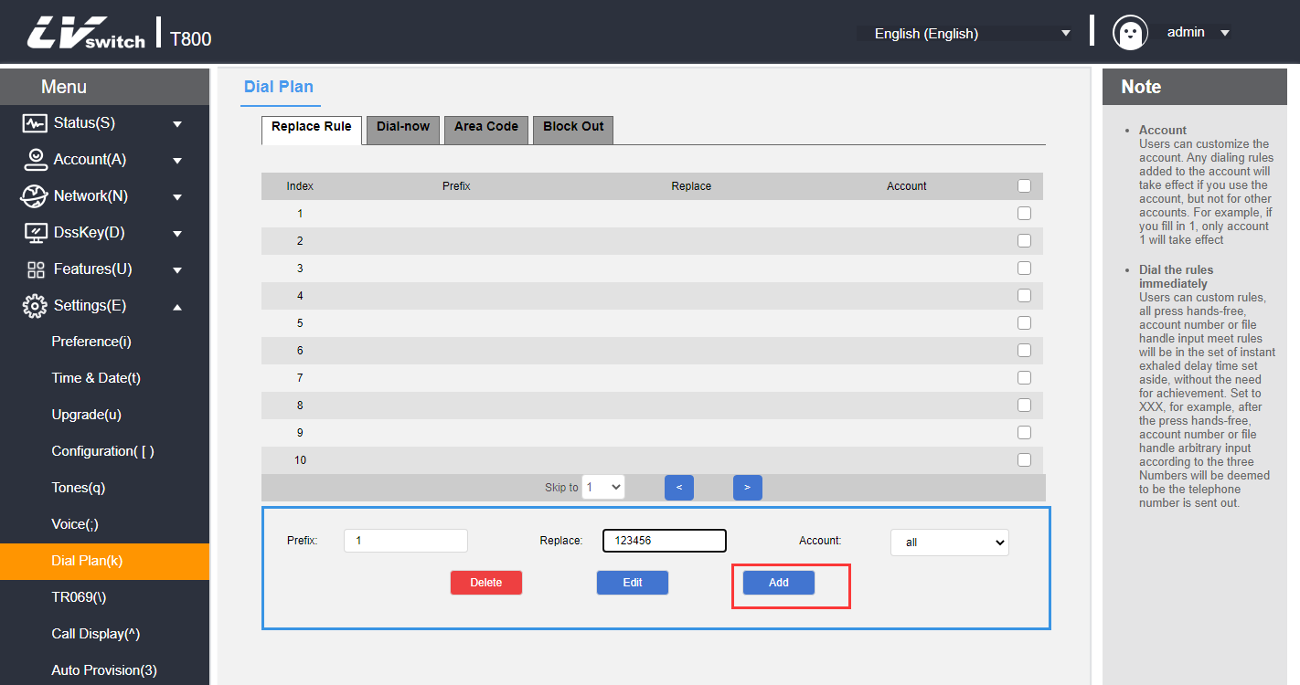
After adding the above rules, when you dial the number "1", press the Send soft key or # to call, the phone will automatically replace the number with "10086" for dialing.

- Modification of replacement rules through the web interface
1. Log in to the phone page by IP address.
2. Click Settings (E) -> Dialing Rules (k) -> Replace Rules.
3. Check the checkbox to the right of the rule you want to modify in the rule list.
4. Modify prefixes/replacements/accounts as needed.
5. Click the Edit button to save the changes.
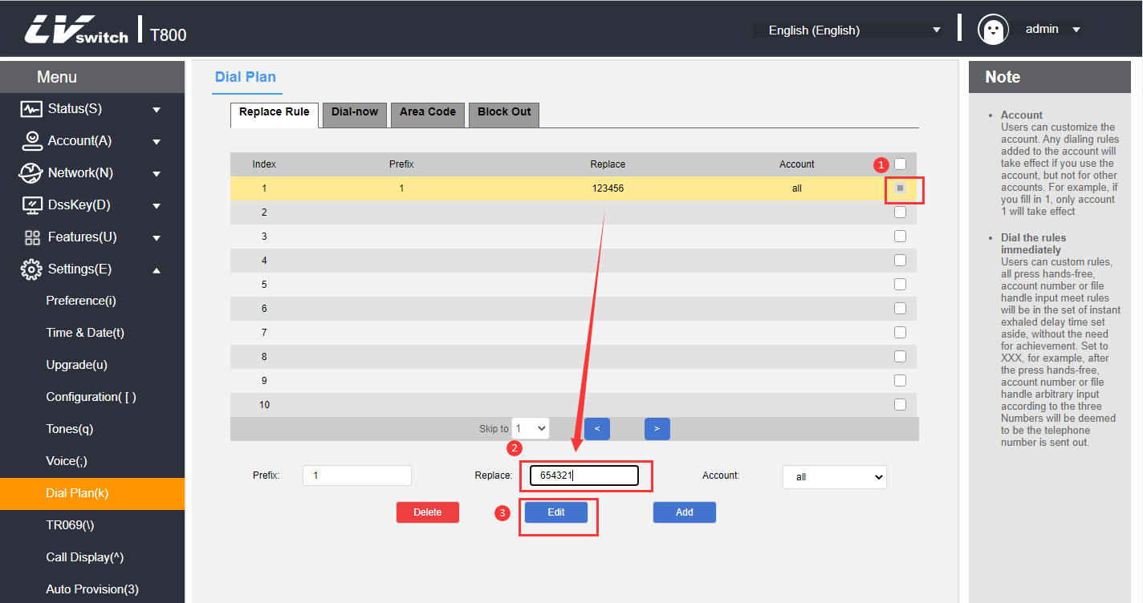
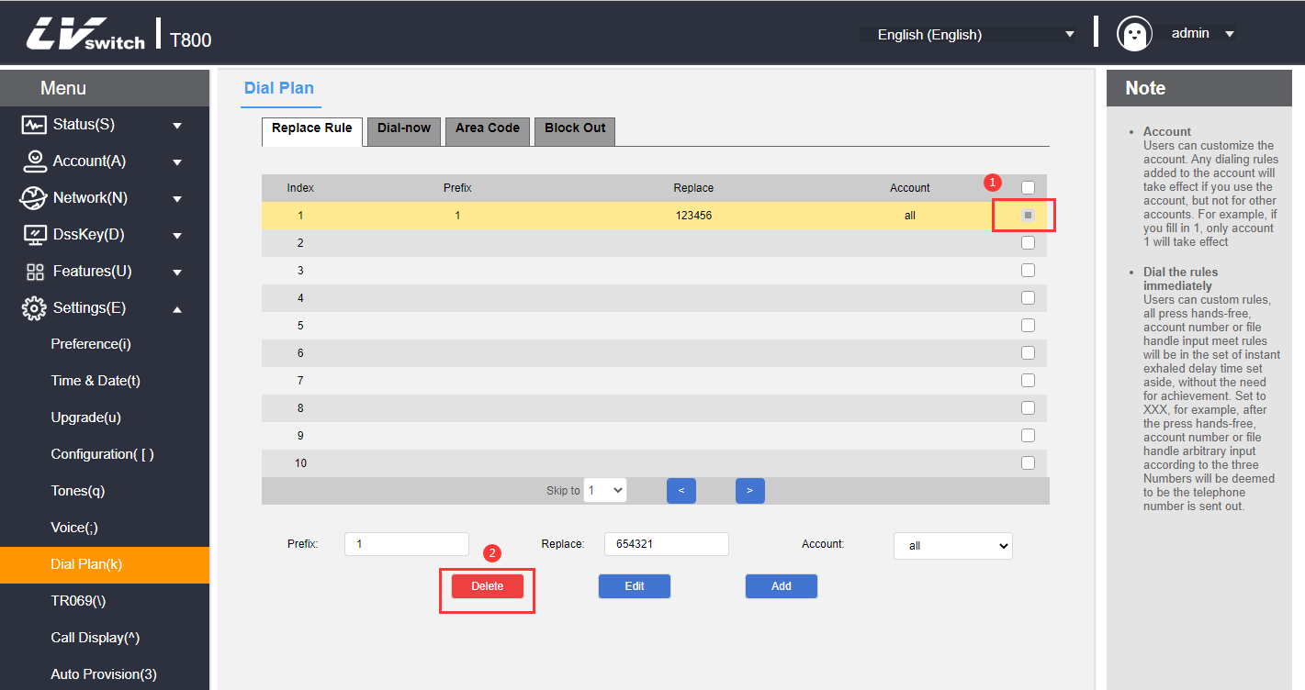
- Deletion of replacement rules through the web interface
1. Log in to the phone page by IP address.
2. Click Settings (E) -> Dialing Rules (k) -> Replace Rules.
3. Check the checkbox to the right of the rule you want to modify in the rule list.
4. Click the Delete button to delete the rule.

2) Exhale immediately
You can customize the immediate outgoing rules, up to 100 rules, all the numbers that meet the rules by pressing the speakerphone, account number key or lifting the handle will be dialed in the set immediate outgoing delay time, without pressing the send key. For example, when you set the call out rule as xxxxxx, the caller account number is all (any account), when you dial any five-digit number of 10086, the phone will call 10086 immediately when you meet the call out rule.

- Adding immediate callout rules through the web interface
1. Log in to the phone page by IP address.
2. Click Settings (E) -> Dialing Rules (k) -> Call Out Now.
3. Enter the rule characters to be set in the rule input area (e.g.: xxxxxx).
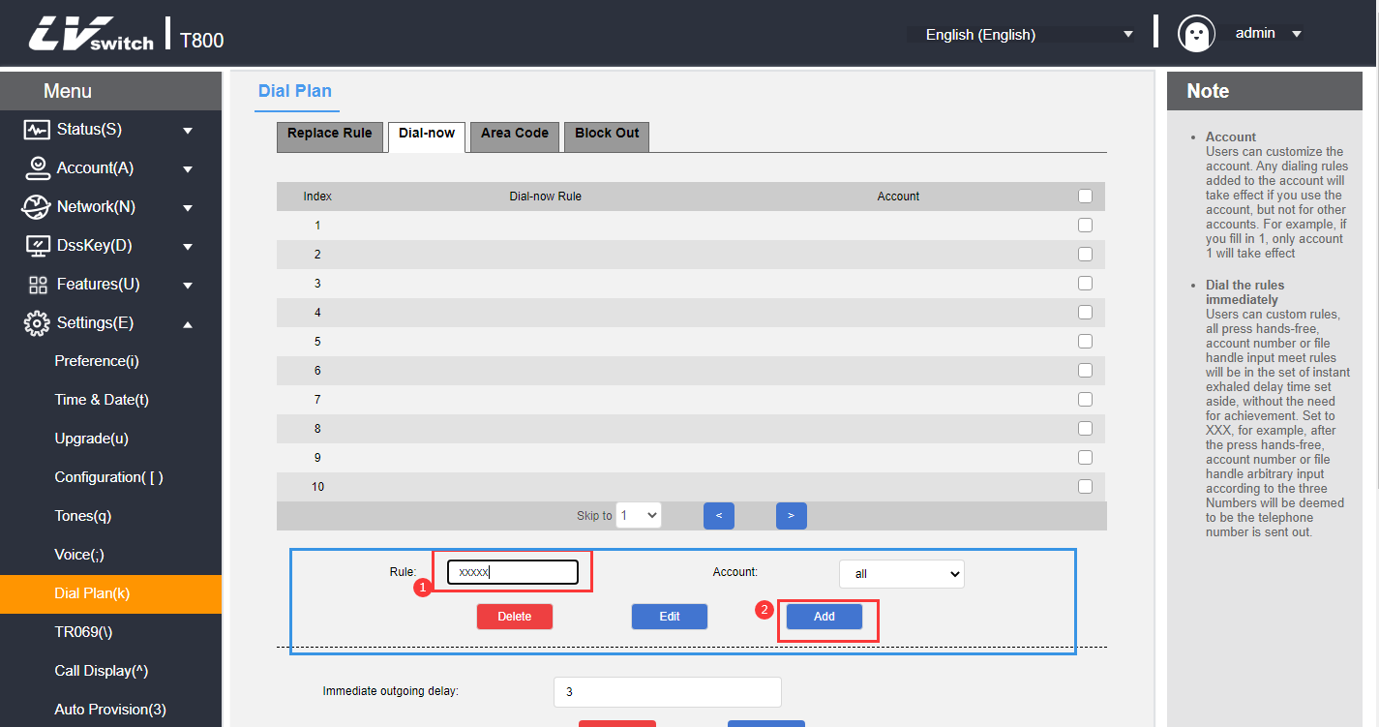
4. Select the account to which the matching rules apply (eg: the current registered account 80011), the default value is all (indicating all accounts).
5. Click the Add button to save the rule.

When any five-digit number such as 10086 is entered, it will be called out immediately after waiting for the delay time.

- Modify the immediate call out rules through the web interface
1. Log in to the phone page by IP address.
2. Click Settings (E) -> Dialing Rules (k) -> Call Out Now.
3. Tap the rule you want to modify in the rule list.
4. Modify the rule in the rule input area, e.g.: (original: xxxxx --> change: 1xxxx).
5. Account area to select the account to which the matching rule applies (e.g., the current registered account 8001), the default value is all (indicating all accounts).
6. Click the Edit button to save the modified rule.
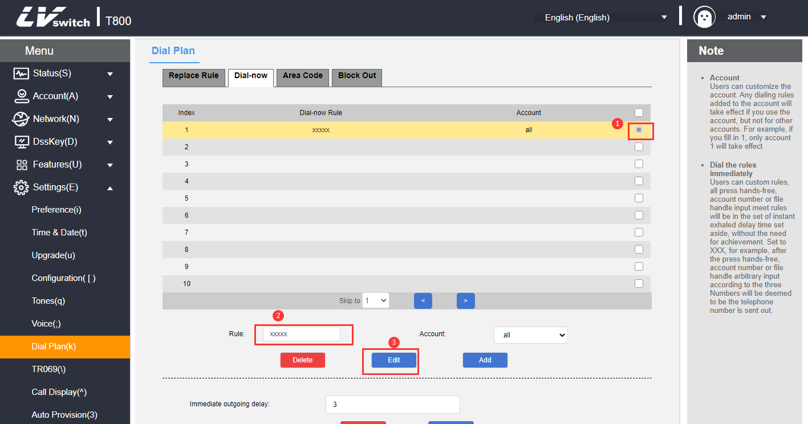
- Remove immediate call out rules through the web interface
1. Log in to the phone page by IP address.
2. Click Settings (E) -> Dialing Rules (k) -> Call Out Now.
3. Tap the rule you want to delete in the Rule List.
4. Click the Delete button to delete the rule.

Immediate outbound delay time
Immediate call out needs to set the delay time, the default time is 2 seconds, the setting range is 0~14 (unit: second), when the number entered when dialing meets one of the immediate call out rules, the phone will automatically call out the number after the delay time, without pressing the send key.

- Setting the delay time for immediate outgoing calls through the web interface
1. Log in to the phone page by IP address.
2. Click Settings (E) -> Dialing Rules (k) -> Call Out Now.
3. In the Instant Callout Delay entry field, fill in the time.
4. Click the Submit button to save.
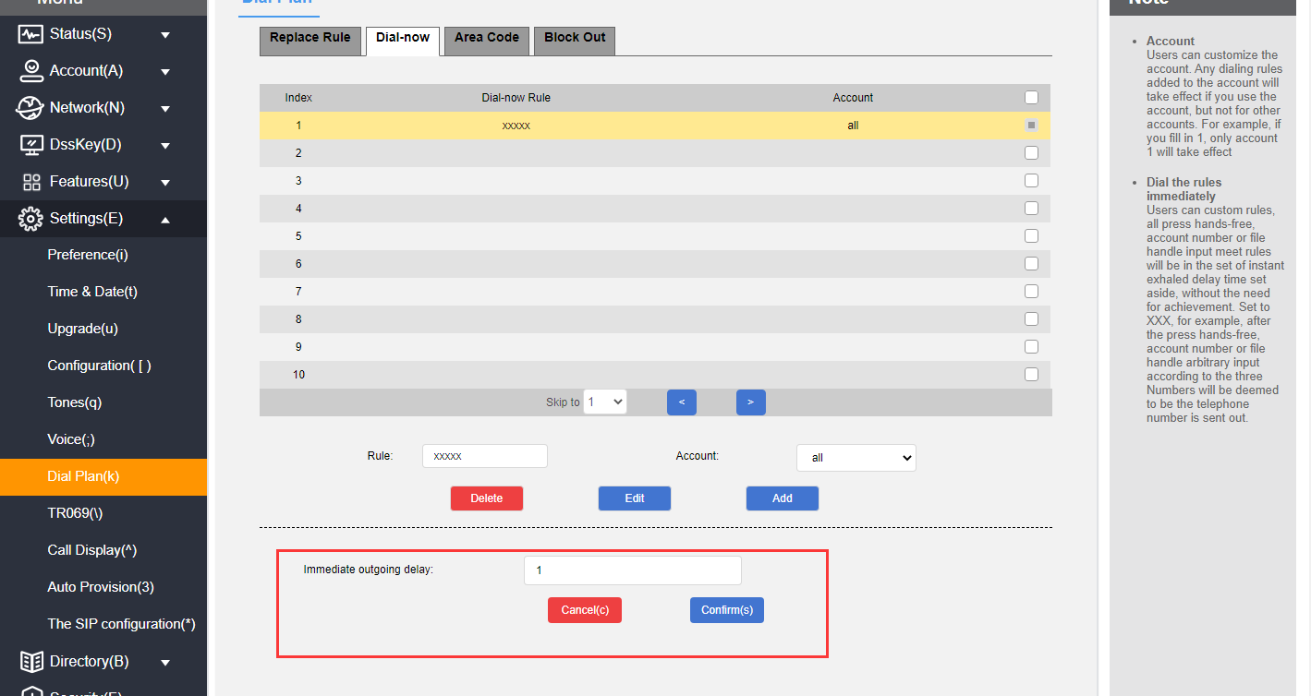

3) Area code
You need to add the area code to make calls between different regions, which are different from one region to another. If you need to call a phone number in a certain area frequently, you need to manually dial the area code prefix of that area.By using this feature it will automatically add the area code/prefix in front of your outgoing number.
Description Only one area code can be set for the T800N.

Example:
Setting the area code (length range: 1~15 digits) | 0757
When you dial the number (length range: 1~15 digits)) | 12345
The actual outgoing number is changed to | 075712345

- Setting up area codes through the web interface
1. Log in to the phone page by IP address.
2. Click Settings (E) -> Dialing Rules (k) -> Area Code.
3. Fill in the area code (length range: 1~15 digits).
4. The account number can be filled in with the registered account of the matching area code or the default value is all (all accounts).
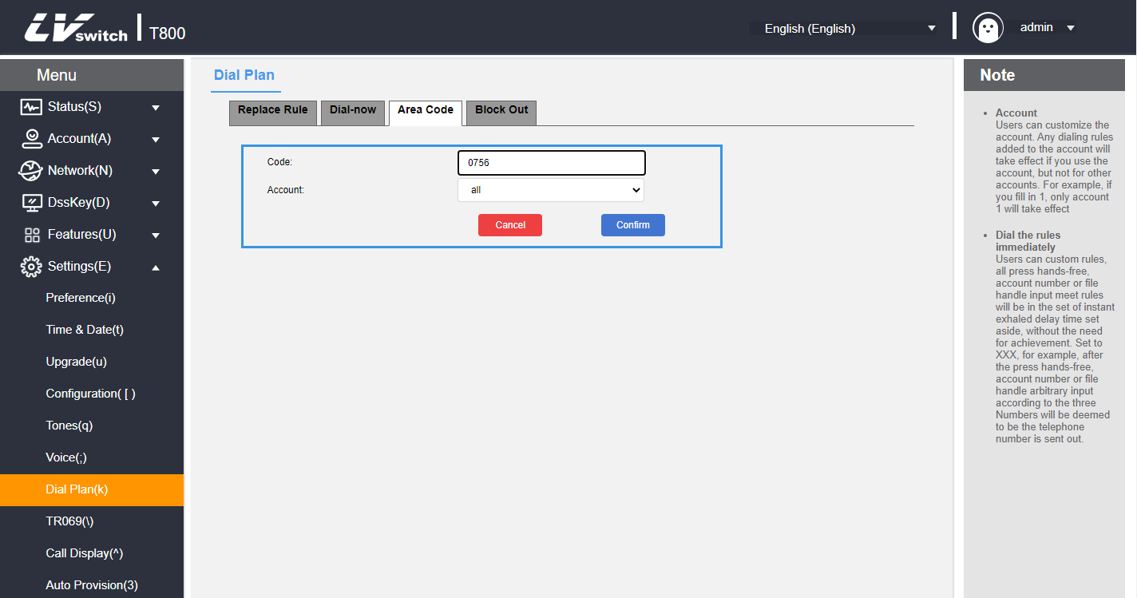

4) Restriction of outgoing calls
You can restrict the phone to call certain numbers by setting the restricted outgoing numbers, T800N supports up to 10 restricted outgoing numbers, when the number you call matches with the rule, the phone LCD will show the word "bannedNum".
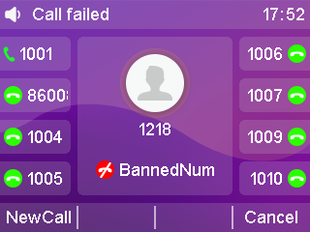
- Adding outbound restriction rules through the web interface
1. Log in to the phone page by IP address.
2. Click Settings (E) -> Dialing Rules (k) -> Restrict Outgoing Calls.
3. Fill in the Blocked Numbers field with the number you want to restrict calls to.
4. Account fill in the registered account of the restricted call.
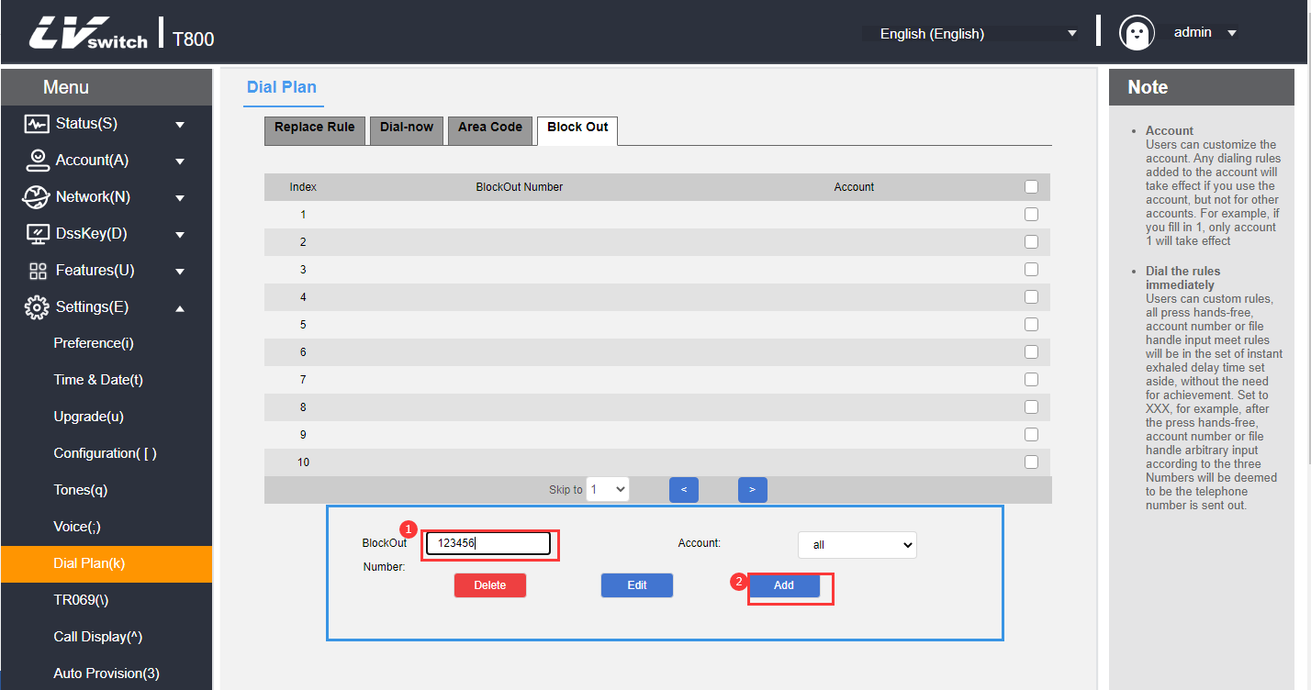
5. Click the Add button to save the rule.

- Modify outbound restriction rules through the web interface
1. Log in to the phone page by IP address.
2. Click Settings (E) -> Dialing Rules (k) -> Restrict Outgoing Calls.
3. Tap the rule you want to modify in the restricted outgoing rule list.
4. Modify the rule in the rule input area, e.g.: (original: xxxxx --> change: 1xxxx).
5. Account area fill in the matching rules of the account (eg: the current registration account 2019), the default value is all (that all accounts).
6. Click the Edit button to save the modified rule.

- Remove outbound restriction rules through the web interface
1. Log in to the phone page by IP address.
2. Click Settings (E) -> Dialing Rules (k) -> Restrict Outgoing Calls.
3. Tap the rule you want to delete in the restricted outgoing rule list.
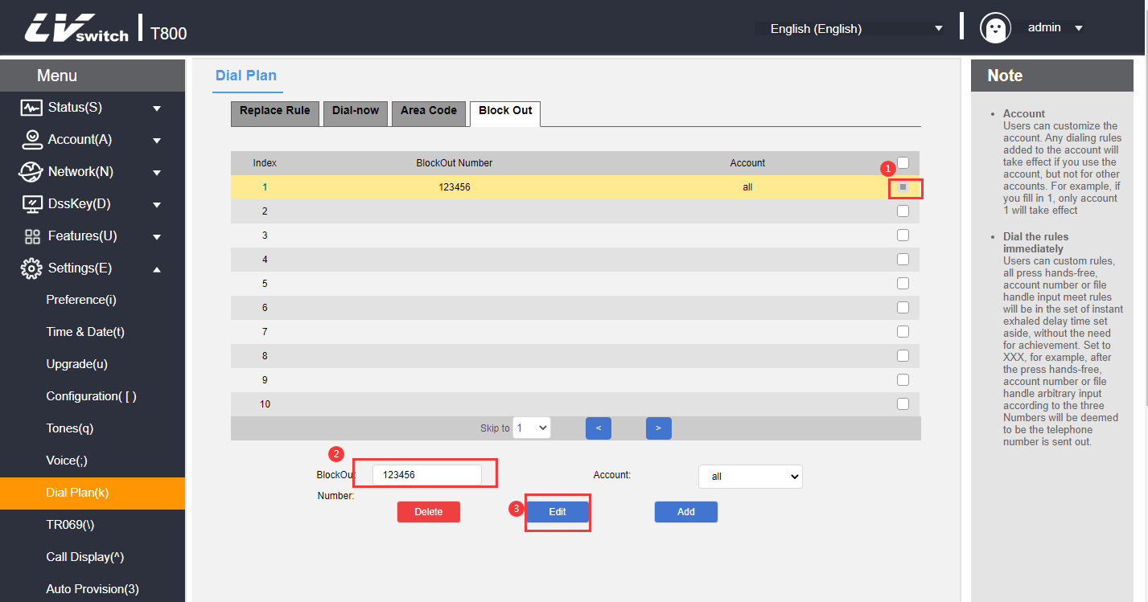
4. Click the Delete button to delete the rule.

Basic Functions

This chapter introduces the basic functions of the T800N telephone as follows:
- make a call
- answer the phone
- end a call
- redial
- DND
- call transfer
- call forwarding
- Call Waiting
- PIN call
- call hold
- Auto Redial
- Call completion.
- Auto Answer
- anonymous call
- hotline
- two-dimensional barcode
- sessions
- Update
- Upload ringtones
- Capture & Diagnose
- reset
- configuration management

make a telephone call
You can choose the way to make a call ① manual dialing, ② call list, local contact selection number dialing.
For the way to dial a phone Record and local contacts, please see Contact Management and CDR Management for more information.

The T800N can talk using three tools:
- handset
- headset
- speaker

- Using the handset to make calls
Any of the following may be used:
Mode 1 | Mode 2
1. Pick up the handle when the phone is idle | 1. Enter the number in the idle state of the phone.
2. Enter the number | 2. Pick up the handle
3. Press , or the Dial soft key to call out the number. | 3. Press , or the Dial soft key to call out the number.
Description The default call out key of the phone is #, you can also set it to * or not set this key as call out key, please check the detailed setting method. Outgoing Keys section.

- Talking with a headset
Any of the following may be used:
Mode 1 | Mode 2
1. After connecting the headset, press to enter headset mode | 1. After connecting the headset, press to enter headset mode
2. Enter the number | 2. Press the account number button to enter the dialing interface, enter the number
3. Press , or the Dial soft key to call out the number. | 3. Press , or the Dial soft key to call out the number.

- Talking on the speakerphone
Any of the following may be used:
Mode 1 | Mode 2
1. Press the hands-free key  to enter the dialing interface | 1. Enter the number in the idle state of the phone.
2. Enter the number | 2. Press , , or the Dial soft key to call out the number.
3. Press , or the Dial soft key to call out the number.
Description The three call tools can be selected by dialing the number first.
You can dial the number by calling the IP address on the phone, view the IP address in the other phone state, and then make a call by dialing the IP address, such as dialing: 192.168.0.123.

- multi-way calling
T800N supports multiple calls, each account supports up to 2 calls, while one call is calls in progress, the other way of call is on hold.
A new call can be initiated using any of the following methods:
Mode 1 | Mode 2
1. During a call, press the account number key, the current call will be put on hold and enter the dialing interface | 1. During a call, press the Hold soft key to put the current call on hold.
2. Enter the number | 2. Press the New Call soft key to enter the dialing interface, enter the number
3. Press , or the Dial soft key to call out the number. | 3. Press , or the Dial soft key to call out the number.
4. Press or to toggle the number and press the Resume soft key to resume the call. | 4. Press or to toggle the number and press the Resume soft key to resume the call.

- Number Filtering
The T800N supports number filtering, which is used to filter out invalid inputs when dialing.
1. Log in to the web interface.
2. Click Functions (U) -> Basic Information (5).
3. Calling number filtering: *#.
4. Click Submit to save.
- Allow IP calls
The T800N supports configuration of whether to allow IP calls.
1. Click Functions (U) → Basic Information (5) from the homepage.
Enable: the phone allows direct IP dialing;
Disable: when calling IP, it prompts: account is unavailable; when called, you cannot receive direct dialing from IP, and you will receive missed calls from IP after restoration.
2. Click Submit to save the configuration.
- IP Direct Dial Auto Attendant
The T800N supports the configuration of whether or not to activate IP Direct Dialing Auto Answer.
1. Click Functions (U) → Basic Information (5) from the homepage.
Enable: Automatically answer the incoming IP calls;
Disable: need to manually answer an incoming IP call.
2. Click Submit to save the configuration.

Answer the phone
The T800N can answer calls using three tools:
- handset
- headset
- speaker

- Answering an incoming call using the handle
When phone’s ringing pick up the handle.

- Answer a call using the speakerphone
When the phone is calling, press the Answer soft key or the speakerphone key .

- Answering an incoming call using a headset
When the phone calls
- Headset mode is activated, press the Answer soft key or press the account key that is blinking to answer.
- Headset mode is not activated or is activated already, press Headset to answer.

- Reject the call.
Press the Reject soft key for incoming call rejection.
If you set up Do Not Disturb, you can automatically reject calls, for details see Do Not Disturb section.

End a call
If you want to hang up during a call, you can use the following methods:
- To talk using the handset: press the Hang Up soft key or return the handset to the phone.
- To use a hands-free call: press the Hang Up soft key or the hands-free key .
- To talk using the headset: press the Hang Up soft key.

Redial
The phone can quickly redial the last call or any call by using the button on the phone. You can use different ways to redial as follows:

- Redialing with the handset
1. Pick up the handle.
2. Press to dial the last call.

- Use of hands-free redialing
Hands-free redial can be used in any of the following ways:
Mode 1 | Mode 2
1. Redial the last call  Press the button twice to redial the last call | 1. Press to enter hands-free dialing
2. Redial any call  1) Press the button once  2) Press or to switch the number  3) Press , the Call soft key or to redial any call. | 2. Press to redial the last call.

- Redialing using a headset
You need to activate the headset mode first, the specific activation method to see Using the Headset Sections
1. Redial the last call
Press the button twice to redial the last call.

2. Redial any call
1) Press the button once.
2) Press or to switch the number.
3) Press , the Call soft key or again to redial any call.

DND
You can set the phone for Do Not Disturb mode, after setting the Do Not Disturb mode, the phone will display icon on the upper right corner of the phone, the phone will not ring when receiving an incoming call and inform the other party that it is busy, and display a missed call alert on the local phone, as shown below:
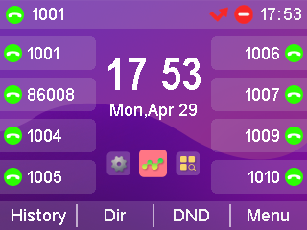

DND has two modes to choose from:
- Phone Do Not Disturb (Factory Default Mode): Turning on this mode will turn on Do Not Disturb for all accounts.
- Customized Do Not Disturb: You can select a specified account to set do not disturb.

- Setting up do-not-disturb on web pages
1. Log in to the web interface.
2. Click Features (U) -> Call Forwarding & Do Not Disturb (4).
3. In the Do Not Disturb Settings area, select Do Not Disturb Mode: Phone or Custom Mode.
4. If you select Custom Mode, select the extension you want to turn on DND.
5. The Do Not Disturb status is set to On.
6. Click Submit to save.
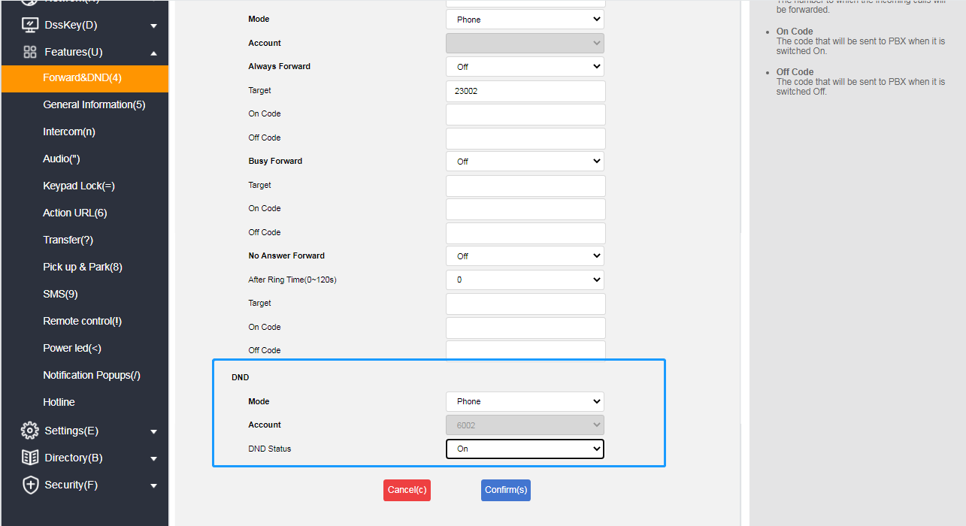

- In phone mode, turn on Do Not Disturb in the phone screen.
Description The Do Not Disturb mode switch can only be set in the web interface.

1. Press the Do Not Disturb soft key while the phone is in standby to set it.
2. or press Menu->Features->Do Not Disturb.
3. Press the Toggle soft key to toggle.
4. Finally, press the Save softkey to save the operation.
When Do Not Disturb is turned on, the icon is displayed in the upper right corner of the phone.

- Enable Do Not Disturb in the phone interface in customized mode
1. When the phone is in standby, press the Do Not Disturb soft key or press Menu->Features->Do Not Disturb to enter the customized Do Not Disturb setting interface.
2. Press or to select the account for which you want to set up Do Not Disturb.
3. Press the Toggle soft key or the Left and Right buttons to select Enable.
4. Press the Save soft key or the key to save the operation.
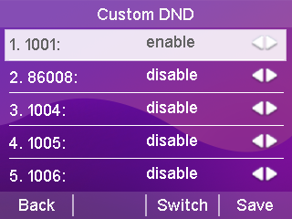

Call transfer
After setting the call transfer on, the external call out to the IP phone will be automatically transferred to the set up of other phones or cell phones. Call transfer is divided into two types, when the phone has an incoming call ringing press the transfer soft key to dial the number to transfer (active transfer), when the phone has an incoming call automatically transferred to a pre-set number (automatic transfer).

Active transfer
- Transfer operation process
1. When there is an external incoming call, the handset is in the ringing state.
2. Press the Transfer soft key.
3. Enter the number to be transferred.
4. Press the button/Send soft key to transfer the call.
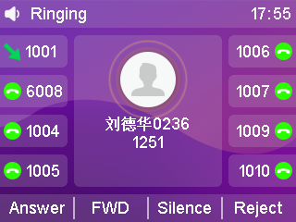

Automatic transfer
There are several main types of automatic transfers:
      - Unconditional transfer: all incoming calls to the phone are transferred to the preset number .
      - Busy Transfer : When the phone is busy, calls are transferred to a preset number.
      - No-Answer Transfer: When no one answers during the ringing period of an incoming call, the call is transferred to a preset number after a timeout.

-Set the call forwarding authentication number through the web page interface:
- Click on Features (U) -> Call Forwarding & Do Not Disturb (4);
- Enable Call Forwarding Emergency Number under Call Forwarding Area;
- Enter the corresponding numbers in the Call Forwarding Authentication Number field, with multiple numbers separated by ",";
- Click Submit to save the operation.
After the authentication number is turned on, the number comes to the telephone set without transfer processing, and the authentication number is applicable to all accounts;
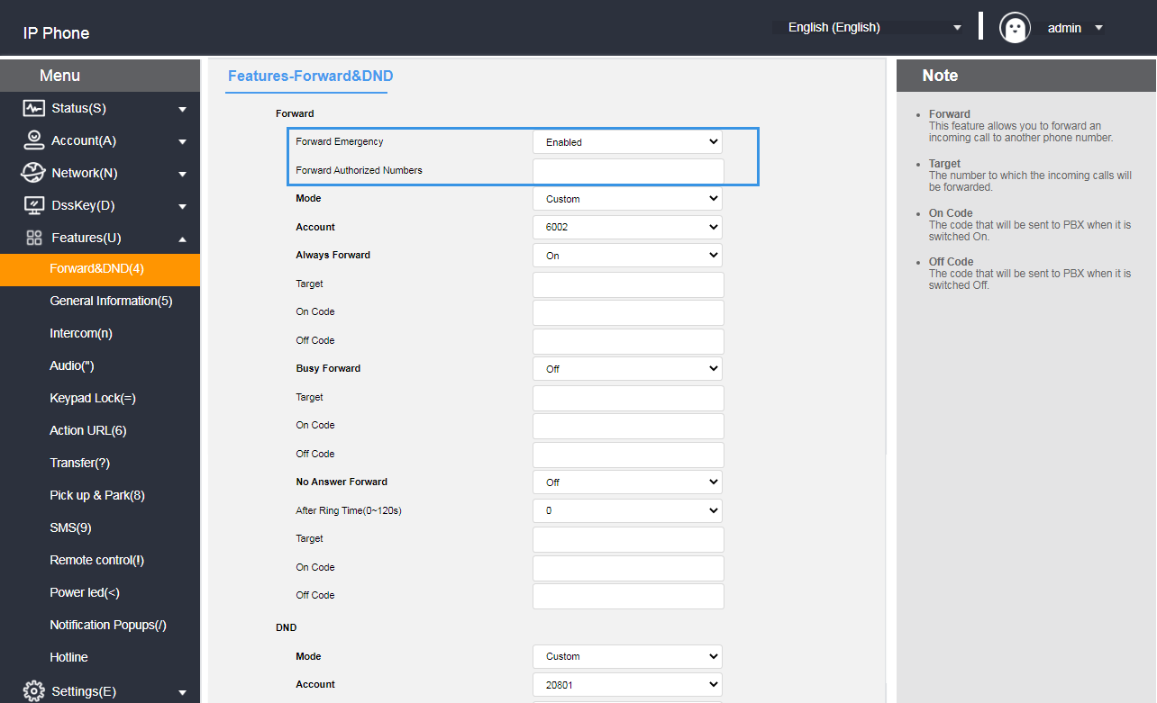

- Setting up call forwarding through the web interface
1. Press Function (U) -> Call Forwarding & Do Not Disturb (4).
2. Select the mode under the Call Forwarding Mode area Custom:
Custom mode:enables the call forwarding feature for a specific account or for all accounts;
Phone Mode:the call forwarding feature will be applied to all accounts on the phone.
3. Select the transfer method to be set as desired and select On.
4. Fill in the target number to be transferred.
5. Setting the feature code on and off in the call forwarding area (optional)
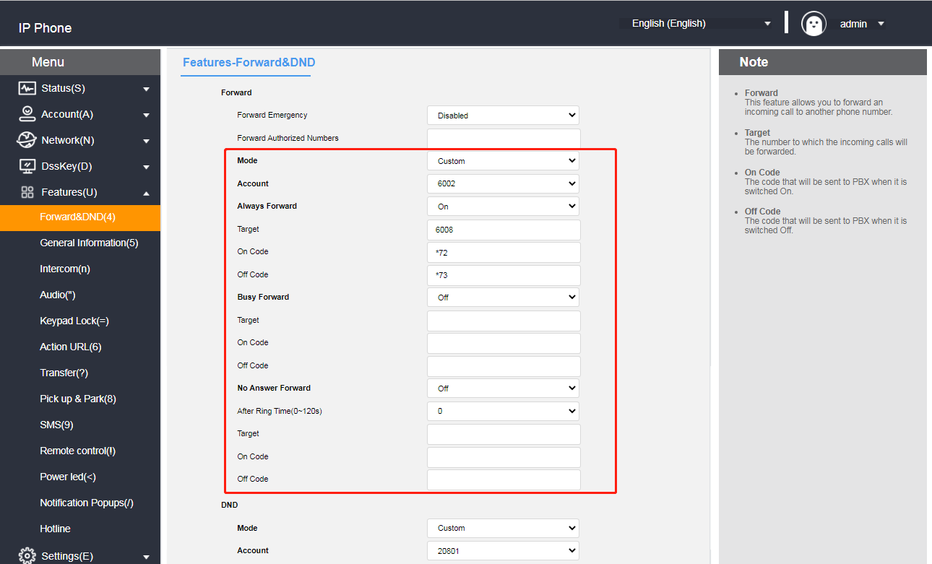
6. Click the Submit button at the bottom of the page to save

Note: If you configure a call forwarding feature code, the phone will send the corresponding feature code to the server. For example, if you set the feature code of unconditional transfer on to *72, and the feature code of unconditional transfer off to *73, and the transfer number is 1000, when you turn on the unconditional transfer, the phone sends *721000 to the server, and when you turn it off, it sends *731000 to the server, so that the server can synchronize the unconditional transfer function to be turned on/off.

- Setting up call forwarding through the phone interface
1. Press Menu->Features->Call Forwarding.
2. Select the transfer method to be set as desired:
- unconditional transfer
1) Press or to select Enter Unconditional Transfer.
2) At the Status option, press the Toggle soft key to turn on/off.
3) Press or to select the number item and fill in the number in case of unconditional transfer.
4) (Optional) Enter the unconditionally transferred on feature code and off feature code in the on feature code and off feature code fields respectively.
5) Press the Save soft key to save the operation.
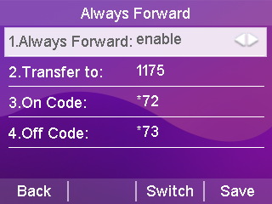

- Call forwarding when busy
1) Press or to select Busy Transfer.
2) At the Status option, press the Toggle soft key to turn on/off.
3) Press or to select the number item and fill in the number in case of busy transfer.
4) (Optional) Enter the on feature code and off feature code for busy transfer in the on feature code and off feature code areas respectively.
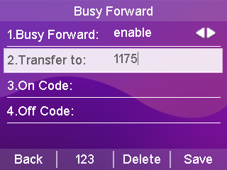
5) Press the Save soft key to save the operation.

- Nonresponsive transfer
1) Press or to select entering No Answer Transfer.
2) At the Status option, press the Toggle soft key to turn on/off.
3) Press or to select the number item and fill in the number to be transferred.
4) Press or to select no answer time, fill in the waiting time before you want to transfer, default 5
Seconds.
- (Optional) Enter the on feature code and off feature code for no answer transfer in the on feature code and off feature code areas respectively.
- Press the Save soft key to save the operation.
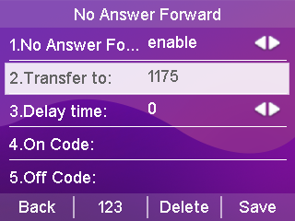

When Call Forwarding is turned on, the LCD screen displays the Call Forwarding Enabled icon when the phone is in standby.
Description If the call forwarding has been set up in advance, call forwarding can be quickly turned on/off by using the TRANSFER button on the phone panel.

call forwarding
Call Forwarding is categorized into the following two types:
- Blind transfer: Direct transfer to the other party without consultation with the transferring party
- Consultation transfer: transferring incoming calls to the person to whom the call is to be transferred when the consultation with the person to whom the call is to be transferred has been completed and the transfer has been agreed upon
Phones A
Phones B
Phone C
- A is on the phone with B
③B enter C number and press the Blind Transfer soft key to transfer to C
④ A and B are disconnected from the call, and A is talking to C.
②B press Transfer soft key, AB call goes on hold (press Resume soft key to resume A and B calls)
Blind transfer flowchart

Blind transfer

- Blind transfer operation process:
1. Handset A is talking to handset B.
2. Handset B presses the Transfer soft key or the Transfer button.
3. The called number input for blind transfer can be done in the following two ways:
- Enter the number directly
1) B enter the number of the transferred phone C. After entering the number, the blind transfer(BTra) soft key appears on the LCD display of the phone B.
2) Phones B press the BTra soft key.
3) The call between B and A will be interrupted and the incoming call is forwarded to Phone C.
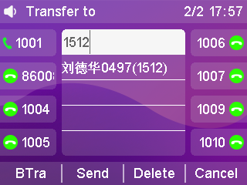
- Selecting numbers by contact
1) B Press the Dir soft key.
2) Press or to select a group and press the Enter soft key to enter the group.
3) Press or to select the contact to be transferred and press the Send soft key.
4) Press or to select the phone or cell phone you want to transfer to and press the Transfer soft key to blind transfer.
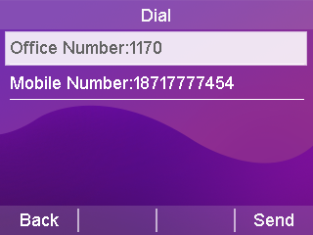
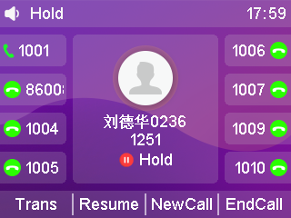
5) The call between B and A will be interrupted and the incoming call is forwarded to phone C.

- Eliminate the blind turn operation process:
When Phones A and B are talking, after Phones B presses the Transfer soft key, Phones B and A will enter a call hold state, and the calling party will hear the ringing of the call hold, and if they want to exit the transfer operation, press the Resume soft key, and the call between Phones B and A will be resumed.

Advisory Transfers
④ If C does not agree to answer, B and C end the call.
⑤B presses the Resume soft key to resume the call between A and B. Explain the reason for not being able to transfer the call, and AB ends the call.
④ If C agrees to answer
⑤B press the transfer soft key to transfer the incoming call to C.
Consultation Transfer Flowchart
Phones A
Phones B
Phone C
- A is on the phone with B
③ B enters C's number and presses the Send soft key to call C. B communicates with C whether to forward A's call to C.
(vi) B and C are disconnected from the call, A and B are disconnected from the call, and A and C are on the call
②B press the Transfer soft key, AB call goes on hold (you can press the Resume soft key to resume the call between A and B)
- Consultation transfer operational process:
1. Phone A is talking to Phone B.
2. Phone B presses the Transfer soft key or the Transfer button.
3. Enter the number of the transferred phone C. The LCD display shows the Send soft key.
4. After Pressing the SEND soft key,Phone B will talk to Phone C. Phone B aks Phone C if he wants to accept an incoming call from Handset A.
5. It is divided into the following two cases:
a) Phone C is unable to answer the call
1) Phone C refuses to answer a call from A or Phone C is unavailable.
2) Phones B and C end the call.
3) Phone B presses the Resume softkey to resume the call with Phone A and informs Phone A that it is unable to answer.
4) End of transfer.

b) Phone C can answer the call
1) Phones B and C have finished negotiating, and Phones C can answer incoming calls from Phones A.
2) Phones B presses the transfer soft key.
3) The call between B and A will be interrupted and the call will be forwarded to C and A will talk to C.

Call Waiting
If you enable Call Waiting feature, you can receive new incoming calls during the call, otherwise new incoming calls will be automatically rejected during the call, if you enable the Play Tone feature, when you receive a new incoming call during the call, the handset will ring a "beep" tone, otherwise new incoming calls will not be reminded.

-Set up call waiting via the web
1. Click Features (U) → General Information (5).
2. Enable call waiting, set on/off feature code (different feature code for different PBX).
3. Press Submit to save the operation or Cancel to cancel it;
If Enable/Disable Feature Code is set, when Enable/Disable Call Waiting the phone will use the default account to send the feature code to the server (only this account is enabled not all accounts) to synchronize Enable/Disable Call Waiting;
If the phone does not have a feature code set:
When the server turns on call waiting, the phone turns on and off call waiting normally;
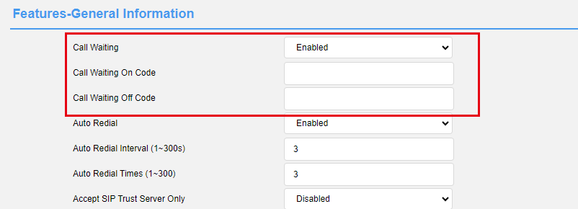
It is not valid for the phone to turn on call waiting when the server does not turn on call waiting;

PIN call
If you are making a call and do not want the caller to see the number you are dialing you can enable passcode calling.

- Setting up password calls via the web
1. Click Features (U) → General Information (5).
2. Setting up a password call;
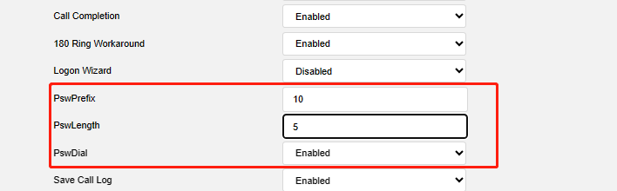
3. Press Submit to save the operation or Cancel to cancel it;
The last 5 digits of a number starting with 10 will be replaced by * after successful configuration;

Call hold
When you have an emergency to deal with while you are on a call, you can press the Hold button to enter the call hold state, and the server will play a hold tone for the other end.
- Setting the Hold Tone via the Web
1. Click Features (U) → General Information (5).
2. Setting the hold tone.
a) Call Hold tone;
b) Call Hold tone delay;
c) Hold tone interval;
d) Call Held Tone;
e) Call Held tone delay;
f) Held beep interval;

3. Press Submit to save the operation or Cancel to cancel it;
When you enter Hold Mode after turning on the beeper, the beeper will play "Di";

- Setting RFC 2543 Hold Mode via the Web
1. Click Menu → Account (U) → Advanced (5);
2. Set to enable disable RFC 2543 hold mode;
3. Press Submit to save the operation or Cancel to cancel it;

The PBX does not play hold tones when RFC 2543 hold mode is enabled;

Automatic redial
If you enable auto redial, the phone will show auto redial prompt in LCD interface after call failure, you can also set auto redial interval and auto redial times.
-Set up automatic redialing through the phone interface:
1. Press Menu → Features → Auto Redial;
2. Select Enable Auto Redial, set Auto Redial Interval (in seconds, default 10, range 1-300), and set Redial Counts (default 10 range 1-300);
3. Press Save to save the operation or Return to cancel it.

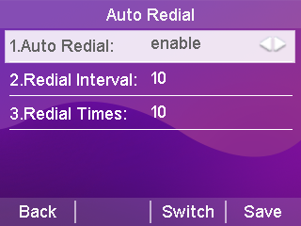

-Set up automatic redialing through the web interface:
- Press Features (U) → General Information (5);
- Select Enable Auto Redial, set the Auto Redial Interval (in seconds, default 10, range 1-300), and set the Redial Count (default 10 range 1-300);
- Click the Submit button at the bottom of the page to save
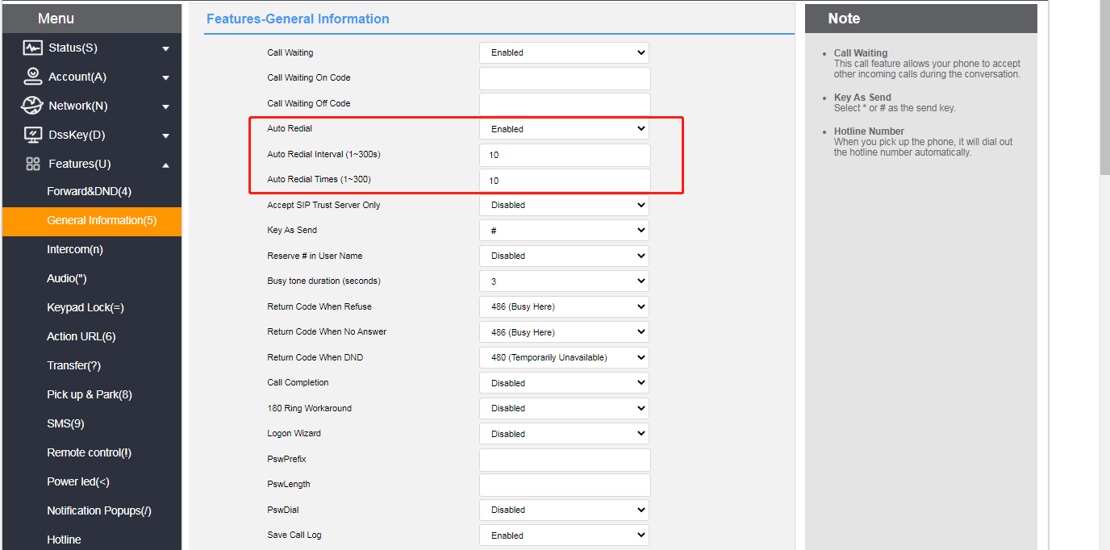
Using the automatic redial function
When the phone call fails, the phone LCD interface prompts as follows:

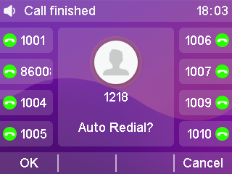
1. Press the OK soft key to activate the Auto Redial feature.
The phone LCD interface prompts as follows:
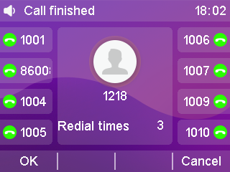
2. Press the OK soft key or wait for a period of time (redial interval), the phone will call out the number again.
The phone will dial the called user for the set number of redials.

Status return code
The phone can set the status return code for Reject/No Answer/Do Not Disturb.
- Setting the status return code through the page
1. Log in to the Web interface.
2. Click Features (U) → General Information (5).
3. Set the status return code supporting: 404/480/486/600/603.
4. Click the Submit button at the bottom of the page to save the configuration.
After successful configuration the phone sends the corresponding return code to the peer:

Call completion.
When the phone is enabled for call completion, the phone enters the call completion prompt interface when a user in busy state, and the server will notify the phone to redial when the called user turns to the idle state after clicking confirm;

-Set call completion via web setup:
- Click Features (U) → General Information (5).
- Select Enable.

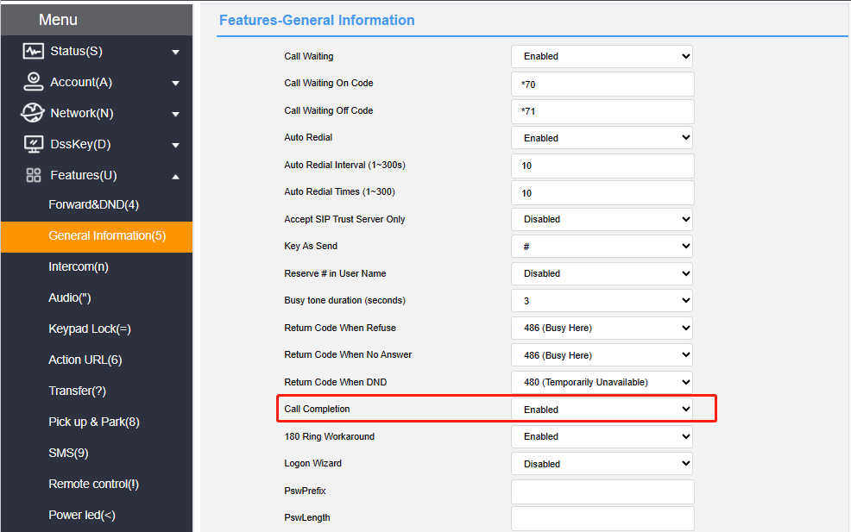

When the called user is busy, the phone interface prompts as follows:

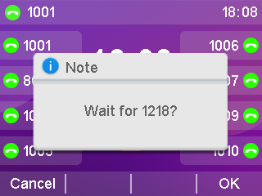
After pressing Confirm, when the called user turns to idle status, the phone interface will show the following prompt:
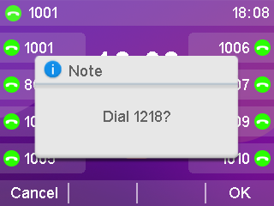

Busy state has been tested to detect only the call state, other states are not detected, all others will prompt the calling user to switch to idle state.
Other can only enter the busy state when it is not possible to dial, it is not possible to detect whether it is idle or not, e.g., DND, blacklist, etc. are not detected;
If the user's transferred number dialed by the phone is busy, the phone will enter the call completion interface but cannot detect the transferred number status, and after detecting the normal state of the dialed phone, it will be prompted to dial the number. For example, if the call completion is enabled on phone A (call completion), phone B (called number, unconditional transfer to phone C is enabled), and phone C (transferred number, DND is enabled), phone A dials phone B, and phone A enters the call completion interface, and after a period of time, it will jump to the dialing interface, and it will not be affected by whether or not DND is turned off on phone C.
Attention:
Call completion requires server support.
Call Completion If there are multiple calls only the dialed call hangs up and prompts for dialing;
Multiple call waiting screens will not appear, and the call waiting screen disappears after operating the call;
Exit Call Waiting prompt does not disappear before entering the dialing screen without dialing, and incoming calls do not interrupt call completion.

Auto Answer
You can set up an auto-answer function for the registered account of the phone. When an account with auto-answer enabled receives an incoming call, the phone will automatically answer the call after the set auto-answer wait time.

- Setting up Auto-Answer through the handset interface
1. Press Menu->Features->Auto Answer.
2. Press or to select the account you want to enable auto-answer.
3. Press the Toggle soft key to toggle the enabled or disabled state.
4. Press the Save soft key to save the operation.
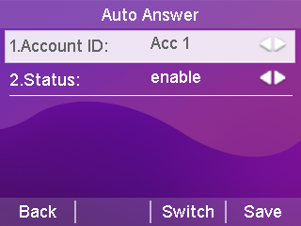
When Auto Answer is turned on, the Auto Answer icon appears on the display of the handset standby, indicating that the handset is in the Auto Answer state. When the phone is in a call state, it will not answer automatically.
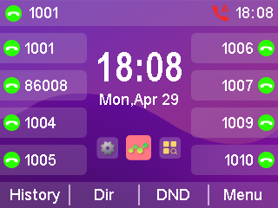

Anonymous call
The phone can turn on the anonymous reject feature to automatically reject an anonymous call when it comes in. If the server supports the anonymous reject function, you can also turn on/off the anonymous reject function of the account by dialing the server's service code.

At the same time, the phone can turn on the local anonymity function, the call initiated by this phone, the other party can not see the caller number.But after turning on the anonymity ,it may be rejected by the other party.

- Setting up an anonymous reject function through the phone interface
1. Press Menu->Features->Anonymous Call.
2. Press the Toggle soft key to toggle the Enable or Disable state of Anonymous Reject.
3. Press the Save soft key to save the operation.
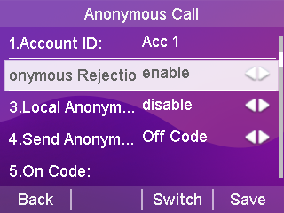
- Setting up local anonymization through the handset interface
1. Press Menu->Features->Anonymous Call.
2. Press or to select the local anonymization option.
3. Press the Toggle soft key to toggle the local anonymization enabled or disabled state.
4. Press the Save soft key to save the operation.
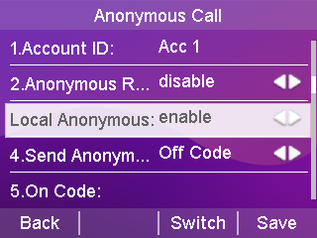
- Setting up anonymous reject/local anonymization through the web interface
- Log in to the web interface.
2. Click Account->Advanced, as shown below
3. Select the account for which you want to enable anonymous rejections.
4. Select Enable in the Anonymous Reject field/Local Anonymous field.
5. Click Submit to save.
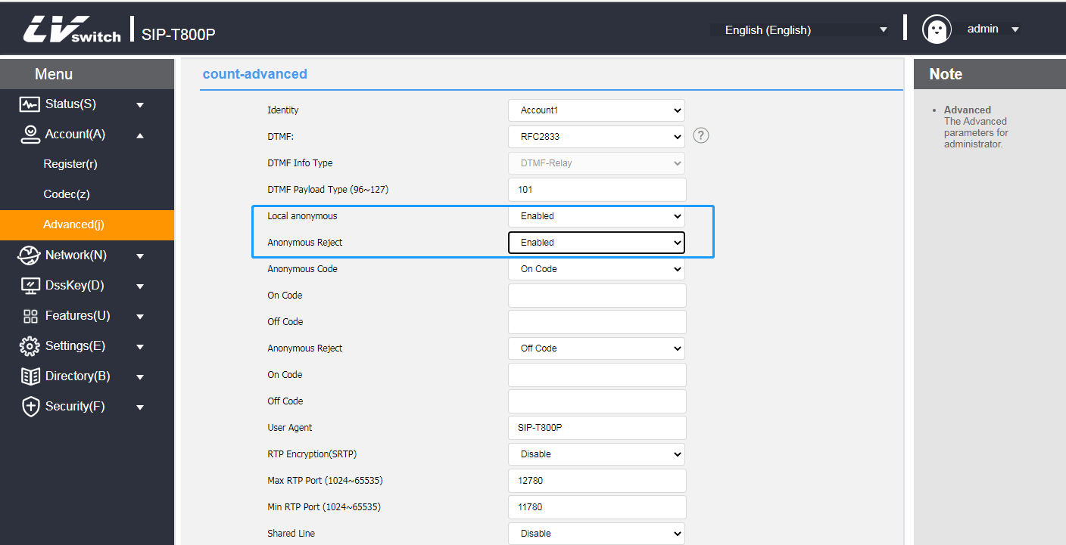

Hotline
You can set a frequently dialed number as the hotline. When using the hotline, when you pick up the handset, press the speakerphone, or use the headset for dialing, wait for the hotline delay time to expire, and the phone will automatically dial the set hotline number. If the delay time is set to 0, the hotline number will be called out immediately upon dialing.

- Setting up hotline functions through the telephone interface
1. Press Menu->Features->Hotline.
2. Fill in the hotline number to call.
3. Press or to select Hotline Delay Time and fill in the number of seconds after the handset is taken off the hook to automatically dial the hotline.
4. Press the Save soft key to save the operation.
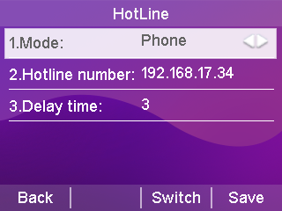

Two-dimensional barcode
T800N supports scanning the QR code provided by the phone to enter the web interface through the smart phone, and configuring the information of the phone on the phone through Menu->Features->QR Code QR Code Information. Before scanning the QR code, the cell phone must be connected to the LAN where the phone belongs to, and be in the same network segment as the phone, such as connecting to the WIFI of the router.
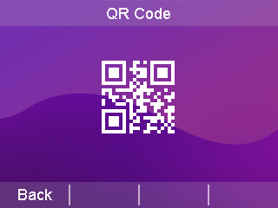
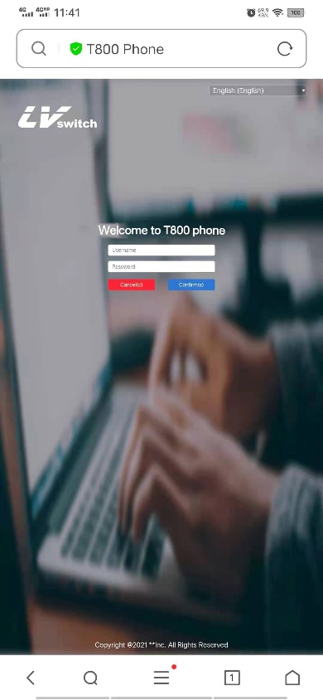

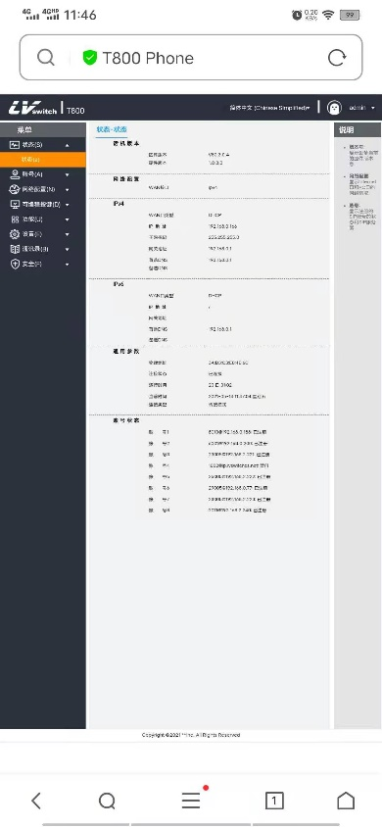
The interface of the cell phone logging in the phone likes the following figure, the specific use method is the same as the computer web operation, to understand the configuration method of each function, please go to the function introduction of each chapter to view, if there is any question about the use of QR code, please contact your network administrator.

Conference
The T800N can initiate a three-way call locally and use the Conference softkey during a two-way call to invite a third party call into the current call.

- Create a local three-way call at the phone
1. It happens in the middle of a call between A and B.
2. A presses the Conference soft key to initiate a three-way call, the call between A and B goes on hold, and A enters the dialing interface.
3. A Enter the C number and press the Dial soft key.
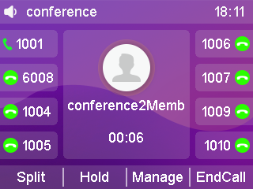
4. When C answers the incoming call, A presses the Conference soft key and ABC will start a three-way call.

- Add calls from both accounts to a three-way call
1. Account 1 of Handset A is talking to Handset B, and Account 2 of Handset A is talking to Handset C (but is on hold).
2. If Account 1 is on a call and Account 2 is on hold, press or to switch the call, using account 1 that is on a call, press the Conference soft key to enter the dialing page, press to select the held call, and press the Send soft key to start the three-way call.
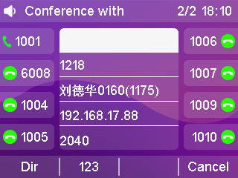
- What you can do during a three-way call
1. Split soft key: You can split a three-way call into multiple independent calls, press or to switch between calls.
2. Hold soft key: You can put two other parties on hold and press the Resume softkey to resume the three-way call.
3. Manage Soft key: Enter the Management page to perform the following operations on the other two parties' calls:
1) Delete soft key: deletes the selected conference member.
2) Hold soft key: Holds the selected conference member.
3) Return softkey: return to the previous level interface.
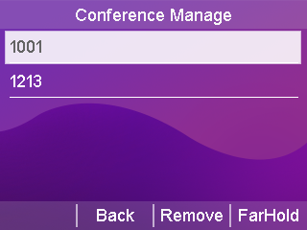
4. Mute button: so that the other two parties can not hear your own voices, and the other two parties can still make a call.
5. Hang up soft key: ends the meeting.

Update
T800N phones can be upgraded to the latest version via the Web, The latest version can be downloaded from the official website or contact your dealer for a copy.

- Upgrade Firmware Version via Web
1. Through the web interface, click Settings->Upgrade->Upgrade Firmware, select the version that needs to be upgraded and click Upgrade.
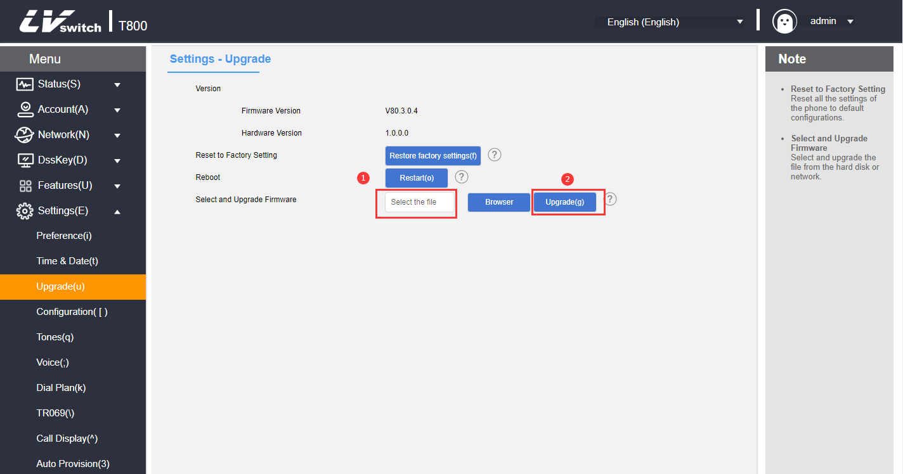
2. Disconnection of power and network is prohibited during the upgrade process, otherwise irreversible problems may occur, such as inability to power on the phone.

Upload ringtones
T800N phones can upload customized ringtones via the Web.

- Upload customized ringtones via Web
1. Click Settings (E) → Preference (5)->Load Ringtones through the web interface.
2. Select the ringtone you want to upload in the Load ringtone item, click the Import button to import the ringtone (maximum ringtone limit 100KB).

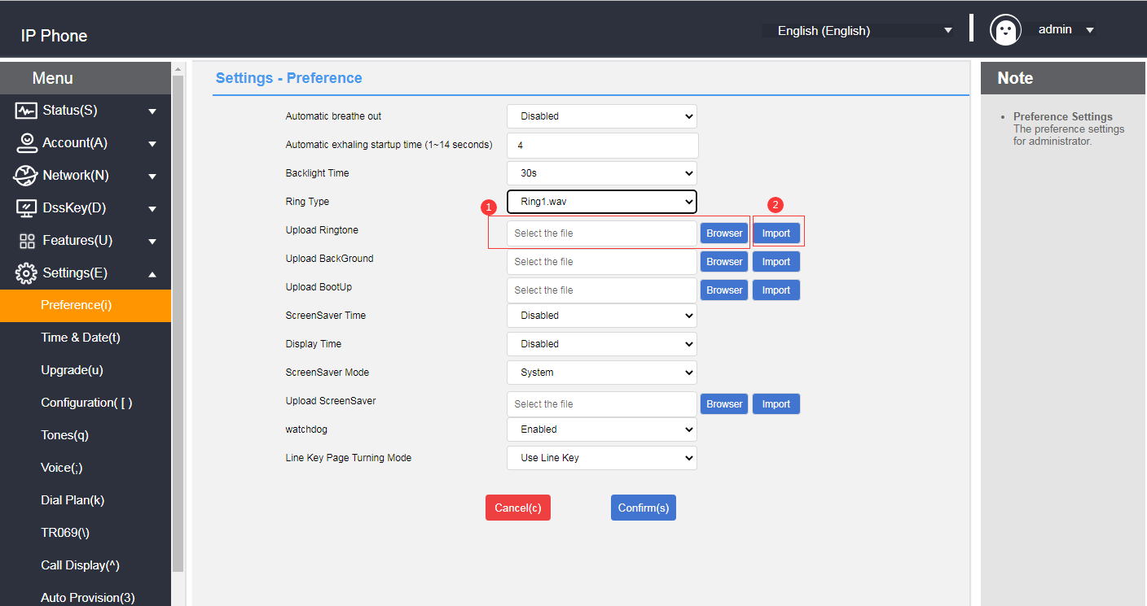

3. After successful upload you can select it in the ringtone type option.

Capture & Diagnose
T800N phones can be used to capture packets via the Web for professionals to easily locate phone problems.

- Grabbing packets from the web
1. Click Network Configuration->Diagnostics from the web page.
2. Select the packet capture method.
3. Click Start and download the file after the packet capture is finished.
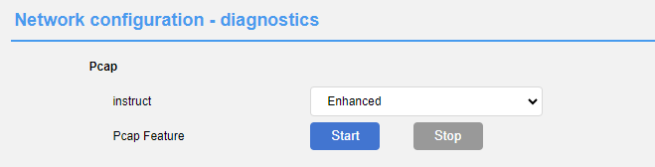
- Diagnosing the network through the web
1. Click Network Configuration->Diagnostics from the web page.
2. Select the diagnostic command.
3. Click Submit to check the network status.
- Network diagnostics via phone
1. The phone clicks Menu->Settings->Basic Settings->Diagnostics->Network.
2. Select Ping or Route Trace, enter the IP address or URL and click Start.
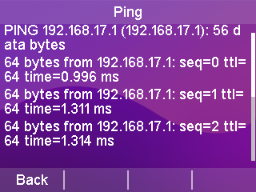

Scheduled reset
T800N phones can be set to restart automatically via the web page, It is disabled by default.

- Configure automatic reboot via web page
1. Click Settings->Time Management through the webpage.
2. Configure the restart program.
a) Auto Restart Enable/Disable;
b) Configure the restart time;
c) Configure the restart date;
3. Click Submit to save the configuration.
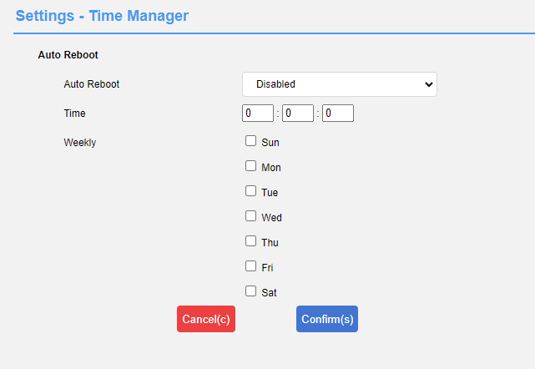

Configuration management
T800N phones can import/export configurations via web page, and the configurations can be common for phones of the same model.

- Configuration management via web page
1. Click Settings->Configuration Management from the web page.
2. Click the Export button to export the bin configuration file.
3. Select a configuration file and click Import to import the configuration.

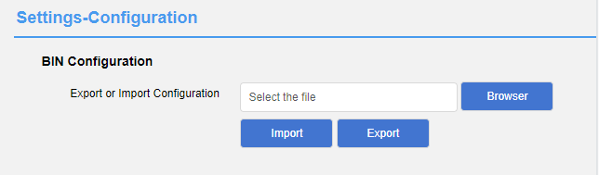

Advanced Features

This chapter introduces the advanced features of the T800N telephone as follows:
- BLF
- walkie-talkies
- multicast
- Message
- TR069
- SIP Configuration
- Action URL
- Trusted Certificates

BLF (Busy Lamp Field)
You can use the BLF feature to monitor the account usage status of a particular user. For example, you can configure a BLF key on the phone to monitor a coworker's account usage status (busy or idle). When a coworker's account is busy, the BLF key's LED lights turns red to indicate that the coworker's account is busy.

Configure the BLF function:
You can configure the function of BLF monitoring on the phone, and the monitored phone does not need to do the configuration.

Configuring the BLF key
- Configure BLF keys through the phone interface
1. Press Menu → Features → Dess Key.
2. Select the account key for which you need to set the BLF.
3. Press or to toggle and select BLF in the Type field.
4. Press or to toggle and select the appropriate account in the Account ID area.
5. (Optional) Enter the label to be displayed in the standby screen in the Label field.
6. Enter the number to be monitored in the value field.
7. (Optional) Enter the intercept feature code in the extension number field. sip server support is required.
8. Press the Save soft key to save the operation or the Back soft key to cancel the operation.
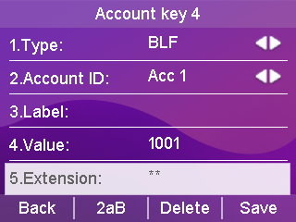
- Setting the BLF key through the web interface
1. Web page click Programmable Keys -> Account Key.
2. Select the account key for which you need to set the BLF.
3. Select BLF in the Type drop-down box.
4. Enter the account you want to monitor in the Value field input box.
5. (Optional) Enter the label to be displayed in the standby screen in the label input box.
6. Select the corresponding account in the Account drop-down box.
7. (Optional) Enter the Intercept Characteristic Code in the extension number entry box. sip server support is required.
8. Click Submit to save the operation or Cancel to abandon the operation.
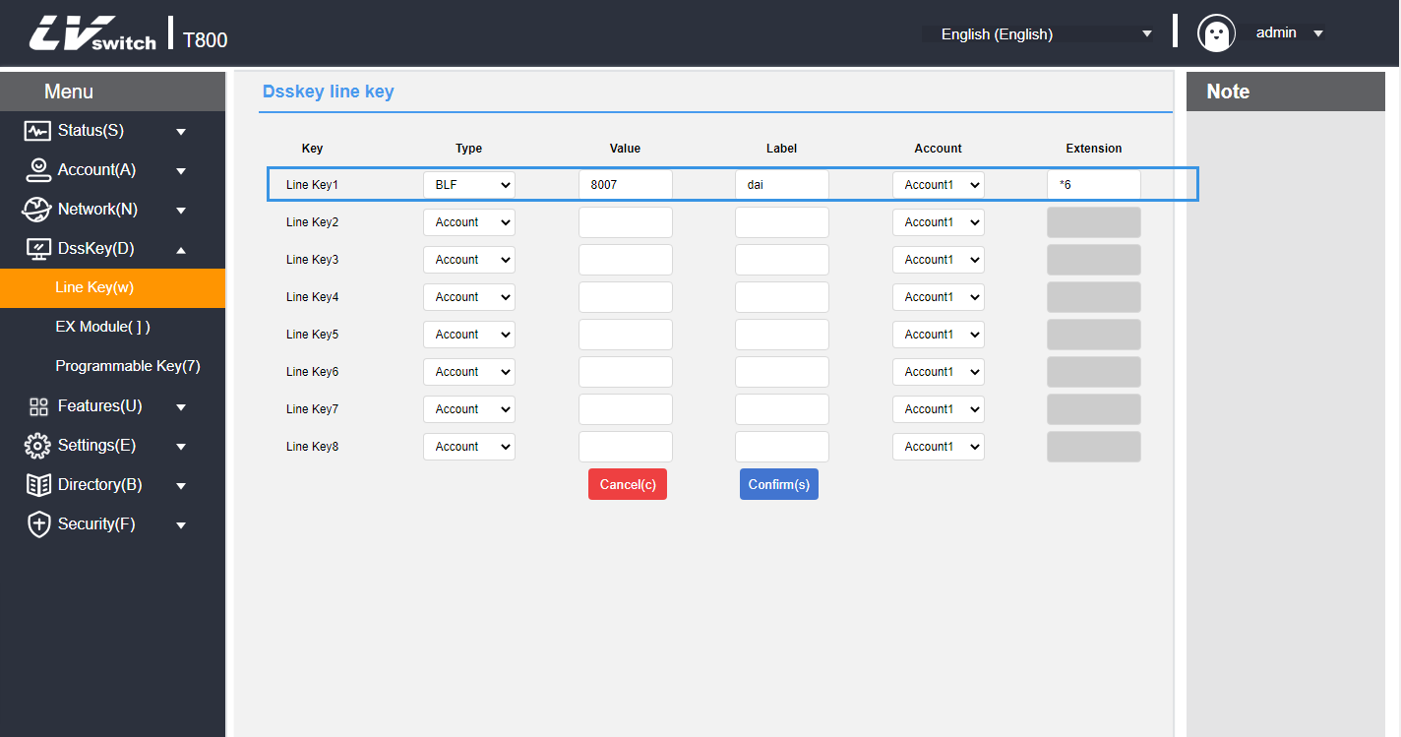

Using the BLF Function
The BLF key is used in the following way:
- Calling the monitored account.
When the monitoring account is idle, press the BLF key and the phone calls out the monitoring account.
- Intercepting calls from monitored accounts.
When an incoming call is received from a monitored account, the LED of the BLF key corresponding to the monitored account turns red. If the extension number is configured as an Intercept Feature Code, the incoming call from the monitored account is answered when the BLF key is pressed.

Walkie-talkies
By setting the account number key as the intercom function, you can speed dial the called number that has been set when pressing the account number key, and quickly connect to your secretary or operator in an office environment. The called caller of the intercom will automatically answer the intercom call.

Setting the intercom function buttons
Before using the intercom you need to set up the account key function as an intercom key, see Programmable Keys for details on how to set this up, for help please contact your network administrator.

Intercom function setting
- Turn on the intercom through the handset interface
1. Press Menu->Features->Intercom.
2. Press or to select the intercom function.
3. Press the Toggle soft key to turn the function on/off.
4. Press the Save soft key to save.
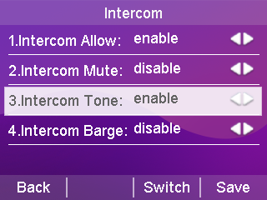
- Turning on the intercom through the web interface
1. Log in to the phone page by IP address.
2. Click Features (U) -> Intercom (n).
3. Select different functions in the type selection.

4. Press Submit to save when you have finished selecting.
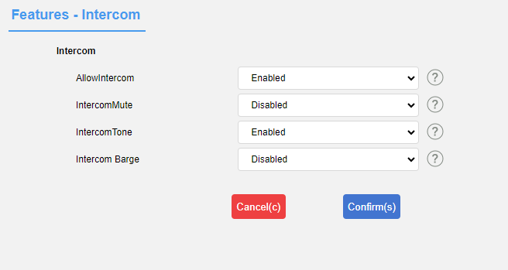

Intercom function description
functionality | clarification
Enable walkie-talkies | Enable or disable the intercom function.
Walkie Talkie Mute | Enable or disable mute on the handset for incoming intercom calls.
intercom tone | Enable or disable the intercom tone for incoming intercom calls.
Intercom Intervention | Enable or disable access to incoming intercom calls while you are on a call.

Multicast
Multicast allows you to send time-sensitive announcements to each member of a multicast group simply and quickly. Send RTP streams to pre-configured multicast addresses via multicast keys or multicast lists set on the phone. By setting up listen multicast address on other phones, the phones can listen to and play RTP streams sent from the multicast address. The multicast process does not involve SIP signaling. Phones can be set to listen to up to 31 multicast addresses.

Multicast Configuration
- Configuring Multicast Keys via the Handset
1. Press Menu → Features → Dess Key.
2. Select the account key for which you need to set up multicast.
3. Press or to toggle and select Key Event in the Type area.
4. Press or to toggle and select Multicast in the Key Type area.
5. (Optional) Enter the contents of the standby screen display in the label area.
6. Enter the multicast address IP address + port number in the value field, IP range 224.0.0.0-239.255.255.255.
7. Enter the appropriate channel number in the channel area: 0-30.
8. Press the Save soft key to save the operation or press the Return soft key to cancel the operation.
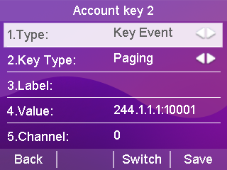
- Configuring Multicast Keys via the Web Interface
1. Web Programmable Keys → Account Key.
2. Select the account key for which you need to set up multicast.
3. The Type area drop-down box is set to Multicast.
4. The Value field input box is filled with the multicast address IP address + port number, IP range 224.0.0.0-239.255.255.255.
5. (Optional) Enter the contents of the standby screen display in the label area.
6. Enter the appropriate channel number in the extension number area: 0-30.
7. When finished, click Submit to save the operation or Cancel to abandon the operation.

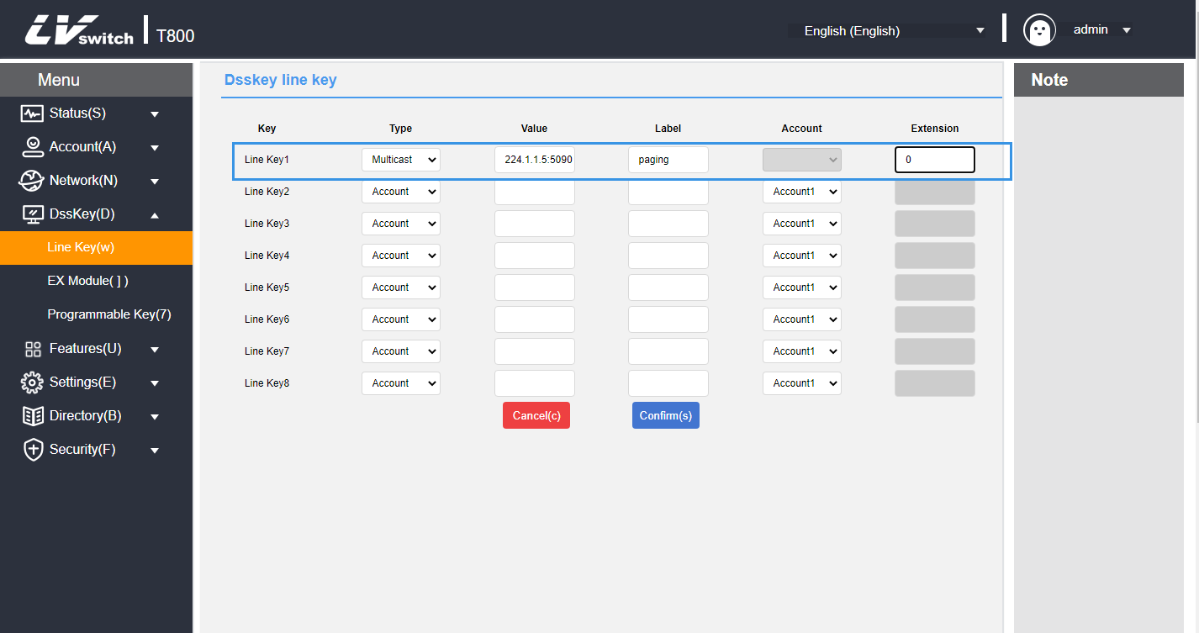

Multicast List Configuration
- Configure multicast lists through the phone
1. Press Menu->Features->Multicast List.
2. Press or to select the appropriate group.
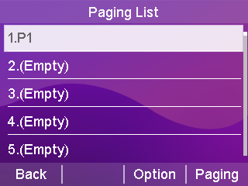
The label defaults to empty before configuration.
3. Press the Options soft key, and then press the Edit soft key.
4. Enter the multicast IP address and port number in the address area (for example: 224.5.6.20:10008).
5. Enter the group name in the label area.
6. Enter the appropriate channel number in the channel field.
Valid channels are numbered 0 through 30.
7. Press Save Software to save the operation.
8. Repeat steps 2-7 to add more groups.

- Configuring Multicast Lists via the Web
1. Web Directory(B) → Multicast IP(2) → Multicast List.
2. Fill in the Multicast Address input box with the multicast address IP address + port number (e.g., 224.5.6.20:10008).
3. Enter the group name in the label area.
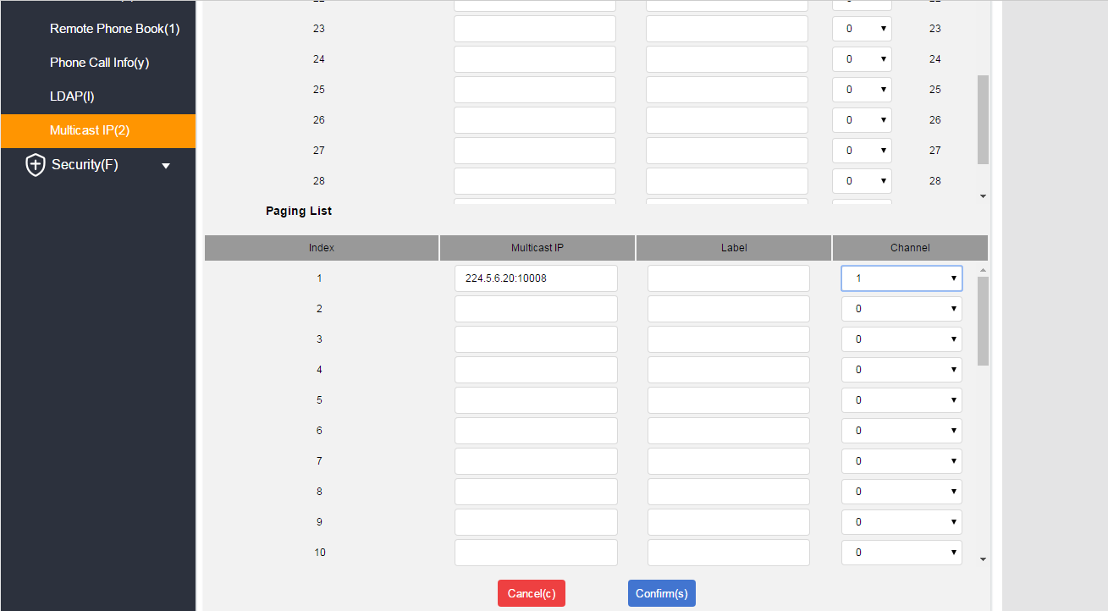
4. Select the appropriate channel number in the Channel drop-down box.

5. Click Submit to save the operation when finished.

- Configure multicast codecs via web page
1. Web Features(U) → General Information(5).
2. Select: PCMA, PCMU, G722, G729 in Multicast Codec.
3. Click Submit to save the operation when finished.
If the codec is G722 then the phone is sending a high definition voice stream and the LCD interface displays HD (High Definition icon)

- Deleting a multicast group through the phone interface
1. Press Menu->Features->Multicast List.
2. Press or to select the appropriate group.
3. Press the Options soft key, and then press the Delete soft key.

The phone's LCD screen prompts "Delete Group?" .
4. Press the OK soft key to delete.
To delete all multicast groups, press the Delete All softkey.
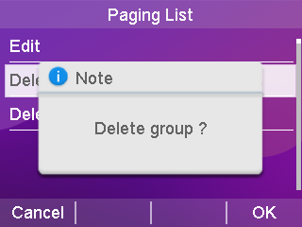

You can also set the handling method of RTP streams received by the phone through the Web, which is categorized into Paging Intervention, Penetrating NDN and Paging Priority,and the Configuration Path: Directory(B) → Multicast IP(2).
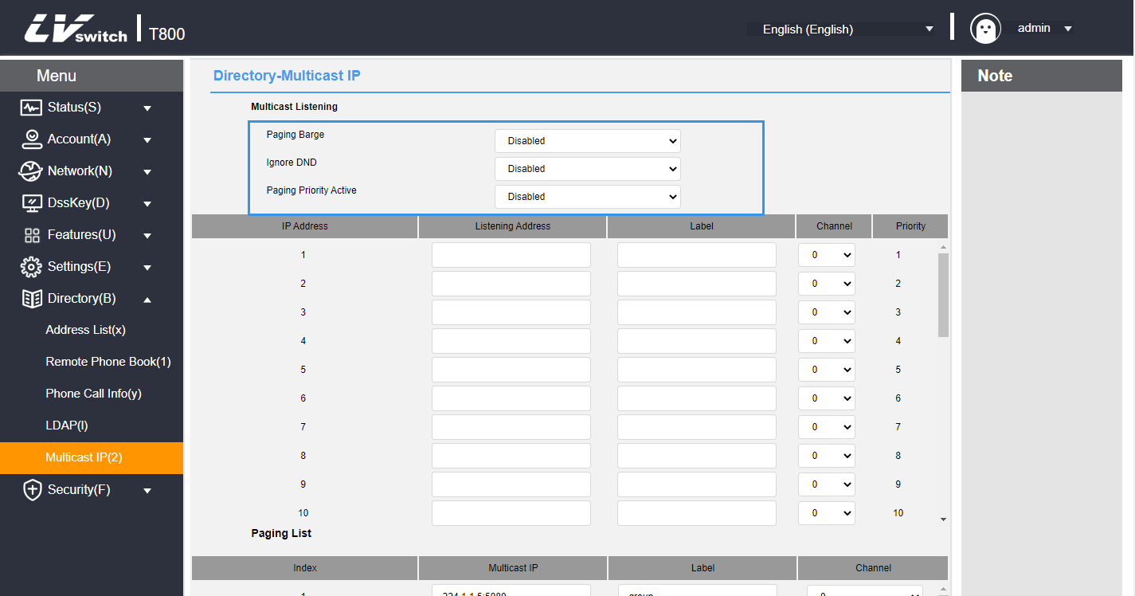

1. Paging intervention: if there is a multicast during the call, if the current multicast priority is lower than the call priority, the phone will automatically ignore the multicast; disable it to ignore all multicasts, range 1-31. e.g., set the priority to 1 to ignore multicasts of priority 2-31.
2. Penetrating DND: If the phone opens Penetrating DND, priority 3; when the phone opens DND Mode, multicasts with priority greater than or equal to three can be answered normally.
3. Paging Priority: If you turn on Paging Priority, when the phone is listening to a multicast RTP stream with priority 5, and a multicast RTP stream with priority 3 is sent at this time, the phone automatically receives a multicast RTP stream with priority 3.

Accept multicast RTP streams
You can set the phone to receive multicast RTP streams sent from pre-configured multicast addresses. the multicast process does not involve SIP signaling. Up to 31 different multicast addresses can be configured to listen on the phone.
Description RTP multicast listening is played in hands-free mode by default, if you want to play through other modes (hands-free, joystick or headset), please consult your system administrator.

1. paging intervention: if there is a multicast during the call, if the current multicast priority is lower than the call priority, the phone will automatically ignore the multicast; disable it to ignore all multicasts, range 1-31. e.g., set the priority to 1 to ignore multicasts of priority 2-31.
2. Penetrating DND: If the phone opens Penetrating DND, priority 3; when the phone opens Disturbance Free Mode, multicasts with priority greater than or equal to three can be answered normally.
3. Paging Priority: You can enable or disable Paging Priority, a feature that determines how the phone handles newly received multicast RTP streams when it is currently engaged in a multicast session. If you enable paging priority, the phone automatically ignores multicast RTP streams with low priority, receives multicast RTP streams with high or equal priority, and places the current multicast session on hold. If paging priority is disabled, the phone will automatically ignore all received multicast RTP streams.

- Set the multicast address to listen to via the web page:
1. Click Directory(B) → Multicast IP(2).
2. Select the appropriate value in the Paging Intervention drop-down box.
3. Select Enable in the Paging Priority drop-down box.
4. In the Listening Address field, enter the multicast address to which you are listening: IP address and port number (for example: 224.5.6.20:10008).
5. (Optional) Enter a label in the label area. When a multicast RTP stream is received, the LCD interface displays the label for that multicast.
6. Select the appropriate channel in the Channel drop-down box, the default is 0.
7. Click Submit to save the operation.
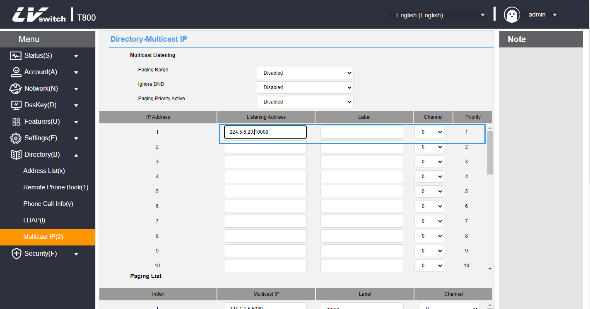
Description The priority of the listening address is predefined: 1 is the highest priority and 31 is the lowest priority.
You can only set the multicast address to listen to through the web interface.

Multicast Usage
Phone A sets up account 1 for multicast and account 2 for multicast list, and phones B, C, D, etc. set up listening addresses.
1. Multicast key sending: when the phone A is in standby state, press the account 1 multicast key, the pre-configured listening phone will receive the multicast RTP stream; when the phone A presses the hold key, the receiver will automatically hang up the multicast RTP session, and then press the resume key to restore the held multicast. Pressing Hangup ends the multicast RTP session.
2. Multicast list sending: press Multicast list in standby state, select the option you need to multicast and press Multicast, or press Menu→Function→Multicast list in standby state.

Caveats:
1. Multicast RTP streams are unidirectional and can only go from the sender to the receiver. When the phone is in a call. initiating a multicast RTP session the current call is on hold.
2. Multicast does not generate call records.

Message

Text message
SIP-T800N IP phone can send and receive text messages. When receiving a new text message, the phone will emit a beep, the power indicator will flash red slowly, the LCD interface will indicate "n new text messages" (n means the number of unread text messages, e.g. 1 new text message), and the icon of unread text message will be displayed. The icon is displayed for unread text messages.
SMS messages can be stored in the Inbox, Sent, Outbox and Drafts boxes, each with 100 messages. If the number of messages exceeds 100, the oldest messages are deleted.
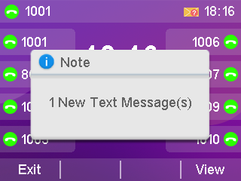
- Read the text message:
1. Press Menu->Messages->Text Messages->Inbox.
2. Select the message you want to read and press the View soft key.
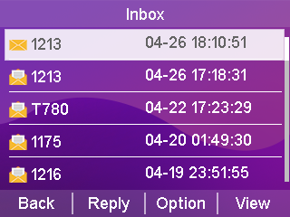
- Sends a text message:
Description If the phone prompts to receive a new text message, you can simply press the View soft key to read it.

1. Press Menu->Message->Text Message->New Message.
2. Compose a new message and press the abc soft key to switch the input method.
3. Press the Send soft key.
4. (Optional) Press the Toggle soft key to select the sending account in the From area.
5. Enter the recipient's number in the Send To field.
6. Press the Send soft key to send a message or the Return soft key to cancel.
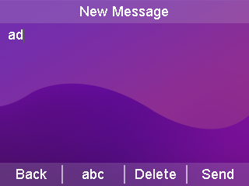
- Sending text messages through the web interface
1. Log in to the web user interface.
2. Click Features (U)->SMS (9).
3. Select the sending account.
4. Enter the sending number.
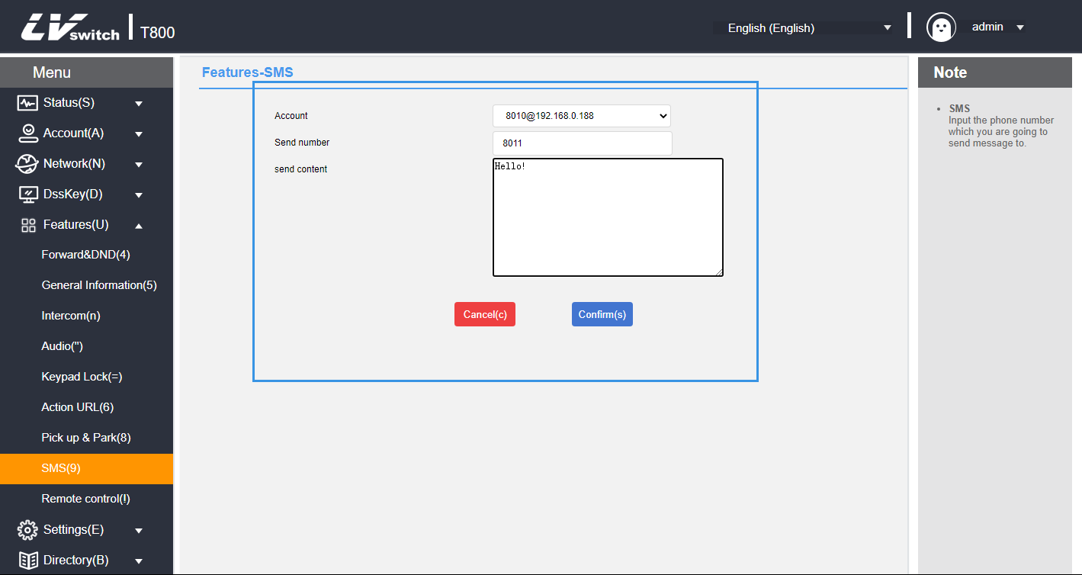
5. Fill in the send content.
6. Click the Submit button to send the short message.

- Respond to the text message:
1. Press Menu->Messages->Text Messages->Inbox.
2. Select the message you want to reply to and press the Reply soft key.
3. Write the message and press abc to switch the input method.
4. When you have finished writing, press the Send soft key.
5. Check the From and To areas and press the Send soft key.
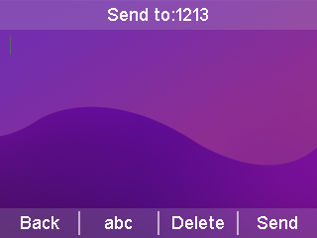
- Delete the text message:
1. Press Menu->Messages->Text Messages->Inbox (Sent Messages, Outbox or Drafts).
2. Select the message to be deleted and press the Options soft key.

3. Select Delete and press the OK soft key to display "Delete Selected Information?" on the LCD screen. The LCD screen displays "Delete Selected Information?".
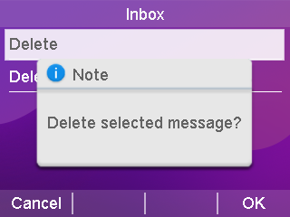
4. Press the OK soft key to delete and press the Cancel soft key to cancel.
To delete all SMS messages, press the Options soft key and select Delete All. For more information, see the steps above.
Description You can delete a message by pressing the Delete soft key directly after you have received and viewed a specific short message.

Voicemail
The SIP-T800N Phone can send and receive voice messages. You can subscribe to voice messages cached in the voice mailbox on the phone. This feature requires the server pre-setting. Not all servers support voicemail.
When a new voicemail is received, the power lamp of the phone blinks red slowly, the LCD interface displays "N voice messages" (N means the number of unread voice messages, e.g., 1 new voice messages), and the voice message icon is displayed.
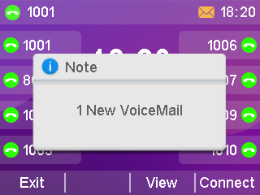
- Send a voice message:
When the called user is busy or inconvenient to answer the incoming call, you can leave him a message according to the server's voice prompts, and hang up the phone after leaving the message.

- Set the voice message access feature code through the phone interface:
1. Press Menu->Message->Voice Message->Set Voice Feature Code.
2. Press or to select the account to be set up.
3. Enter the voice message access feature code (e.g., *97).
4. Press the Save soft key to save the operation or the Return soft key to cancel the operation.

- Listening to voice messages
1. Press the SMS soft key or call out the voice message accessed the feature code after setting the voice feature code.
2. Just listen to the voice message according to the voice prompts.

- Viewing Voice Messages
1. Press Menu->Message->Voice Message->View Voice Message.
2. Select the account you want to listen to and press the Connect soft key to linsten to the voice message.

TR069
TR069 is the communication protocol between CPE and ACS. TR069 is the communication protocol between CPE and ACS, through which CPE can complete initialization and operation management such as service activation, function setting, file uploading and downloading, and system testing.

TR069 workflow diagram for SIP-T800N phones:
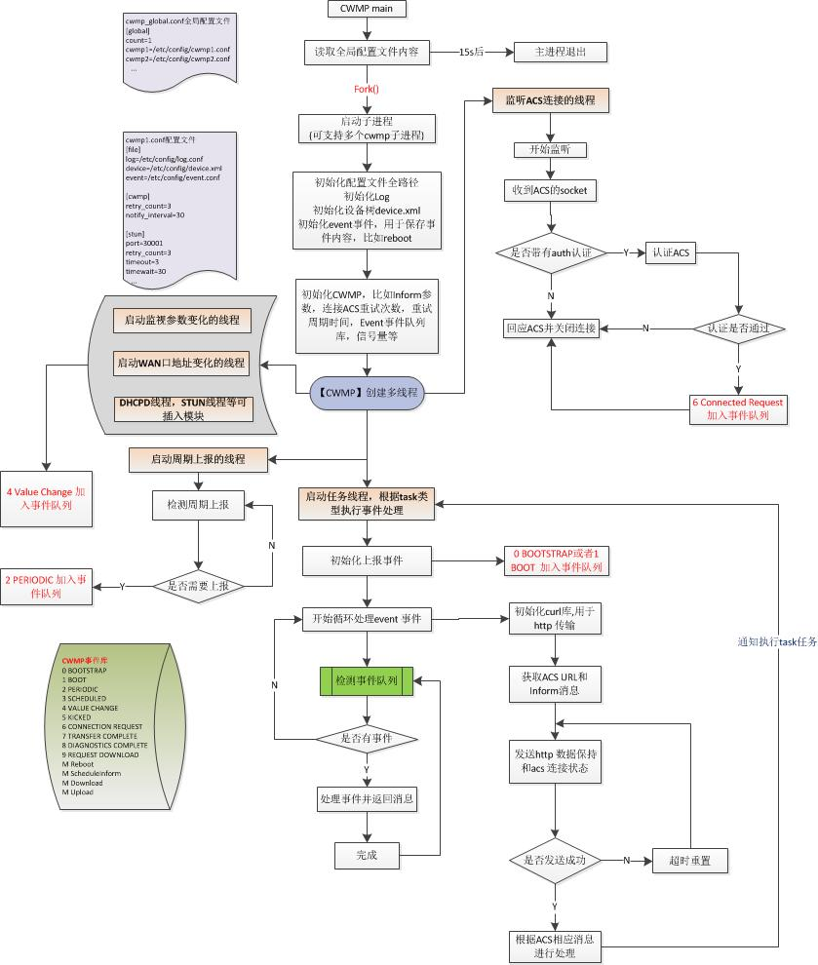

- Enabling TR069 through the web interface
1. Log in to the phone page by IP address.
2. Click Settings (E) -> TR069 (\).
3. Enable TR069. Enter: user name, password, and server address.
4. Enable periodic notification, periodic notification interval, user name, and password.
5. Press Submit to save when you have finished selecting.
As pictured:

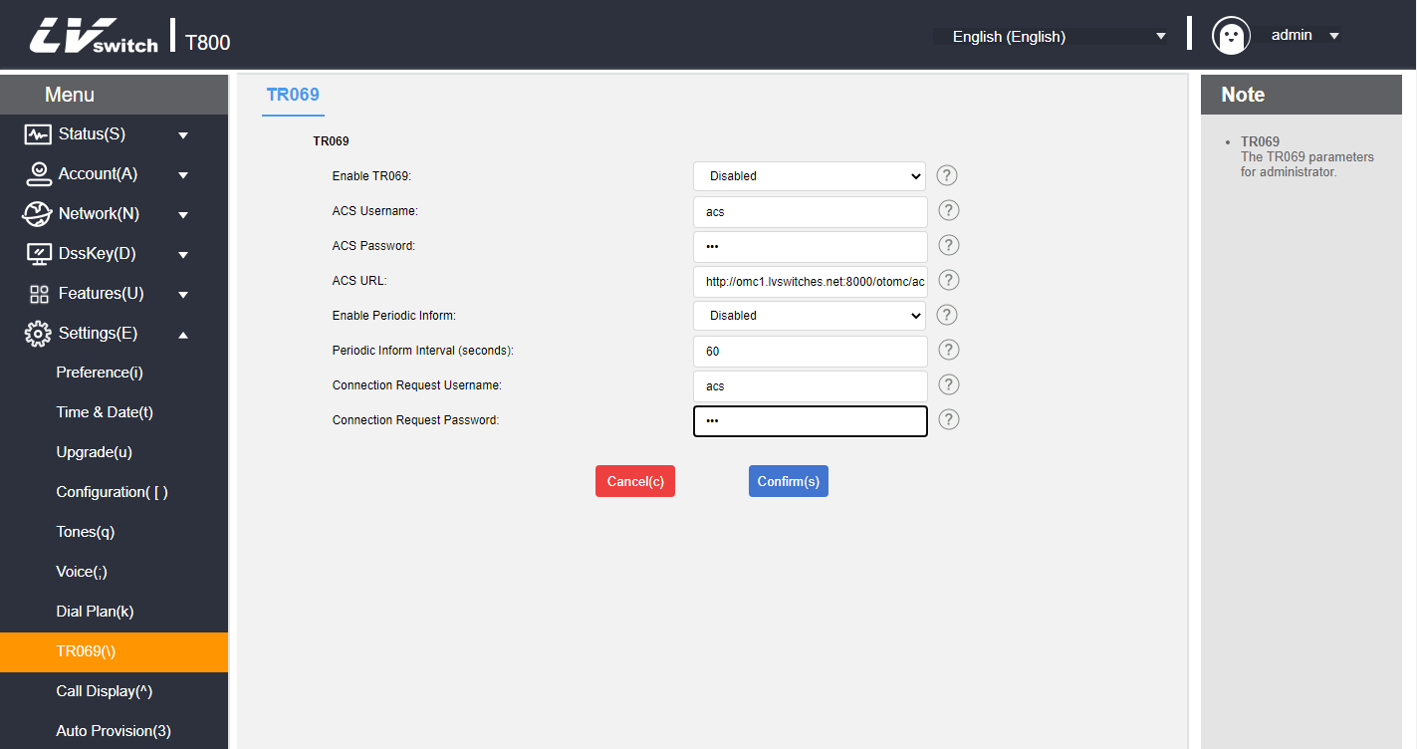

Automatic update
Automatic updates can deploy the same configuration for multiple phones at scale.

Preparatory step
Prepare the necessary documents:
The following steps need to be performed before auto-configuration can take place:
1. Get Boot boot file;
2. Get the CFG configuration file;
3. Obtain information about the phone;
4. Setting up a renewed environment.
Bootstrap files, configuration files can be obtained by contacting your dealer for template files.

- The way to view information about the phone:
MAC: The phone is viewed in standby mode by pressing the OK key.
Phone Model: Standby phone press OK→More→Equipment, the product name is the phone model.

- Bootstrap file description:
When the phone is auto-configured, it will first try to download the common.boot boot file, and according to the boot file, the phone will be guided to refer to the specified CFG configuration file. The sequence is shown below:
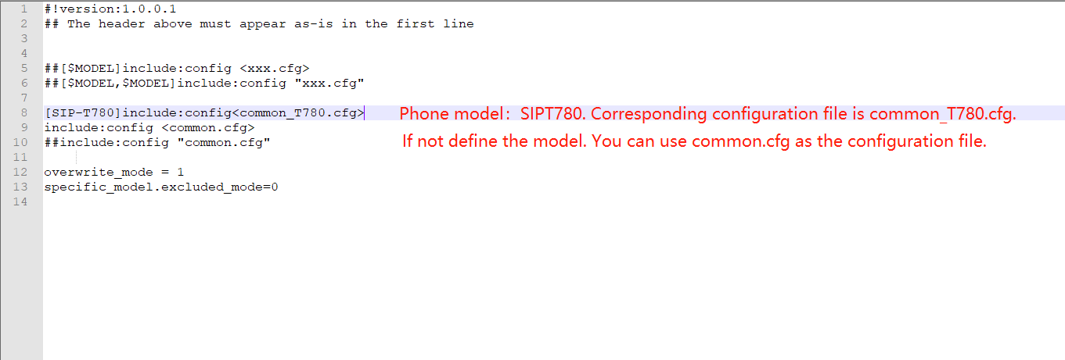

- Configuration Profile Description:
Before you configure the phone, you need to get the CFG configuration file, common.cfg for the common configuration file, mac.cfg for the mac-based configuration file; you can also create your own needs according to their own needs of the configuration file such as account.cfg which is used to configure the phone account and so on.
The list of configuration support is as follows:
 | Content
Phone Configuration | Account, DTMF, User Agent, Time, STUN, Network, Vlan, LLDP, CDP, Language, Signal Tone, QoS, Sound.
Function Configuration | Call Forwarding, Anonymous Calling, Intercom, TR069, Programmable Keys, DND, Hotline, Voice Mailbox, Keypad Lock, Action URL, Auto Update.
Other configurations | Upgrade phone , pager configuration.

Example: If the phone needs to be upgraded to a specific version and the language is set to Chinese, create a LanguageAndUp.cfg file, add the configuration and place it in the root directory of the server.
### Language ###
language_setting.languages = 0
### Upgrade ###
static.firmware.url = ftp://192.168.17.xx/V2.0.0.3_T800N_rootfs.sqhfs
Description If you set up an upgrade, the upgrade file must be in this directory or the upgrade will fail.

Automatic update procedure

HTTP(S) method update
To configure the server, run HFS.exe directly; after running it, place the configuration file directly in the environment root directory; The configuration file contains files such as xx.boot and xx.cfg.
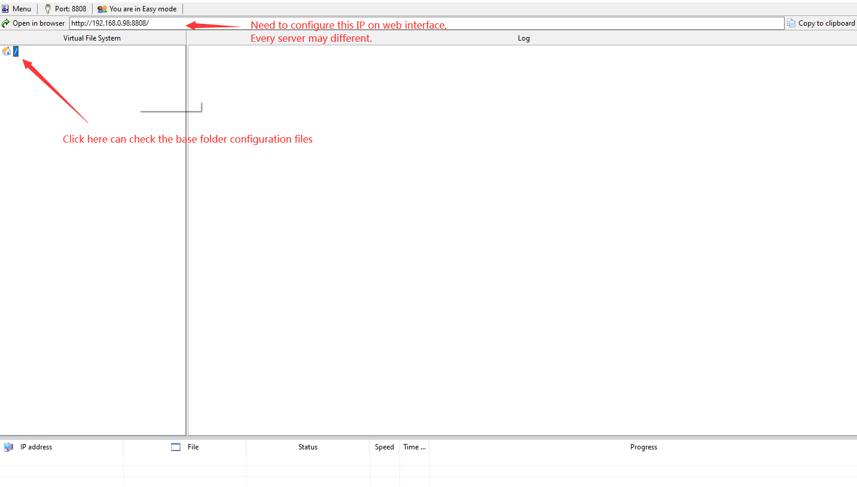
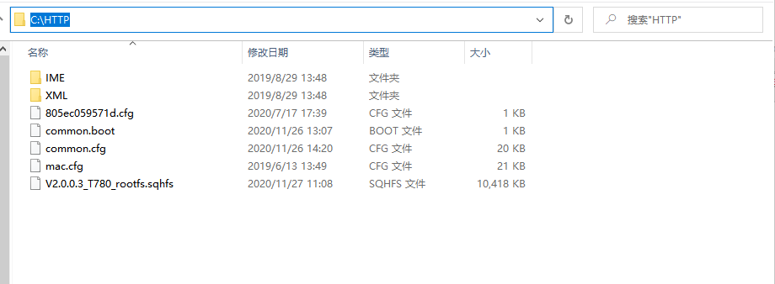
Root directory file map:

Setup Steps:
Web-side Settings(E)→Auto Update→Fill in http(s) address in Server Address e.g.: http(s)://192.168.17.xx to enable power-on startup; automatically configure the information to be updated after reboot.

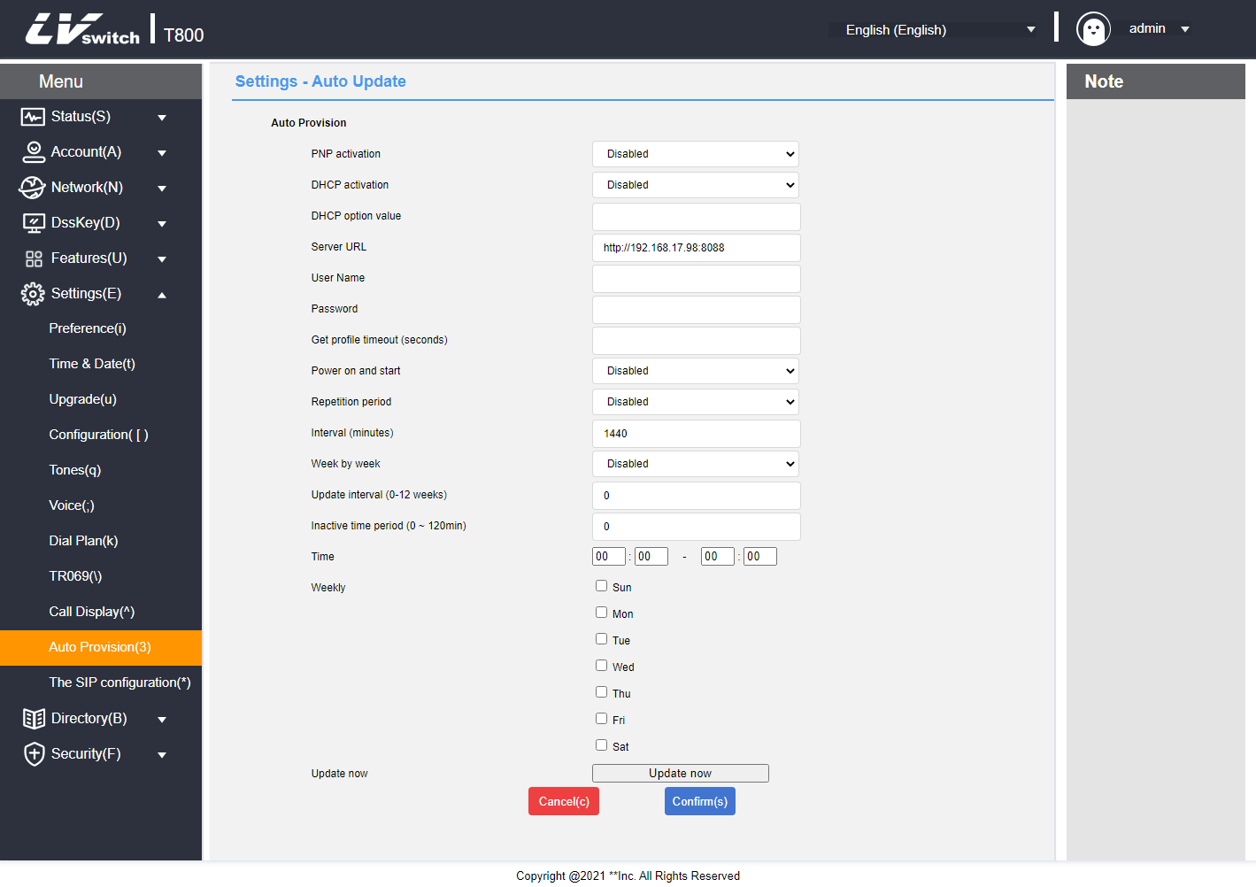

FTP/TFTP update
Configure the server, directly run IPOP.exe to enable FTP/TFTP inside the service, you can also use 3CDaemon, TFTPD32, etc. as the server; run the configuration file directly in the root directory of the environment; the configuration file contains xx.boot and xx.cfg and other files. The configuration steps are shown in the following figure:
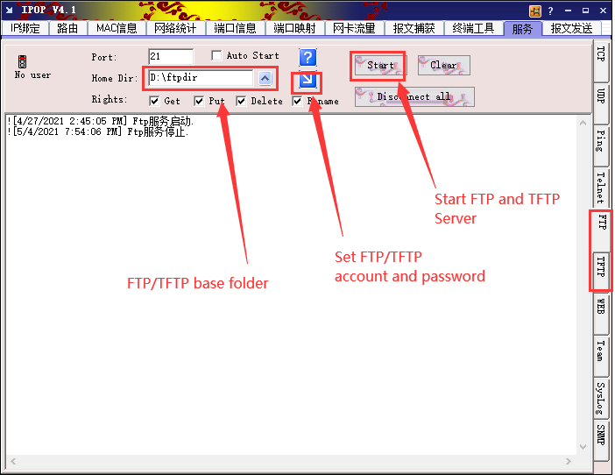
Setup Steps:
Web Click Settings (E)→Auto Provision Fill in the ftp/tftp address in Server Address for example:

ftp://192.168.17.xx/ to enable power-on startup;automatically configure information update after reboot.
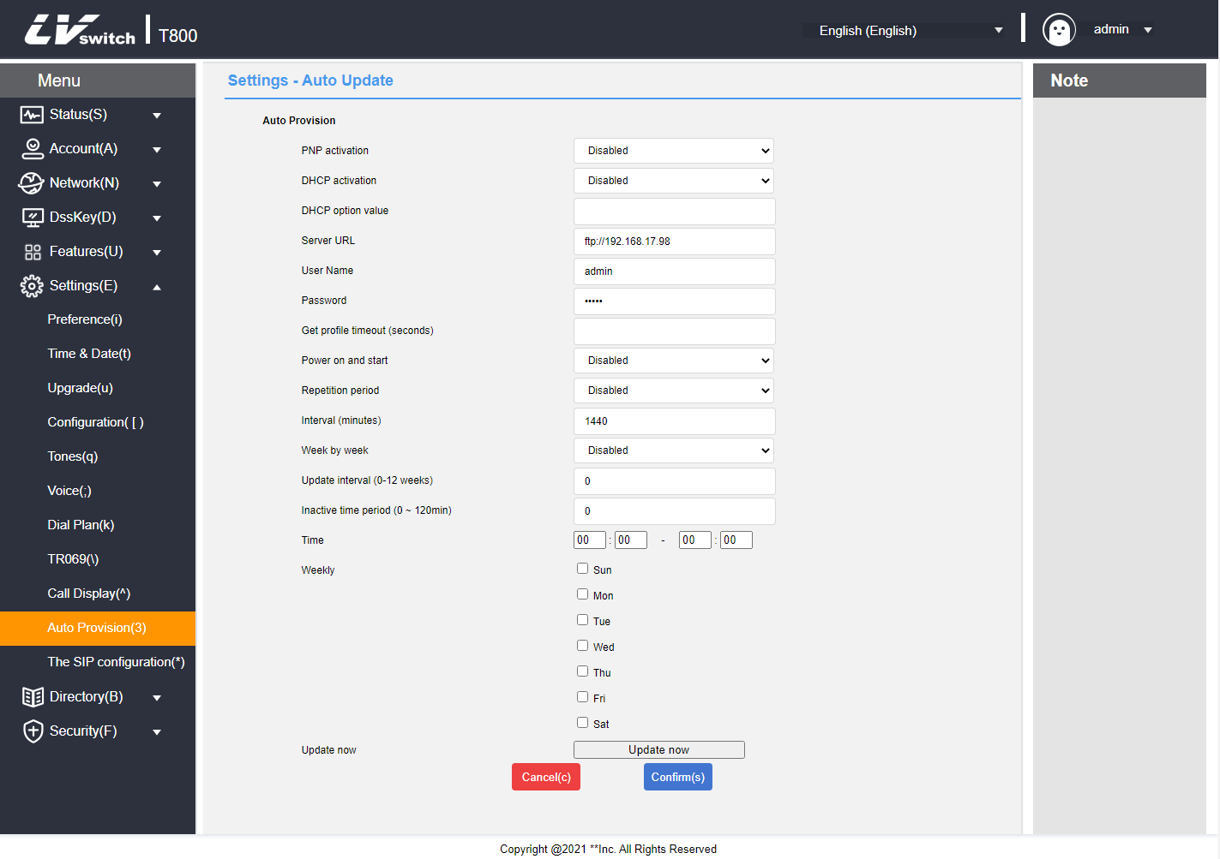

Remote control
Used to control the configuration related to remote XML push.
- Configure remote control via web page
1. Log in to the web user interface.
2. Click Features (U) -> Remote control(!).
3. Configure remote control.
a) XML push server address;
b) User name: Set the XML push server address user name;
c) Password: Set the XML push server address password;
d) SIP NOTIFICATION: Enable/disable phone call SIP NOTIFY message processing XML push;
e) Blocking XML push in calls;
f) Allow control IP list: Multiple IPs are separated by ",", allowing all IPs to fill in any;
g) CSTA control;
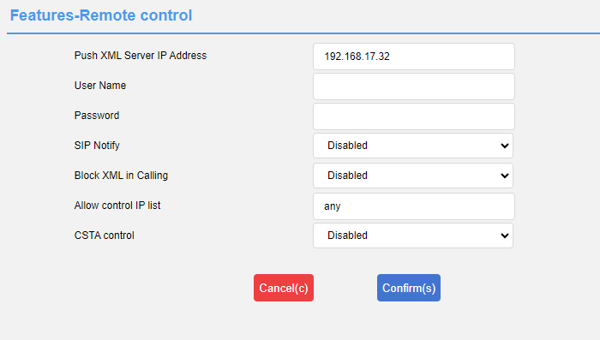
4. Click the Submit button to save the changes.
XML can perform the following operations:
Displaying menu options, displaying text prompts, collecting user submissions, downloading address books from the server, prompting the phone for status information, notifying the phone to perform a series of commands, modifying phone configuration (e.g., registration, etc.), displaying text prompts in a fixed format on the interface, displaying graphic prompts on the interface, displaying menu items in graphic format, and customizing function softkeys.

- Server pushes XML to phone
Remote control application, the server can push XML to the phone by POST, and the end user does not need any action. This time we don’t do introduction of server building.The interested parties can learn a programming language. Here we take the PHP environment as an example to push the XML file to the terminal of the phone:
The file format is as follows, just access it after the configuration is complete.
<?php #
function pushtophone($server,$phone,$data){
$xml = "xml=". $data;
$post = "POST / HTTP/1.1\r\n";
$post . = "Host: $phone\r\n" ;
$post . = "Referer: $server\r\n";
$post . = "Connection: Keep-Alive\r\n" ;
$post . = "Content-Type: text/xml\r\n";
$post . = "Content-Length: ".strlen($xml)." \r\n\r\n".
$fp = @fsockopen ( $phone, 80, $errno, $errstr, 5);
if($fp){
fputs($fp, $post.$xml); flush();
fclose($fp);
}

}
$xml = "<IPPhoneTextScreen Beep=\"yes\">\n";
$xml . = "<Title>Push test</Title>\n";
$xml . = "<Text>This is a test for pushing text to a phone.</Text>\n";
$xml . = "</IPPhoneTextScreen>\n" ;
pushtophone("192.168.17.xx", "192.168.17.xx",$xml);

? >

SIP Configuration

SIP Session Timer
SIP session timers T1, T2 and T4 are SIP transaction layer timers defined in RFC 3261.

- Configure SIP session timer via web page (only via web page)
1. Log in to the web user interface.
2. Click Settings (E) -> SIP Configuration (*).
3. Configure T1, T2 and T4.
4. Click the Submit button to save the changes.

SIP Session Timer T1: Timer T1 is an estimate of the round-trip time (RTT) of a transaction between a SIP client and a SIP server.
SIP Session Timer T2: Indicates the maximum retransmission time for any SIP request message. the retransmission multiplication of T1 will continue until the retransmission time reaches the value of T2.
For example, a user registers a SIP account and sets the values of Timer T1 and Timer T2 respectively (Timer T1:0.5, Timer T2:4). the SIP registration request message will be retransmitted between the phone and the SIP server. The retransmission multiplication of timer T1(0.5) will continue until the retransmission time reaches timer T2(4). The total registration request retry time will be less than 64 times T1(64 * 0.5 = 32). The retransmission intervals are in order:0.5s, 1s, 2s, 4s, 4s, 4s, 4s, 4s, 4s, 4s, 4s, 4s, 4s, 4s, 4s, 4s, 4s, 4s, 4s, 4s.
SIP Session Timer T4: Indicates how long it takes for the network to clear messages between the SIP client and server.
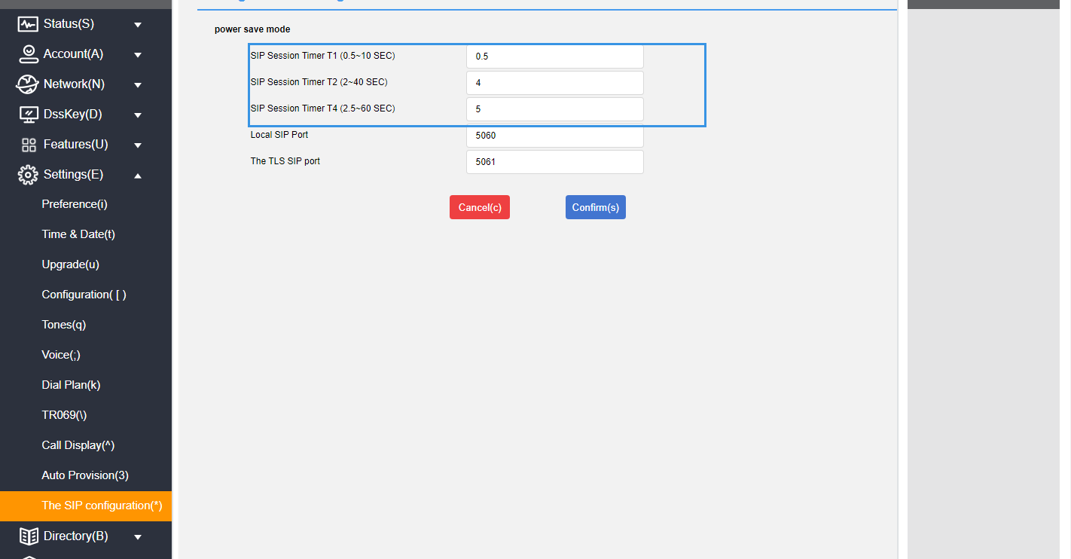

Native SIP ports vs. TLS SIP ports
If NAT is not enabled, the port number is displayed in the header of the SIP message for via and contact. If NAT is enabled, the phone will use the port and address for NAT in the header fields for via and contact, but will still use the configured source port.

- Configuring Local SIP Ports and TLS SIP Ports via Web Page
1. Log in to the web user interface.
2. Click Settings (E) -> SIP Configuration (*).
3. modify the local SIP port and TLS SIP port.
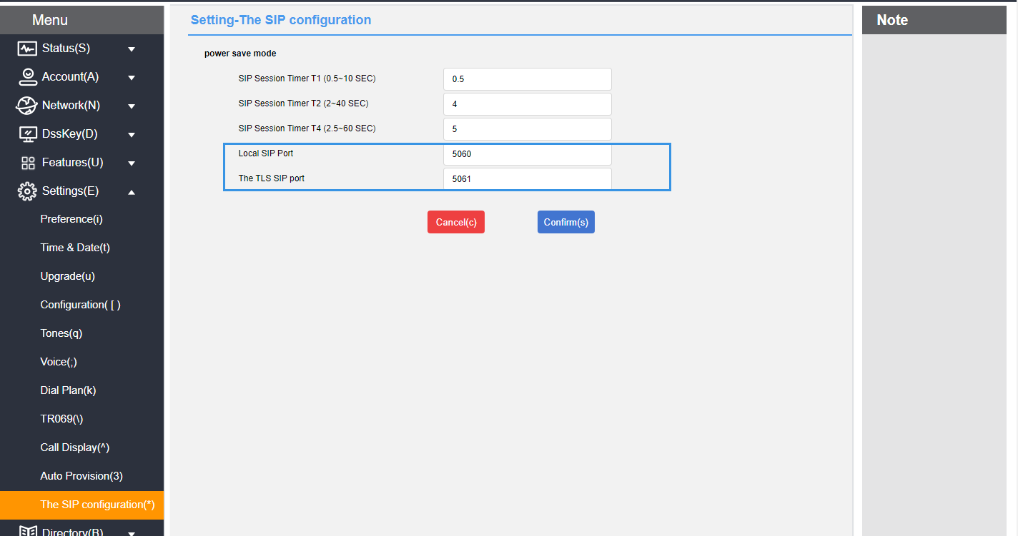
4. Click the Submit button to save the changes.

Action URL
The Action URL function is mainly used for the phone to report its own behavior to the computer, an action generates a URL on the phone side, and the actions on the phone side include incoming call, outgoing call, call transfer, etc. The web management interface lists all the supported actions, and each action corresponds to a user-defined URL. when an action is generated, such as an incoming call, the phone sends out an HTTP/HTTPS GET to the computer of the corresponding URL, so as to achieve the purpose of reporting its own actions. HTTP/HTTPS GET to the computer to report the action.
This function works in conjunction with the Action URI to enable mutual control between the phone and the computer.
URL format: http(s)://server address/help.xml?mac=$mac

Enables actions to be reported to the server
Enables reporting of server actions and a list of variables supported by each action:
Reportable actions | clarification | Supported Variables
Startup complete. | When phone startup is complete | $mac  $ip  $model  $firmware (base)
registered | When SIP account registration is successful | $mac  $ip  $model  $firmware  $local
unregistered | When the SIP account is not registered | ibid
Registration Failure | When SIP account registration fails | ibid
Drop the handle. | When the handle is hanging | $mac  $ip  $model  $firmware (base)
Pick up the handle. | When the handle is off | ibid
When there is an incoming call | When the phone calls | $mac  $ip  $model  $firmware  $active_url  $active_user  $active_host  $local  $remote  $display_local  $display_remote  $call_id  $callerID  $calledNumber (call related)
send a call | When the phone dials | ibid
establish a session | When the call establishes a session | ibid
end a call | At the end of the call | $mac  $ip  $model  $firmware
Turn on Do Not Disturb | When Do Not Disturb is turned on | ibid
Turn off do-not-disturb | When you turn off Do Not Disturb | ibid
Turn on unconditional forward | When unconditional call forwarding is turned on | ibid
Close unconditional forward | When unconditional call forwarding is turned off | ibid
Open up a busy forward | Turn on the busy call forward | ibid
Turn off busy forward | Turn off call forwarding when busy | ibid
Turn on no-answer forward | Turn on no Answer Forward | ibid
Turn off no-answer forward | Turn off no Answer Forward | ibid
transfer a call | When a call forward transfer occurs | $mac  $ip  $model  $firmware  $active_url  $active_user  $active_host  $local  $remote  $display_local  $display_remote  $call_id  $callerID  $calledNumber
Blind transfer | blind transfer | ibid
Advisory Transfers | Consultation transfer | ibid
preserve | hold a call | ibid
Discontinue holding | When canceling the call holding | ibid
mute | When mute is on | ibid
unmute | When mute is canceled | ibid
unanswered call | When there is a missed call | ibid
IP Change | When changing the IP address of the phone | ibid
Idle Entry Call | When the phone enters a call from the idle state | $mac  $ip  $model  $firmware  $active_url  $active_user  $active_host  $local  $remote  $display_local  $display_remote  $call_id  $callerID  $calledNumber
Calls go into idle | When the phone goes from talking to idle | ibid
Rejection of calls | When rejecting an incoming call | ibid
Answer new calls | When answering a new call | ibid
transfer failure | When call forwarding fails | ibid
Transfer complete. | When call forwarding is complete | ibid
forward call | forward call | ibid
Auto-provision | When the automatic update is complete | ibid
Turn on call waiting | When call waiting is turned on | $mac  $ip  $model  $firmware
Turn off call waiting | When call waiting is turned off | ibid
Using a headset | When using a headset | ibid
hands-free | hands-free | ibid
Cancel Outbound | When canceling an outgoing call | ibid
remotely busy | Remote call on busy | ibid
Cancel Remote Call | When canceling a remote call | ibid
Peripheral Information | When updating peripheral information | ibid
VPN IP | When the VPN obtains an IP | ibid

Description of variables
Variables supported in the Action URL:
Reportable actions | clarification
$mac | Phone MAC address.
$ip | Phone IP address.
$model | Phone Type.
$firmware | The firmware version number of the phone.
$active_url | The sip_uri of the current active account (only in effect for inbound, outbound, and calls).
$active_user | User account replenishment for the sip_uri of the currently active account (only in effect for inbound, outbound, and calls).
$active_host | The server portion of the current active account's sip_uri (only in effect for inbound, outbound, and calls).
$local | The local sip_uri.
$remote | The sip_uri of the opposite end.
$display_local | The local display name.
$display_remote | The name of the opposite end of the display.
$call_id | Call ID.
$callerID | The display name of the caller on an outgoing call.
$calledNumber | The number that is called out on an outgoing call.

Web Configuration Instructions
- Configuring Action URLs on Web Pages
1. Log in to the web user interface.
2. Click Features (U) -> Action URL (6).
3. Enter the information to be reported to the server in the appropriate fields.
Example:
http(s)://server address/help.xml?mac=$mac
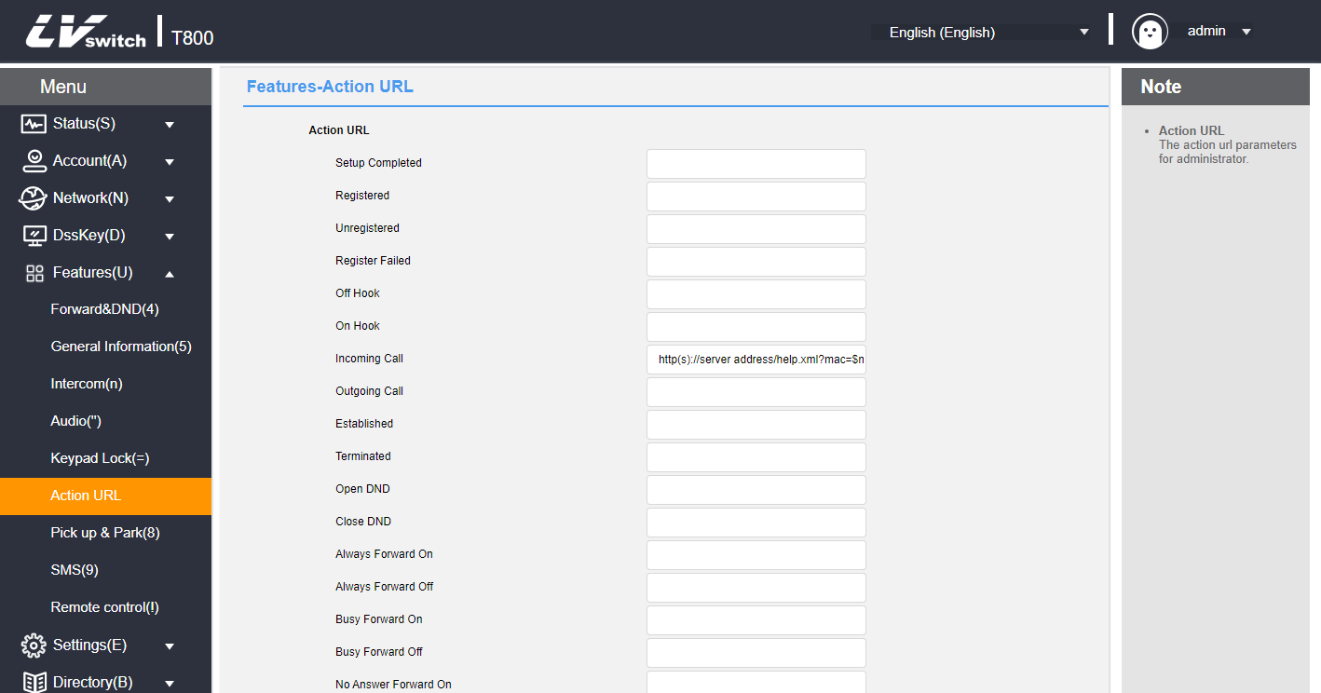
4. Click the Submit button to save the changes.

Type of web access
You can configure the web access type to restrict web logins.

- Configuration of web access types through web pages
1. Log in to the web user interface.
2. Click Network (N) -> Advanced(v).
3. Configure the type of network access click Web Server.
a) Enable/disable http access;
b) Configure the http access port, When using the default 80 access without adding the port when others port need to be added after the IP to access;
c) Enable/disable https access;
d) Configure the https access port, default 443 access without adding the port,when other ports need to be added after the IP to access;
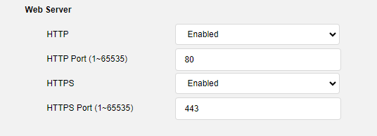
4. Click Submit to save the configuration.
Pages cannot be accessed via web pages after disabling http and https, you can enable access via phone menu->Settings->Advanced Settings->Network->Network Access Type.

Trusted Certificates
You can upload specific CA certificates to your phone.

- Configuration of trusted certificates via web page
1. Log in to the web user interface.
2. Click Security (F) -> Trusted Certificates (@).
3. Select the appropriate value from Allow only trusted certificates, User name confirmation, CA certificates.
4. Click Submit to confirm the operation.
A dialog box pops up, prompting for a reboot to take effect.
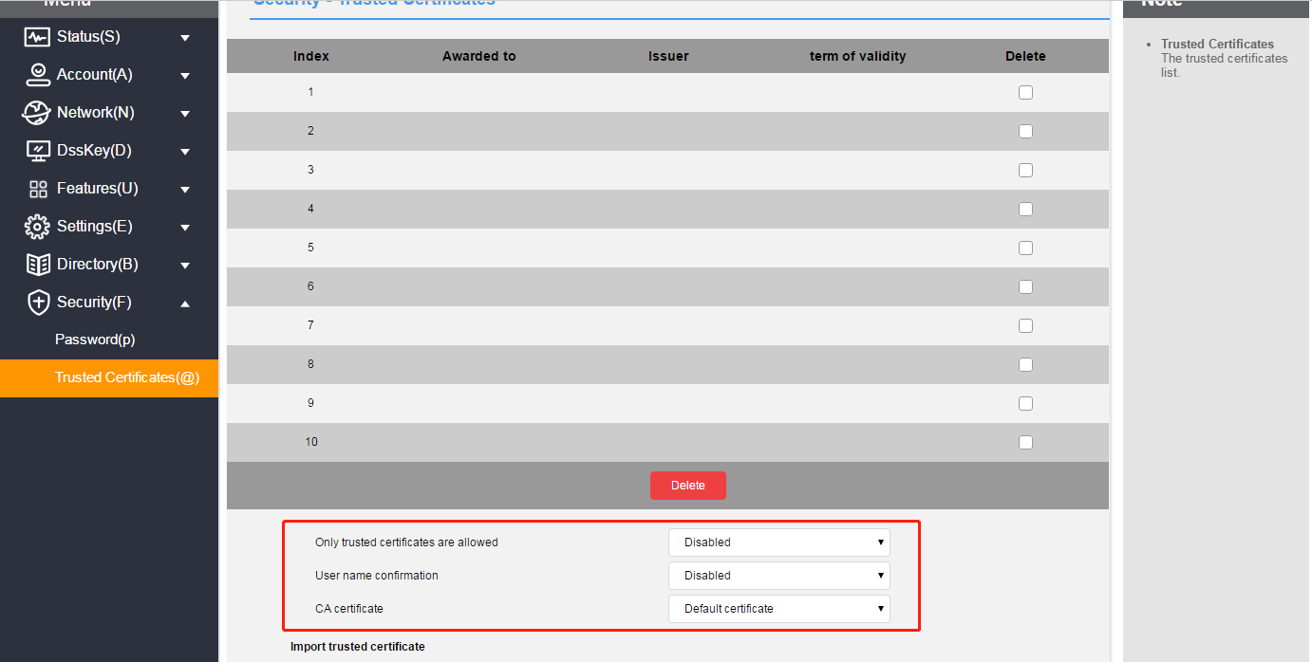
5. Click Confirm to restart the phone.

- Uploading trusted certificates via the web
1. Log in to the web user interface.
2. Click Security (F) -> Trusted Certificates (@).
3. Click Browse in the Load Trusted Certificate File area to select a local certificate file (*.pem, *.crt, *.cer or *.der).
4. Click Import to upload the certificate.
